**Introduction**

**Introduction**

**1.1 Defining Science**

The word science is a derivation of the word “Scientia”1. The Latin word has the closest equivalent to knowledge hence communication of science is effectively communication of knowledge. But if science is knowledge How is science different from let’s say historical fact which is also knowledge going by the common parlance? The difference lies in the method used to obtain knowledge. Science always relies on a hypothesis that is tested and if proven right becomes a theory. After Several observations and experiments, a conclusion is made which is agreed upon by the science fraternity thus giving it greater credibility. On the other hand, a historical fact is a description of events that happened in the past which has been passed down to younger generations as information. A historical fact can’t be tested whereas scientific knowledge can be put to test and modified if a new revelation is found.

Aristotle in his writings refers to science as a body of knowledge that is reliable and rationally, coherently, and logically stated and explained. Classical antiquity mostly refers to the time when Greek philosophers were at their prime and at this time science was quite close to philosophy. The words “science” and “philosophy” which became part of the English language were sometimes used in place of each other to convey the same meaning in the modern era of the earlier period2. The 17th century marked the renaming of natural philosophy as natural science and altogether a different discipline prior to which it was a separate branch of philosophy. However, the word “science” held on to the broader idea that it denotes knowledge that is trustworthy and reliable, whether it was attached to some other domain like political or social didn’t change the sense that the knowledge was accurate and methodical.

Another definition given by Frederic Fitzpatrick is "Science is a cumulative and endless series of empirical observations which result in the formation of concepts and theories, with both concepts and theories being subject to modification in the light of further empirical observations. Science is both a body of knowledge and the process of acquiring it”3.

In today’s world, “science” does not limit itself to the idea of information itself but the idea that the information has been built up using a structured methodology. Terms like Natural and Physical science used in the academic world come under the umbrella of “Science” when referred to by non-academicians which binds the notion of science to the field that pertains itself to the physical aspect of the realm we inhabit and laws that apply to it. In this realm, pure mathematics also sometimes doesn’t find a place to exist. In common parlance, this is the idea of science that is most popular now. Science refined its meaning when scientists such as Galileo Galilei, Johannes Kepler, and Isaac Newton began exploring. They searched for concepts and were able to formulate laws such as laws of motion known widely in today’s world. In this period, referring to natural philosophy as “natural science” became far more popular. During the 19th century, many developments took place regarding science and the most noteworthy was that it no longer retained its meaning as knowledge but it meant methodical attainment of knowledge which can be brought about through a disciplined approach. Physics chemistry geology, and biology every important subject was now methodical. William Whewell is known to come up with the idea of the word scientist to differentiate between people who were pursuing methodical knowledge and other disciplines4. A study of the Oxford Dictionary reveals the year that the word scientist can be dated to and it was found to be 1834. Human thought is a subject of study and society itself is another subject of study. A linguistic limbo was created as we were advancing in our studies because the subjects could not be classified hence these areas of academic study where society as a whole was involved was clubbed together as a social science. Similarly, applied science formal science and many other subjects exist in society today which have their disciplines under them while they fall under the title of Science itself.

**1.2 Types of Science**

**1.2.1 Natural Science**

The kind of branch of study that talks about matter and energy and their relations was brought under the term Natural Science. Curiosity to find out the reasons behind phenomena is very important. Curiosity leads us to discover methods to adapt to our environment whenever necessary. Explaining the phenomena, describing the activities, investigating the mysteries, and predicting the occurrences enables us to define natural science.

Like many other disciplines of the world natural science also has branches which means organisation of the subject matter into different subheads. Organizing subheads into different areas helps us understand different dimensions of the natural and observed phenomena. Like all scholarly subjects, it is also an academic discipline and allows people to shape academic careers in various branches of natural science.

As natural science branches off to various disciplines, there are diverse fields of research within the subject. What could be studied and researched for practical purposes under natural science is as follows

Erosion of beaches and hydrological risks, inventions, and discoveries. Biological diversity and impact of species of the animal kingdom. Astronomical objects and their whereabouts. Agriculture and use of insecticides pesticides and fertilizers.

A degree of research in any of the branches of natural science can lead to a lectureship or professorship or research fellowship in areas like physics, chemistry, biology, geology etc.

Through the course of the development of science, many changes have been witnessed. One major difference is how science was being explored in the past and how it’s done today. Science deals with understanding the natural world through observation and experiments and the series of steps involved make up the scientific method. Since the time of the most famous philosopher from Athens Socrates, Francis Bacon in the 17th century and Karl Popper in the 20th century scientists and philosophers have used observations to postulate something with certainty5. The elementary step to employ the scientific method has stayed throughout the history of science but the subject of natural science has advanced to modern science because of the use of technology. Modern science is done following the scientific method then peer-reviewed then reported in media and uploaded online for all the people to gain access to it and study and discuss about it. The complexities of our natural world have increased as science made us aware of numerous phenomena occurring around us while making progress. It has approached science also complicated. Earlier the topics were broad e.g., animal sciences or Zoology now more specific subject matter is studied like aquatic ecosystems which is related to the study of species living underwater.

Physical science is something that holds a lot of value and merit to human beings as this is the science that is concerned with digging deep into matter up to the point that it explains everything from the tiniest of particles making up matter to the whole system of universes. It was physical science being explored by Einstein who found out that matter and energy could be related. Inanimate objects and the laws that govern them are studied under Physics. Chemistry is all about the composition properties and interactions of different elements and compounds and how they react to give desired or sometimes undesired results. Biology/Life sciences is the study of living beings. Living beings include humans, plants, animals, and microorganisms. There are many professions students can follow if they study science. Students can pursue a degree in engineering following education in the elementary natural sciences. Engineering itself has various disciplines.

**1.2.2 Engineering and Technology**

The application of science and maths to create and construct and design and maintain buildings, structures, transportation machines, and devices is known as engineering (Cambridge Dictionary). Like many other subjects of study engineering also branches off to other specialised fields of study. Latin ingenium is something in Latin that most of us don’t know but this is the origin of the word engineer which denotes “cleverness” and ingeniare, meaning “to contrive, devise”6.

The first ever significant achievement in the field of engineering was the invention of wheel in the ancient times. Levers and pulleys were also engineered during that era to facilitate the daily lives of the people. The word engineering as sources informs us came from the word engineer. At around the end of the 14th century constructor of military machines was addressed as an engineer and at the same time military machines used in war were referred to as engines hence the term engineer (oxford dictionary). Later on, when the construction of roads, bridges, and buildings progressed as a specific discipline it came to be known as civil engineering. Civil engineering can be considered as oldest the subhead of engineering in this respect. Aqueducts and the Colosseum of Rome, the Brihadeswara temple of Thanjavur, something we all marvel at were the products of engineering. Some more popular engineering marvels we have witnessed are the Chinese creation “The great wall” and something archaeologists have been obsessed about the pyramids which were found in Egypt. Some lesser-known marvels would be the hanging gardens which were the pride of Babylon. The past is filled with engineering products to marvel at. In the history of engineering the invention of the steam engine by Thomas Savery can be considered as the watershed moment because it kicked off the industrial revolution in the following time period and marked the beginning of mass production7. Mechanical and Electrical engineering also has roots in the industrial revolution which created the need for machine tools8. Lathe machines and milling machine metal planers were born out of this need. The electric telegraph and electric motor were the major inventions that can be credited to the discipline of electrical engineering. Vacuum tubes and transistors facilitated in branching off of electrical engineering to electronics engineering. Chemical engineering it is believed belongs to the nineteenth century. The industry was asking for new materials and new processes which was answered by chemical engineering. Another significant discipline of engineering that emerged in the 20th century was bioengineering. In the 21st century, new chemicals were produced; imaging technology and diagnostic devices were developed which met the requirements of the people in the field of medicine all because of bioengineering9.

**1.2.3 Medicine and Health Sciences**

When we talk about medical and health sciences the question arises that when the subject gained attention as a discipline and who could be considered as the first doctor. Primitive societies are believed to have attempted treatment for common health issues although religion and superstitions were mixed with the practise of treatment. Herbal remedies for the common cold or constipation or diarrhea might have been used once the mind of the people was prepared for reasoning and rationale. The earliest traditions in medicine are speculated to have come from Babylon, Egypt, China, and India. The first systematic organization of doctors or physician are believed to have begun training in Italy around 1220 CE. Prehistoric times were not recorded so the information given comes from archaeological sources10.

In the context of Indian health sciences Ayurveda and Unani medicine is known to have a profound influence on the system of treatment. Eight branches of medicine are mentioned in the texts of Ayurvedic literature: shalyachikitsa which study of anatomy and practice of surgery, Kayachikitsa or internal medicine, Kumarbhartya includes pediatrics the study of obstetrics and practice of gynecology and, shalakyachikitsa which is related to the diseases of eyes, nose, ear, and the throat, bhutvidya which is related to spiritual treatment and psychiatric procedures and medicine agada tantra is the study of toxins and deals with cures for bites and stings, rasayana which deals with revival and rejuvenation, and vajikaran which deals with fertility and related illnesses along with aphrodisiacs. Anyone who learned ayurveda was expected to have some skills which were essential for the preparation of medicines: the most important of those would be cooking and then other skills like distillation, skills to handle operations, horticulture, Skills to develop pharmaceutical products, metallurgy, manufacturing sugar, analysis and separation of minerals, compounding and making alloys of metals, and preparation of alkalis11. Unani medicine like Ayurveda is also based on the theory of balance and imbalance of elements fire water earth and air causing health and illness12.

In the field of medicine, the invention of the microscope was game-changing as prior to it the humoral theory was given precedence over other schools of thought. Galen of Pergamon who was a Greek philosopher and surgeon is credited with the theory of humorism13. The theory proposed that the human body has humors. The reaserch claimed that the humors were four in number and they were majorly fluids as we know most commonly there was blood and another was phlegm which is associated with cough, and the other two were biles, yellow and black which were considered to be responsible for diseases14. As time progressed germ theory based on a scientific method involving observations through a microscope gained preference. Germ theory bases its reasoning for diseases on the invasion of humans by microorganisms like bacteria and viruses. It was the middle of the 20th century when antibiotics like penicillin were discovered which were found very effective against bacterial infections. Advancements in the field of chemistry, biology, and genetics, and the most important invention of radiography led to the era of what we know as modern medicine although it was Hippocrates of Kos who is still considered to be the father of modern medicine as he had systemized the humoral theory for the students to learn. Today also Doctors around the world swear by Hippocrates before going on to practice medicine.

**1.2.4 Computer and Information Sciences**

As computing is something that is deeply related to mathematics many consider computing as mathematical science15. Computers register themselves in the long history of mankind only after the 19th century began with the earliest designs of them and developed exponentially in the following century. During the 200 years old history of computers, it was first theorized by mathematicians and then calculating machines were invented to solve big numerical challenges. Later on, the machines evolved into more complex devices which could perform difficult tasks in a fraction of a second. Charles Babbage is known to every student of computer studies and he is famously remembered as the father of computers. It was in the 1820s that he first developed an analytical engine, the first programmable calculator ever in the history of machines16. Famous poet Lord Byron’s daughter Ada Lovelace wrote the first algorithm for a computer in 1843. Herman Hollerith designed a punch card for calculation in 1890. A Mathematician named Alan Turing from Britain developed the principles of a universal machine which was named after him the “Turing machine”. The modern computer has a central concept based on his ideas and principles. (National Museum of Computing). In the context of computers there is a very important engineer known for his inventions also a man from the land of Germany whose name was Konrad Zuse. Konrad was an enthusiast of digitalization which meant he was destined to build the Z3, a computing machine in a digitized version in the year 194117. It was unfortunate that at that time world war II was going on and a bomb intended to destroy Berlin destroyed Konrad’s machine also. ENIAC which is short for Electronic Numerical Integrator and calculator was the brainchild of two professors working at the University of Pennsylvania. One of the two professors was John Mauchly and the other was J Presper Eckert. This machine was the first automatic one and could do electronic computing as well as decimal and digital computing 18. EDSAC which is short for Electronic Delay storage Automatic Calculator was created by learned scholars of the University of Cambridge. It was developed after the world war in May 1949. It was “the first practical stored-program computer," The machine was so capable that prime numbers and lists of squares could be generated through it 17. The National Museum of American History is a well-known organization documenting landmark events of American history and the development of Common Business Oriented Language abbreviated as COBOL finds itself marked in the museum. The development of the language is credited to Grace Hopper. Another scholar named John Backus finds himself marked in the museum for developing the language Formula Translation abbreviated as FORTRAN. He developed it in 1954. Moving on to bigger things like operating systems was the need of the hour. The need felt was primarily because a fully functional computing machine requires an interface between hardware and software, something that connects them to carry out other complex tasks based on user input. The need was answered by a scholar named Ken Thompson who worked at Bell Labs and along with him there was Dennis Ritchie who worked with him to produce UNIX. UNIX made "large-scale networking of diverse computing systems and the internet practical,". “Popular Electronics” was a popular magazine among electronic enthusiasts which published the latest developments of the electronic world. In an issue it informs about the Altair 8080 and refers to it as the "world's first minicomputer kit to rival commercial models." “Popular Electronics” didn’t go unnoticed by two "computer geeks", one of them we know very well was Bill Gates and other was a friend of his named, Paul Allen. The pair was keen to employ their coding skills and began writing in BASIC language for Altair. The two friends were successful in writing codes for the machine which laid the foundation for their phenomenal endeavor, the establishment of the enterprise we all know as, Microsoft17.

**1.2.5 Astronomy**

The word astronomy comes from the Greek language, which combines two words meaning star and law thus astronomy can be defined as the study of laws governing stars. Stars could have been an umbrella term for all the objects in space perceived by humans. Today we know many objects of space by their names like planets, satellites, galaxies, black holes, comets, nebulae, etc. There are many phenomena occurring in space that are studied as a part of the subject of astronomy which includes gamma-ray bursts, Quasars, supernovas, blazars, pulsars etc.

Disciplines such as Celestial navigation, Observational astronomy, and astrometry were studied in the past as a part of Astronomy. A new term astrophysics is being used for the professional study of astronomy today owing to the fact that natural sciences like physics and chemistry are required to gain deep insights into the subject19.

Astronomy it is believed is one of the natural sciences whose origin belongs to antiquity. As a subject of interest, it has been considered separately because it has been observed that quite a lot of people take a special interest in learning about heavenly objects while the fundamental sciences draw the attention of a niche audience. People of the oldest cultures used to see celestial objects as gods and spirits20. Priests were the people who used to talk about heavenly objects with some authority which is why they were considered astronomers. It was rectified and categorized as astrology which priests were teaching when understanding improved in the later part of our history.

The invention of the telescope did not happen until the 16th century prior to which the naked eye was the only source of perception of Celestial objects. Mapping and positioning the objects using the naked eye helped astronomers to study the motion of planets and other celestial bodies which includes our ball of fire, the sun, the tide-causing moon, and our habitat, the earth. The Earth being at the center of the universe was the geocentric model postulated by Ptolemy21.

The scientific revolution which was happening around the 15th and 16th centuries gave birth to many theories and one of the path-breaking theories was the heliocentric model of the solar system proposed by Nicolaus Copernicus. In this theory, the sun was at the center of the system with planets revolving around it. Copernicus’ theory was worked upon by Galileo Galilei and Johannes Kepler thus lending more credibility to his work. Later on, Isaac Newton came up with the law of gravitation which explained the celestial dynamics quite clearly. Newton is also credited with the invention of the reflecting telescope22. Earth Is part of a group of stars or a galaxy named as Milky way was postulated and proved in the 20th century. The observed recession of those galaxies led to the discovery of the expansion of the Universe23.

**1.3 Science Communication**

Any kind of communication which intends to inform, educate make people aware of science-related study material is known as science communication. Science communication when conveying information about discoveries and arguments causes a sense of wonder and increasing the sense of wonder is an art to learn. Communicating any information effectively is not easy let alone science communication as the receiver may not have the necessary cognitive tools to process it and comprehend it as it was intended to be. For instance, News about ice hockey may not be well received and understood by a person who watches cricket and other games. But with the right skills and will a good communicator can accomplish the task of making their target understand the information completely. When it comes to communicating science it’s imperative that communicator themselves understands science and is an effective communicator also.

**1.4 History of Science Communication in Ancient India**

Science and communication have come together to make great strides in our history of development. India’s contribution is also unparalleled when it comes to science and communication. It is quite evident from old texts that our ancestors had exemplary communication skills. The knowledge of mathematics, medicine, and complex philosophy was majorly communicated through chants and verses. The oral tradition of conveying information saw a huge change. Copper plates and sometimes barks and leaves had come into use for writing information but by the end of the 12th and 13th century AD, the use of paper had begun. Prose became popular in the later part of history and it was also used to explain celestial phenomena through Astronomy, calculations, and enumeration through Mathematics, life, and diseases through Medical science and practical subjects like technology and agriculture. Prior to Prose Hymns and verses were the ways to communicate.

Communication in the ancient past of India was abundant with discussions and debates adhering to rules and regulations. All these rules are quite applicable to the field of communication in science & technology even in the modern era, therefore, more research into ancient Indian communication patterns might actually be quite helpful in uncovering the rich tradition of knowledge sharing.

Ancient communication pattern is a vast subject requiring intense research across various civilizations. With limited resources at hand, this task may be easier said than done. However, researchers may contribute towards collating and documenting information using first-hand knowledge of their culture’s history and curating data on ancient communication tools and strategies employed. A thorough work of research can lend insight into communication patterns, networks, methods of cross-talk, and knowledge exchange utilized in ancient times.

While the West has contributed immensely towards documenting communication patterns through research articles and books; historical research from the East on this subject has been sparse.

A civilization as primeval as the Indian civilization warrants extensive research and exploration into archetypes of communication methodologies and patterns employed. A study of old texts substantiates that complex equations of mathematics and formulas and medical knowledge and prescriptions were communicated through enchanting verses. Philosophical thoughts complex in nature were also enshrined in the verses. ‘Sadharanikaran’ is a word in Sanskrit that is synonymous with the concept of communication. ‘Sadharanikaran’ translates to simplification. Sadharanikaran’s Latin equivalent is ‘communis’ and the English equivalent is ‘communication’ which means oneness or commonness through sharing. Natyashastra written by Bharat Muni in around the 2nd century B.C finds the first mention of Sadharnikaran.

According to JS Yadav Indian concept of Communication lays down three important tenets.

**i)** **Sahridaya** Individual is not at the core of emotions but relationships. Sahridaya means there is the establishment of compassion between the one who sends the message and the one who receives it. The emphasis of the concept of Sahridaya is on having real communication which can happen only if there is compassion between people exchanging messages. Sahridaya is common Compassion.

**ii**) **Rasa Utpathi** & **Rasa Swadan**: Rasa Utpathi is about emotions that are invoked whenever there is a presence of aesthetics in any form. Rasa utpathi occurs when there is stimulation of the senses and rousing sensation causes emotions to go high. The stimuli cause a range of emotions like ecstasy, joy, wellness, calmness, happiness, and so on.

**iii)** **Sadharanikaran** Sadharanikaran means “simplification without dilution”. There is a principle that has to be followed for the messages to be acceptable to the audience and it says that communication should be entertaining and easy to understand while the content is being presented. Simplification has been practiced in the past in India by town criers using folklore. Metaphors in common use and illustrations were also used to simplify the messages. The researcher Yadav had some insights about the approach of communication. He articulated that the aforementioned approach made communication more dynamic than static and easily decipherable in many ways thus making it flexible also. The communication of this kind was practical and best way to wield control on social relationships24.

‘Istaka’ or ‘Istika’, is the Sanskrit term for the English word brick which was used in the construction of an altar. ‘Medhatithi’’s commentary on Manusmriti, a collection of Sanskrit verses finds mention of bricks and their use. His contribution is quite significant when it comes to numerals and the methodical study behind them. Another field where he contributed was the enumeration and the use of powers of ten. The verses related to bricks and numerals are given in Yajurveda25

‘Sulba Sutras’ is considered to be the appendices to the Vedas containing knowledge on bricks and their shapes. The shapes could be triangular or circular or diagonal or square or rectangle or oblong etc. The practice of pharmacy related to medicinal herbs was based on the application of devices and instruments that were capable of pounding and grinding the hard substances, macerating with liquids, squeezing out the juices or the extract, fermenting, straining and drying, preserving and similar other processes. The yajnasala as described in Vedas gives us a sense that it might have been the laboratory of the primitive era and this yajnasala could have been the precursor to the chemical laboratory of the alchemic period as well as modern times26.

Ayurveda is a system in the field of medicine that exists as a form of treatise in the ‘Charak Samhita’. Sage Bharadwaja who is considered to have some credentials in the field of health & medicine sciences was the one who presided over the symposium held in the Himalayas around 700 BC. This symposium which is detailed in the text known as ‘Charak Samhita’ was about different subjects related to health & diseases. The text contains the names of the people who participated in the event and all the details regarding discussions and queries that were held as a part of the event.

Charak Samhita has information on other significant symposia held in that period where there are details about the salutary influence of Vata as well as the unsalutary effect also. The origin of illnesses, how fetal limbs develop and the use of **emtic** nut, and the right dose of enema are some notable information recorded in the Charak Samhita.

Debates and discussions should be held with predefined rules and these important rules are also recorded in the Charak Samhita. It says, “Discussion with a person of the same branch of science is indeed what makes for the increase of knowledge and happiness. It contributes towards the clarity of understanding, increases dialectical skill, expands reputation, dispels doubts regarding things heard by repeated hearing, and confirms the ideas of those who have no doubts.”  
Such dialogues and debates among the men who studied the discipline of science belonging to the same domain were branched into two types (i) friendly discussion and (ii) the discussion where challenges are presented or hostile discussion27

The friendly method of Discussion  
“The friendly discussion is held with the person who is well versed in the subject and has experience. Someone Who does not lose temper easily, someone who is receptive to logic and arguments, someone who is adept in the art of persuasion, someone who has tolerance and pleasantness of speech……”

The Hostile Method of Discussion  
“The person who is about to hold an unfriendly discussion must find out beforehand the points of merit and demerit of the opponent, and the difference, in competence between himself and the opponent. He must investigate well the nature of the assembly.”  
There are many statements found in the ‘Charak Samhita’ which assume relevance in the modern communication of science also. Here are some statements for example:  
*“*Proof - first a proposition is to be made, then it has to be proved. For example, there is a proposition ‘Man is eternal’, Its Cause is stated – he is not made by anyone. For example – even as space is not made and is eternal so is man. Deduction – hence man is eternal.”  
“As regards counterproof – it is one which establishes the contrary of the opponent’s proposition. For instance, there is a proposition that ‘Man is not eternal’. Its Cause is stated – Man is a sense object. For example – even as a pot is a sense object and is not eternal so is man. Deduction – hence man is not eternal.”  
“As regards cause – it is the means of acquiring knowledge. That is of four kinds - sense perception (direct experience), inference, tradition, and analogy.  
“The knowledge that is obtained by these means is ‘Truth’. For instance, ‘fire is hot’, ‘water is fluid’, ‘earth is firm’ and ‘the sun illuminates.”  
Direct Perception as explained above finds mention in the Charak Samhita:  
“Direct perception is that which is perceived by the mind and the senses directly. Of them, happiness, sorrow, like and dislike, etc. are perceived by the mind. Sound and other objects are perceived by the senses.”   
Gautam Buddha had always preached one’s own experience is the first thing any person should trust while gathering knowledge. His teachings form the basis for the scientific method to collect information28.

Vachaspati Mishra is a somewhat known scholar who is credited with the commentary on Sankhya Karika’ titled ‘Sankhya Tatwa Kaumudi Tika. It is a note for anyone who seeks truth and advises everyone on how to critique and inspect theories formulated and propositions forwarded by people, before concluding something substantial. The method that he proposed for going about seeking knowledge has 5 steps. The process begins with the step ‘Taram’ which means studying the concerning subject thoroughly under the guidance of an authentic teacher. The next step is called ‘Sutaram” which means that the truth seeker must try to grasp the meaning of words as clearly as possible. The third step is gathering information and processing it along with analysing and critiquing it thoroughly.After that comes the fourth step named ‘Ramyak’ which means discussing the collected information in a seminar with other scholars of the same field. The doubts are put forward and dissected to gain deeper insights and once the answers have been arrived at the findings are presented as the final step. This fifth step is named as ‘Sadmuditam’29.   
6th century BC is important in the context of progress of Indian medical science; by this time Ayurveda had gained the status of primary route to health and wellness. At this time knowledge on medicine and practice of surgery was prevalent all because of cogent record on the subjects found in the texts of Ayurveda named ‘Susruta Samihita’ and ‘Charak Samihita’. 184 chapters constitute the ‘Susruta Samhita’ which are under the title of six classifications. One deals with fundamental postulates while others deal with pathology and embryology and anatomy. The Susrita Samhita is also known for rhinoplasty and is famously regarded as the oldest one to record details on plastic surgery of the nose. Three hundred operations and procedures are described with the details of surgical instruments like the tongs. Tongs are used for culinary purposes today but in the past, they served as surgical instruments. The forceps still in practice also find their use in the past of surgery. Scalpels and catheters along with needles hooks and scissors also make it to the surgical instruments of the past28.

600 Drug-compositions of plants were found in Charak Samhita. Some of the compositions are based on animals and minerals. The two aforementioned scriptures of Ayurveda are good examples of communication in the field related to science among ancient people of India. Like the Susruta Samhita Charak Samhita is also a well-organized treaty; 150 chapters constitute the great Charak Samhita under the title of eight classifications including ‘materia medica’.

Communication of science in the ancient past of India was happening under the guise of hymns and verses and any saying that was mixed with religious notions. Leaves of palm trees came into use as a text carrier for scientific information in the later part of history. Bhurja tree and plates of copper carrying scientific information have also been found during the investigation of the lost past. When the paper was invented, impressive prose was articulated on it making the communication even more artistic. People from the ancient past of India when Vedas were the prime source of knowledge, were keenly interested in the objects of space. They had mapped the motion of the sun and the moon. Intercalation was a method used in those days to develop calendars pertaining to lunisolar motions. They used a minimal number of postulates to explain major phenomena occurring around them. Mathematicians with caliber of Aryabhata I were being produced by India in the 5th century AD. The 7th century was the time of great mathematicians like Bhaskar I and another one named Brahmagupta to shine and rise to fame. Mahavira from the 9th century was believed to be the one who differentiated the fields of astrology from Mathematics.

The 10th and 11th century was the time for Aryabhatta II to showcase his math skills and during this period also rose the names like Sridhara and Sripati. The 12th century witnessed the prowess of Bhaskaracharya II who was good at astronomy along with Mathematics. Quite a few scholars of Vedic times who were acknowledged as mathematicians were keenly interested in the subject of astronomy. They worked in the field of astronomy and wrote most of the equations and concepts in the form of verses.

All the rules regarding debates and discussions discussed in Charak Samhita are so relevant that they find their worth even in modern times. The significance of the concept of Sahridaya where people come to a common state of compassion to understand the intricacies of the physical world can’t ever be understated. The other two tenets of Indian communication Sadharnikaran and Rasa Utpati & Rasa swadan emphasize simplification of communication and emotional involvement which is helpful in widening the reach of science communication.  
  
Agriculture of ancient India witnessed the effective use of plow, and crop-raising practices which ensured well-yielding rice crops along with other new varieties of crops and grains. Improvement of technology in agricultural tools produced plows, sickles, spades, iron rods, and bond pins of better quality, and the know-how of all the equipment and device was passed on to the coming generation. Blacksmiths and carpenters who belonged to the lower class of the society were benefitting from the knowledge and passing on to their descendants. There is quite a lot to learn here also when it comes to development communication30.

**1.5 History of Science Communication in Modern India**

National Council for Science and Technology Communication (NCSTC)which has taken up the responsibility to spread science communication as far as possible can be classified as institutional communication, managed by the government, a body designed for the purpose of promoting a large number of initiatives. The government has been trying to reach as far and remote as possible to make education available to everyone through mass communication operated by bodies like NCSTC and the National education system. The second classification of communication is the informal and unorganized one. This kind of communication takes place when people form communication channels on their own. Since the time the people of India got freedom from the British government the second kind of communication had taken upon itself the responsibility to spread out scientific knowledge, among people of rural and remote areas also. It is noteworthy how information that was available to the rich was now within the reach of the last person in the row. These two types of communication came together to build a sophisticated impression of the levels, structures, methods, and the most important aspect which was language efficiency that characterize communication-related to science in India.

Science communication in India has a history that dates back to a century ago from now. At this time which was around the end of the 19th century, many science books were brought into the country from Britain and translated into various local languages. The downside was that these were circulated among the well-off sections of society. India gained independence in 1947 and thereon science communication movements started taking shape. The newly formed Indian government in the nineteen fifties stated that a new nation should be built upon the pillars of rationality, modernity, and scientific attitude. Communication regarding science subjects took place along with the beginning of a remarkable period from the point of view of Publications. A host of translations and publications of school and popular science books began its course. Translation of science content was faced with a problem of scarcity in the pool of words that Indian languages could offer for scientific explanations. Science subjects like Physics and chemistry need suitable expressions for the ideas and concepts to be conveyed effectively. The expressions were few as compared to the English language.

Scientific knowledge available at this time in India was within the reach of all social classes which meant that people actively participating in the dissemination of science stories were increasing substantially. The Kerala Sastra Sahitya Parishad (KSSP) was the foremost association to be formed and soon it was quite a widespread and active association in its field. The All-India People’s Science Network (AIPSN), which was earlier known as the People’s science movement in the decade of the eighties consisted of a committee that coordinated numerous NGOs formed over the years in various regions.

The People’s Science Movement was an important landmark in the history of science communication as it resulted in the formation of the KSSP. The KSSP which was formed in the nineteen sixties came forward with the idea of Science Jahtas. It was a group of artists, enthusiastic inventors and scientists, academicians and their pupils, and young population, which carried out processions, and enacted theatre shows filled with songs, in the middle of their journey wherever they met crowd while giving out explanatory leaflets. The *Jahtas* garnered popularity in a short period of time among village inhabitants and were welcomed by them every time they came to perform. The People’s Science Movement began the preparation for an event of huge magnitude in the year 1987. A 5000 kilometers journey was undertaken which attracted thousands of volunteers, in the course of 37 days. Elaborate shows were staged in the rural and remote areas of the major districts of India which culminated in a grand event in the city of Bhopal. Bhopal was chosen because in 1984 a toxic gas leak for which Union Carbide corporation was responsible had taken the lives of hundreds of people and the time for the event finale marked the anniversary of the catastrophe. A huge portion of India’s population estimated to be around one-third of the total was present when the stage shows related to diseases and their prevention, water scarcity, and climatic disasters were performed. Riding on the success of earlier events an event was organised in 1992, which was quite similar to the earlier one. Today more than fifty Indian nongovernmental associations are still running with the aim of spreading scientific information as far as possible thanks to the *Jahtas*.

There had been many efforts in India to build institutions for the diffusion of science communication since the time of independence. While many unorganized bodies were involved in spreading scientific knowledge for a long time it wasn’t until 1982 when the National Council for Science and Technology Communication (NCSTC) was established. The new story of a young India which premised on science & technology was being narrated by Journalist Manoj Patairiya who was a member of NCSTC for a long time.“Jawaharlal Nehru was indeed the first to understand how important the diffusion of scientific knowledge is, and he introduced a special provision into the Indian constitution, to make it clear that it was every citizen’s duty to adopt ‘scientific temper, humanism and spirit of inquiry’. Creating scientific awareness and developing a ‘scientific temper’ does not merely entail the diffusion of science. It means giving people the tools to develop an ability to think in line with the scientific method, which is as logical and rational as possible. All NCSTC’s efforts - and those of many other organizations set up over the years - are made with this in mind”.

The activities carried out by NCSTC are numerous and hard to keep track of. The Council has offices and delegations all over the country. These offices are responsible for running programs related to science in about 18 different languages. The NCSTC has also been looking over the activities of a group of around a hundred organizations that are not government-run.

The NCSTC provides training for communication in science and technology and their programs are spread around most of Indian territories. Mega events like the National Science Day programs intended to raise awareness about science are organized for some duration throughout the year. Then there is National Children’s science congress which was first organized in 1993 and is held every year and gathers over one hundred thousand children from across the nation. The congress is meant for giving children exposure to debates and discussions as well as exhibitions held during the event. It’s no less of an achievement that NCSTC also collects organizes and distributes educational material among rural populations. They prepare videos and audio for television and radio, especially for the local media and government-run media. The NCSTC takes every step possible to make sure that science-related communication activities go on uninterrupted. To fulfill this objective, they publish monthly newsletters in the language that is majorly spoken Hindi and English. It might not be known to many but 200 courses on the subject of Science related communication have also been run by them.

The history of science communication saw the addition of the Indian science communication society in 1994 which later began publishing the Indian Journal of science communication. Another association named Vigyan Prasar was set up in 1989 and it is one of the most valuable organizations working for the cause of promoting science related articles and stories. It publishes books and magazines for both adults and children and acts as a center of cooperation and coordination for places conducting scholarly activities related to science.

The National Institute of Science, Technology, and Development Studies (NISTADS, part of the Council of Scientific and Industrial Research), was founded in the year 1989. PAUS which is short for ‘Public Attitudes and Understanding of Science’ is evident by the name a very important one of the many fields NISTAD is working on. Sustainable development is another area along with innovation in technology where NISTAD has been carrying out academic activities. NISTAD has an interesting finding to show after conducting research that Indian culture is sometimes at odds with science popularization therefore ways have to be found to bridge the gap between people and science31.

**1.6 Online Communication**

It is believed that the first kind of online/digital journalism happened with Teletext in the UK at the end of the decade of the sixties when news stories were broadcast between frames of television signals. The second major development was the videotext used by Prestel (UK Post office telecommunications) in 1979. In 1986 Videotex shut down as it could not meet the demands32. The most significant development in the field of online journalism was the emergence of the web browser Netscape Navigator launched by Netscape Communications Corporation33 which lost to Internet Explorer developed by Microsoft34. Media entities in a couple of years were all over the web as a consequence of user-friendly web browsers.

Today the Internet is used for various reasons like reading, watching, and purchasing products and services. Consumers are increasingly extending internet usage to network with other people and serve the purpose of sharing information through blogs and video channels. New categories have emerged of content creators and influencers who share content of various kinds.

Castells has said that no media has achieved penetration as rapidly as the Internet35. World Wide Web and later 'Web 2.0' which includes social networks made the Internet a household media for information consumption. The Internet has been quite appropriately described as follows “We have the fundamental elements of an information society. Once established, these information networks become the highways of the modern age, akin to the roads, railways, and canals of the Industrial Age. As the latter were crucial because they carried back and forth the materials and goods that made the industrial revolution”36. This is a universal network on which travelers may ride whether their communication purpose is commerce, public service, or the pursuit of happiness.

The advanced technology of mass media is also being experienced by people today all because of the invention of the internet. Old mass media was not as quick and widespread as today’s media which is why online media is termed new age media. The Internet is a Pandora that hides so many aspects inside it that anyone can be overwhelmed by the things it can be used for. Websites and blogs are also becoming outdated things as now a handheld cell phone is capable of holding a plethora of information and apps and whatnot. Just a tap on the screen can take you to places and accomplish complex tasks in minutes and seconds. New developments like Artificial intelligence are making information transmission, processing, and analysis quicker than ever.

At the end of the 20th century, the world witnessed a huge transition owing to the development of computer and satellite communication, and in the 21st century, the world was coming closer than ever with the help of the internet. Media was freed from the conventional mode of transmission, by the computer. The process of digitization is inherently linked to this development. The computer introduced binary code for the fast processing of information. Negroponte explains in simple terms how 1 and 0 form the base of all the information being stored and transmitted. The audio video and other outputs are all just combinations and manifestations in different forms, of two bits 1 and 037.

Multimedia is a combination of different media like computers, laptops, mobile, projectors, printers and the internet, and various other technological equipment which come together to form a fast way of communication. It won’t be an exaggeration to say that communication has been revolutionized with the advent of Multimedia/Online media/social media. All the different media interact and give us an experience that is wholesome. The coming together of different media like print radio television and digital is known as ‘media convergence’. Marshal McLuhan had anticipated such a development in information and its transmission quite early and termed it as ‘Hybrid energy’38.

The first time media convergence was witnessed in Orlando Sentinel in the USA in the year 1995. Tampa Tribune came up with further modifications which gave birth to different forms of convergent journalism39. This kind of journalism wasn’t contained in the Western countries alone but spread far and wide. Asian countries also found a way to practice the aforementioned journalism. ABP group, Times of India group, TV Today group, NDTV, and many other small and big organizations are making their presence felt on digital/online platforms. The progress isn’t as easy as there are many challenges media companies/persons come across while expanding their audience base. Digital platforms can be kept operational for a long time only if revenue generation is consistent which is a tough challenge.

**1.7 Online Science Communication**

There are three major platforms where communication regarding science can be easily disseminated. One of them is websites. Websites are more credible as they are on public records and registered with credible authorities. In-depth information with the tiniest of details is provided. The downside is that they are not interactive and engaging as other platforms. The second platform is the blog. Blogs are not as credible as websites and quite informal and casual in nature but with popularity comes public scrutiny also which might lend credibility also. The third platform is social media. Social media is immensely popular today because of the various sub-platforms it provides for social engagement with people from the remotest of areas also. That’s how widespread it has become in just over two decades. It gives an opportunity for real-time interpersonal communications.

Science communication in web-dominating media is no more cloistered now and reaches unimaginable audiences in a quick time. Science communication through Online media presents a great opportunity for science journalists/communicators to reach as many users of the internet as possible. However, the communicators have to make certain important decisions like choosing the best platforms to suit their goals. Facebook as we have observed is good for building a brand for ourselves whereas Twitter is best used as a conversation medium.

The various platforms present online are different in terms of dynamics, pace, reach, etc. Twitter for example is quick in disseminating information but limited to a certain number of characters which is 140 to be precise. So, when online science communicators want to have extensive and detailed dialogues moving on to media like Facebook seems more plausible.

Social media is interactive in nature and sharing content can build relationships with other users which can help build a network of communicators. The likelihood of sharing content increases once the users become so familiar that they aren’t inhibited anymore. Another important factor while using online media for science communication is the credibility of the communicator. If the communicator is associated with a reputed organization that lends authority and credibility, then other users trust the source and relay the information with little or no hesitation. As of now, it seems boundaries between experts in the field and non-experts have started diminishing.

**1.8 Science Communication in Hindi**

Digdarshan was a magazine for the masses which used to come out every month with information and editorial on general issues. The interesting part was that it contained science related articles also. A magazine as old as something started in 1818 giving out articles on science was a pioneering initiative. As it was started in Shrirampore, West Bengal the language of the magazine was Bengali but editions in other two languages Hindi and English were also circulated. Efforts from Individuals and backing by institutions carried on for some time which lead to the development of new genre of mass communication widely known as science communication today. Vigyan Parishad Prayag began publishing Vigyan magazine in Hindi in 1915. It was a monthly science magazine which was wholesome for any science enthusiast and interesting enough for any common person reading it. The magazine completed its centenary recently in the year 2015. On this glorious achievement Vigyan Parishad held an event which was graced by renowned scientist Dr. A.P.J Abdul Kalam. He articulated his opinions and views regarding the state of science communication in the country. There have been two landmark events in the history of science related communication in India, one occured in 1952 when monthly magazine ‘Vigyan Pragati’ came out and the other occurred when ‘Science Reporter’ came out in 1964. The magazines were the products of government organization CSIR. Many other magazines were published later, some noteworthy were Vigyan Jagat, Awishkar, Invention Intelligence, Science India etc40. The first science-related communication book in Hindi is believed to be “Rasayan Prakash Prashnottar’ published in 1847 by the School Book Society of Agra but some researchers believe ‘Saral Vigyan Vitap’ was the first science communication book in Hindi which was first published in 1860. The dispute regarding this may carry on and the date may vary as research about the origin is still going on. It is known to only a few people that Pranishastra was the magazine published as a manifesto by Devi Shankar Mishra ‘Amar’ after establishing Bhartiya Pranishastra Parishad. From 1949 to 1955 8 volumes of the magazine were published. The three main purposes of the magazine were (i)communicating Knowledge of ancient sages of India regarding Zoology to common people(ii) Busting Superstitious beliefs and explaining Mysterious and unexplained phenomena to the people. (iii)Explaining about lives of different species found on our planet. The First Hindi Science and technology publication directory was published in 1966. It had details of science and technology-related publications published till 1965. According to the first directory before independence, 2256 books and 81 magazines had been published41.

**1.9 Scientific Temper**

Scientific temper can be defined by open-mindedness, the ability to accept new ideas in the light of new evidence and welcome any new knowledge even if it is against long-held beliefs or theories. The way one lives life and develops perspectives and puts thoughts into action is dictated by one’s temper and if that temper is driven by observing physical reality, questioning, analyzing, and applying scientific methods then that is a scientific temper. The purpose of inculcating scientific temper is to dispel all the superstitions, baseless thinking, pseudo-science, and bigotry prevailing in society. A mind is willing to discuss and analyze any information and then put forth arguments in favor/against it before concluding anything significant42, 43

As a notion or an idea scientific temper can be found to have been in use for a long time but the term came into frequent use in the mid-19th century44

India’s first prime minister Jawahar Lal Nehru was a man of progressive ideas. In the book Discovery of India written by him, he says that scientific temper is not limited to conventional domains of scientific knowledge but it transcends the limitations and explores out of the box. He was of the belief that the scientific method was not at all in sync with ways of religion. Religion according to him bases its belief system on emotion and intuition. While religion tends to close the mind and produce "intolerance, credulity and superstition, emotionalism and irrationalism", and "a temper of a dependent, unfree person", a scientific temper "is the temper of a free man. He believed that the objectivity of science would lead to creativity progress and harmony among the people of India. He also stated, "It is science alone that can solve the problems of hunger and poverty, of insanitation and illiteracy, of superstition and deadening custom and tradition, of vast resources running to waste, of a rich country inhabited by starving people."45

It was due to the efforts of Jawahar Lal Nehru and Dr Bhimrao Ambedkar that India was the first and still remains the only country to enshrine the development of scientific temper as a fundamental duty in its constitution. The forty-second amendment made in the constitution in 1976 added article 51A(h) under fundamental duties. It states that

It shall be the duty of every citizen of India to develop scientific temper, humanism, and the spirit of inquiry and reform46

**1.10 Popularisation of science**

Science popularisation is a task that has been mostly handled by scientists or people who had an educational background in science. It is more often than not considered a science-related activity when it should be seen as a combination of science and art. Good reporting on science requires skillful curation of the subject matter. The art aspect of science reporting goes on the back burner which leads to lesser penetration of the content among the public. Some science-trained persons have been able to gain success in science reporting all because of their ability to make content simple and comprehensive47

In the last seven decades since independence, there has been an increase in the coverage and reporting of science news owing to online media, making the popularisation of science easier than ever. The popularisation of science has two main purposes: the first is to make scientific knowledge accessible to the common public, and the second is to inculcate scientific temper. The first purpose has been fulfilled to a large extent as knowledge is now easily available without costing a fortune whereas the second purpose has found only a limited amount of success. The purpose begs the question of what is the reason for it not finding desired success? The answer lies in the investigation of superstitious beliefs prevailing among people. It is known that anything that follows the scientific method is considered credible but sans the scientific method, it can be categorized as superstition. Religious leaders have quite often found themselves pitted against rationalists when it comes to distinguishing between belief and superstition. Science says there is no belief that is absolute except the implicit belief in the universal validity of the scientific method. The more pragmatic approach to counter superstitions is to classify them into graded categories and rely on your discretion while discrediting them. Four major categories of superstitions can be as follows

1. Harmful Superstitions.
2. Harmless but useless superstitions.
3. Beneficial superstitions.
4. Superstitions that have roots in common sense, but may not be relevant in today's world, because of changed circumstances.

**Review**

**Of**

**Literature**

**Review of Literature**

Any thesis which is supposed to produce new information must be preceded by a review of the literature. Research can be useful only if it is preserved for later generations of people and a review of literature is such an exercise while writing a thesis.   
Science communication holds a critical place in encouraging public engagement with scientific concepts. There's a wealth of research delving into the many ways that science communication can impact society, from shaping public opinion and boosting scientific literacy to informing policy decisions and molding attitudes towards a wide array of scientific subjects. This literature review aims to give a comprehensive overview of the key discoveries in the realm of science communication and its effects.

**2.1 Public Perception and Grasp of Science**

At the forefront of molding public perception and comprehension of scientific concepts is science communication. There's compelling evidence showing that science communication can greatly enrich public understanding of complex scientific themes, consequently driving up rates of scientific literacy48 (Bauer, Allum, & Miller, 2007). Some researchers have also pointed to the critical role that science communication can play in debunking myths and dispelling public anxieties surrounding certain scientific topics, such as genetically modified organisms and climate change49 (Dudo & Besley, 2016).

Digital science communication platforms, in particular, have taken center stage in influencing public perception.50 Massarani & Moreira (2016) suggest that efficacious science communication through digital platforms could bring about a more scientifically literate society, extending the scope of scientific knowledge beyond traditional academic spheres.

**2.2 Effects on Public Perception and Behavior**

Science communication is instrumental in shaping public understanding of scientific truths and theories. Dahlstrom (2014) posits that effective science communication can curtail public misconceptions, bust myths, and cultivate societal consensus on vital scientific truths.51 This ripple effect extends to influencing behavioral trends and everyday choices, such as dietary habits, waste disposal practices, and energy consumption. For public health scenarios like pandemics, effective science communication is critical in guiding public behaviors.52 (Brossard, 2013).

**2.3 Science Communication in Policy Making**

The role of science communication in the policy-making process has been studied extensively. It has been found that effective science communication aids policymakers in making informed decisions regarding science-centric matters like environmental policies, healthcare, and technological regulations 53 (Pielke, 2007). This demonstrates how science communication acts as a connector between the scientific community and policymakers.

Research indicates that science communication influences policy development on several fronts. On one side, it furnishes policymakers with the necessary scientific comprehension to make informed decisions on intricate issues such as climate change, genetic engineering, and artificial intelligence (Pielke, 2007)53. On the other side, it shapes public opinion, which indirectly sways policy decisions. As Nisbet (2009)54 notes, a well-informed public through effective science communication can lead to societal pressures leaning towards evidence-based policymaking.

In addition, science communication could have an indirect influence on policy through public opinion. The more the public understands and accepts scientific concepts, the more pressure society puts on policymakers to act upon scientific findings (Nisbet & Markowitz, 2014)55.

**2.4 Attitudes Towards Scientific Matters**

Science communication significantly shapes public attitudes toward various scientific matters. For instance, it has been suggested that effective communication about climate change can shift public attitudes, leading to heightened concern about the issue and an increased willingness to support preventative measures (van der Linden, Leiserowitz, Feinberg, & Maibach, 2015)56.

**2.5 Science Communication's Role in Education and Career Development**

There's growing evidence suggesting that science communication can positively impact education and career development. Students exposed to effective science communication demonstrate a greater interest in science, improved academic performance in science subjects, and are more likely to follow a career in science (Falk & Needham, 2013)57,58.

**2.6 Science Communication and Society**

The role of science communication goes beyond the immediate perception of scientific facts and theories. It is key in fostering a scientific culture, which encourages curiosity, critical thinking, and an evidence-based worldview. Such a culture drives societal progress by fostering innovation, technology adoption, and informed decision-making (Bauer, Allum, & Miller, 2007).

Science communication can also help level the social playing field. Besley and Tanner (2011)59 argue that ensuring everyone has equal access to scientific information can lessen socioeconomic disparities and contribute to more inclusive societal progress.

**2.7 The Role of Science Communication in Crisis Management**

Science communication is particularly crucial in crisis situations such as natural disasters or pandemics. In these instances, effectively communicating scientific facts is critical in orchestrating public response and mitigating risks. For example, during the COVID-19 pandemic, science communication played a significant role in educating the public about safety measures, vaccine development, and disease spread (Hart et al., 2020)60.

The influence of science communication stretches far and wide within society. It helps shape public perceptions, steer behavior, inform policies, cultivate a culture of critical thinking, and drive societal progress. As society grapples with increasingly complex and science-based challenges, the role of science communication in navigating these obstacles becomes all the more crucial. The influence of science communication extends beyond merely disseminating scientific information. While a multitude of studies show the positive impacts of science communication, it's imperative to remember that more research is needed to fully understand the most effective strategies for communication, particularly in today's digital era.

**2.8 Online Science Communication**

Technological advancements have paved the way for new means of communication, including in the realm of science. As internet access becomes more commonplace worldwide, online science communication has emerged as a crucial method for spreading scientific knowledge. Various online communication platforms, such as blogs, social media, and Twitter, are reshaping the scientific process by facilitating swift discussions and fostering cross-disciplinary interactions among scientists.

According to Stafford and Bell, social media platforms are causing a profound shift in how cognitive scientists communicate, resulting in broader access to specialist debates and heightened interaction between researchers from diverse fields61. As the popularity of social media platforms continues to surge, their significant impact on scholarly communication and the research process is becoming more widely acknowledged.

The CIBER research group notes that social media is making a significant mark on scholarly communication. Platforms such as Twitter are now being utilized for public communication, by everyone from individuals to governments and politicians. Researchers studying Twitter data at both personal and institutional levels are gleaning invaluable insights into how this social media platform is used for various purposes, such as crisis communication and journalism.

However, surveys reveal that the scientific community's adoption of online communication platforms remains limited. Despite this, scientists see several potential benefits of utilizing online communication platforms for disseminating scientific content62.

According to A Scientist's Guide to Social Media, Twitter is deemed the leading platform for scientific communication due to its capacity for quick information and idea exchange. Moreover, highly cited articles on social media are increasingly gaining visibility and citations within the academic literature, implying that online scientific discussions have significant influence and extend beyond mere casual conversation. Social media has also proven to impact behavior and attitudes via the practical distribution of information, personalization, and dialogue among users.

Additionally, employing social media in scientific communication has been shown to offer advantages related to accessibility and engagement. Various sources confirm that the use of social media in scientific communication has enhanced accessibility and engagement among researchers and scientists. Online communication platforms like social media have brought about significant shifts in how researchers interact and communicate with each other. These changes encompass quicker scientific discussions, expanded access to specialist debates, and improved cross-disciplinary interaction.

In conclusion, the academic literature suggests that online science communication through social media platforms has empowered scientific discussions and debates among researchers to occur more rapidly and with enhanced engagement, accessibility, and impact63

**2.9 Online Science Communication & Scientific Attitude**

The significance of scientific communication and its role in cultivating robust scientific attitudes has long been acknowledged by researchers. As suggested by various studies, scientific communication plays a pivotal role in molding and strengthening scientific attitudes, notably by encouraging open dialogue and collaboration among scientists. Additionally, leveraging social media platforms has been shown to yield benefits in fostering a scientific attitude, such as broadened access to information and increased opportunities to participate in scientific discussions.

Academic research also underscores the significance of a scientific attitude in the context of online science communication. A scientific attitude is typically defined by a dedication to critical thinking, skepticism, and objectivity. Online communication mediums, like social media, offer avenues for the cultivation and reinforcement of scientific attitudes among researchers. Studies have revealed that employing social media in online science communication has led to enhanced engagement and accessibility within the scientific community, both of which are crucial elements of a robust scientific attitude.

In summary, the academic literature indicates that online science communication via social media platforms has been instrumental in promoting scientific attitudes among researchers and scientists. Moreover, ongoing scientific communication efforts between scientists and the general public have been seen to increase public trust in science, facilitate the integration of science into policy decision-making, and enhance writing and speaking skills that are crucial to a range of career trajectories. Hence, it is vital for the scientific community to embrace online science communication and utilize social media platforms effectively to nurture an environment of open dialogue64.

**2.10 Scientific literacy**

Scientific literacy is integral in our modern society, as it empowers people to understand, evaluate, and actively contribute to scientific matters. This ability allows individuals to make well-informed decisions regarding scientific concepts and their implications, cultivating a society that is engaged with and knowledgeable about science. This review delves deeply into scientific literacy, considering its definition, how it's measured, its challenges, and effective strategies for promoting it. By synthesizing significant studies and research papers, we seek to illuminate the complex nature of scientific literacy and emphasize its critical importance in today's world.

Understanding Scientific Literacy: Scientific literacy goes beyond simple familiarity with scientific facts. It involves critical thinking skills, an understanding of the nature of science, and the ability to apply scientific knowledge to everyday life. The National Research Council's framework for K-12 science education includes three dimensions of scientific literacy: scientific practices, crosscutting concepts, and core disciplinary ideas (NRC, 2013)65. These aspects cover the capacity to engage in scientific inquiries, utilize scientific reasoning, and interpret and evaluate scientific information.

Evaluating Scientific Literacy: Assessing scientific literacy is a complex task due to its multifaceted nature. Various assessment tools have been established to evaluate different components of scientific literacy, including content knowledge, understanding of scientific processes, and attitudes toward science. Large-scale assessments like the Program for International Student Assessment (PISA)66 and the National Assessment of Educational Progress (NAEP)67 are notable examples that measure scientific literacy on a national and international level.

Obstacles to Scientific Literacy: There are several challenges that obstruct the development of scientific literacy. These include persistent misconceptions, limited access to quality science education, and societal attitudes toward science. Misconceptions can inhibit the understanding of scientific concepts and hamper the development of scientific literacy. Moreover, disparities in access to quality science education may lead to unequal opportunities for individuals to develop scientific literacy skills. Furthermore, negative attitudes towards science and the perception that science is disconnected from daily life can present hurdles to scientific literacy68.

Proactive Strategies for Boosting Scientific Literacy: The promotion of scientific literacy requires a comprehensive approach involving educators, policymakers, and the wider community. Some proven strategies include:

Inquiry-Based Learning: Inspiring students to participate in hands-on investigations, formulate queries, and develop critical thinking skills through inquiry-based methods69.

Nature of Science Instruction: Clearly teaching the nature of science, its processes, methods, and limitations, to help students gain a deeper understanding of scientific knowledge70.

Socio-Scientific Issues (SSI): Integrating SSI into the curriculum, which involves examining real-world issues with scientific implications, enables students to understand the societal relevance of science and its ethical considerations71.

Science Communication: Advocating for effective science communication to bridge the gap between scientists and the public, fostering a better understanding of scientific concepts and their implications72.

In conclusion, scientific literacy is an essential feature of a modern, informed society. It equips individuals to critically scrutinize scientific information, make evidence-based decisions, and actively participate in societal discussions and decision-making processes. By comprehending the complex nature of scientific literacy and employing effective strategies for its promotion, we can nurture a scientifically literate population capable of tackling the challenges and opportunities of the 21st century73.

**2.11 Scientific attitude scale**

Cultivating a positive attitude toward science is vital for individuals to meaningfully interact with scientific ideas and processes. A tool that assists researchers and educators in gauging and understanding one's inclination toward science is the scientific attitude scale. In this article, we take a thorough look at the scientific attitude scale, examining its importance, its development, and its applications. We hope to highlight the significance of quantifying scientific attitudes and how it aids in fostering a scientific mindset by incorporating relevant references.

Understanding Scientific Attitude: A scientific attitude encompasses the cognitive, emotional, and behavioral facets of an individual's orientation toward science. This includes traits like curiosity, open-mindedness, critical thinking, skepticism, and the readiness to delve into scientific inquiries. A positive scientific attitude fosters an appreciation for evidence-based reasoning, the acceptance of scientific uncertainty, and a comprehension of the nature and methodologies of science.

Creating and Validating the Scientific Attitude Scale: Numerous scales have been developed by researchers over the years to measure scientific attitudes, each concentrating on varying dimensions. The Test of Science-Related Attitudes (TOSRA), developed by Fraser, Giddings, and McRobbie in 1995, is a frequently used scale. TOSRA gauges attitudes toward science in terms of enjoyment, usefulness, and self-confidence74. The Views on Science-Technology-Society (VOSTS) instrument is another widely applied scale, that assesses attitudes towards the societal impact of science and technology75.

**2.12 The Uses of the Scientific Attitude Scale**

Educational Research: The scientific attitude scale plays an integral part in educational research. It allows researchers to evaluate the influence of interventions and teaching strategies on students' attitudes toward science. By identifying elements that contribute to positive or negative attitudes, educators can create targeted interventions to augment scientific engagement.

Teacher Training: In teacher training programs, the scientific attitude scale can be used to assess and track the evolution of prospective teachers' scientific attitudes. Understanding teachers' attitudes towards science aids in fostering effective science teaching, as teachers with positive scientific attitudes are more likely to motivate their students and create stimulating learning environments.

Science Communication: Employing the scientific attitude scale to measure public attitudes toward science offers valuable insights into public perceptions, beliefs, and trust in scientific information. These insights assist science communicators in customizing their messages to address prevalent misconceptions, worries, and barriers to understanding science.

Cross-Cultural Studies: The scientific attitude scale has been used in cross-cultural studies to examine the influence of cultural factors on attitudes toward science. By contrasting attitudes across various cultures, researchers can identify cultural variations and devise culturally sensitive science education initiatives.

Limitations and Future Prospects: While the scientific attitude scale provides valuable insights, it's crucial to acknowledge its limitations. Attitudes are complex and reliant on context, and a single scale might not encapsulate the entirety of scientific attitudes. Future research should concentrate on refining and broadening the scale to incorporate more dimensions and adapt it to diverse cultural contexts. Investigating the connection between scientific attitudes and other factors, such as academic performance and career choices, could further enrich our understanding76.

In Conclusion the scientific attitude scale is an invaluable tool for assessing, monitoring and encouraging positive attitudes toward science. By quantifying attitudes, researchers and educators can delve into individuals' cognitive and emotional dispositions, allowing them to design effective interventions and teaching strategies. As we continue to navigate the multifaceted nature of scientific attitudes, the scientific attitude scale will be instrumental in shaping educational practices and nurturing a society engaged with science.

**2.13 Challenges**

The rise of digital platforms has transformed the way we communicate science, offering new possibilities to reach broader audiences. However, the practice of communicating scientific information online comes with its own set of challenges, affecting the reliability, credibility, and effectiveness of the information shared. In this article, we'll delve into these challenges, including information overload, misinformation, polarization, audience fragmentation, and the need for effective engagement strategies. Our goal is to provide an in-depth understanding of the complexities and barriers in the realm of online science communication, referencing relevant studies77.

Information Overload: With an immense amount of scientific data available online, audiences can feel inundated, making it difficult to navigate through and pinpoint reliable sources. Users may struggle to evaluate the credibility and accuracy of scientific content amidst the information avalanche. To combat this, science communicators need to employ strategies like simplifying intricate concepts, curating credible sources, and offering clear guidance to assist individuals in navigating the information landscape (Brossard & Scheufele, 2013; O'Neill et al., 2020)78.

Misinformation and Disinformation: Online platforms have unfortunately become hotbeds for misinformation and disinformation, causing public confusion and mistrust. Science isn't exempt from this challenge; misinformation about vaccines, climate change, and other scientific topics has been widely spread. To counter this, science communicators must actively debunk false claims, encourage critical thinking, and foster digital media literacy skills (Lewandowsky et al., 2012; Pennycook & Rand, 2018)79.

Polarization and Echo Chambers: Online communication can often lead to the creation of echo chambers, where individuals predominantly encounter like-minded views. This reinforces existing beliefs, polarizes opinions, and hampers constructive dialogue and the spread of accurate scientific information. To counter this, there's a need to create inclusive online spaces that promote diverse viewpoints, respectful discussions, and open-mindedness (Nguyen et al., 2019; Sunstein, 2017)80.

Audience Fragmentation and Targeting: Digital platforms allow for precise audience targeting, which can result in audience fragmentation based on pre-existing interests and beliefs. While tailoring content to specific audiences can enhance engagement, it risks reinforcing existing biases and reducing exposure to a variety of scientific topics. There's a need for science communicators to strike a balance between targeted messaging and promoting a broad understanding of science across different disciplines (Dudo et al., 2019; Kahan et al., 2011)81.

Effective Engagement Strategies: Engaging online audiences and retaining their attention can be a challenge due to the sheer amount of distractions and the limited attention span of online users. Science communicators need to utilize effective engagement strategies, such as storytelling, visualizations, interactive content, and leveraging social media platforms, to captivate and inspire audiences (Dahlstrom, 2014; Scheufele, 2013)82.

Evaluating Impact and Reach: Assessing the impact and reach of online science communication can be challenging given the complexity of online metrics and the variety of digital platforms. It's crucial to develop solid evaluation frameworks that not only consider quantitative measures but also qualitative aspects, such as changes in knowledge, attitudes, and behavior stemming from online science communication efforts (Holliman et al., 2017; NASEM, 2017)83.

It can be said about online science communication that it presents immense potential to reach diverse audiences and promote scientific engagement. However, we must navigate through challenges like information overload, misinformation, polarization, audience fragmentation, and the demand for effective engagement strategies to ensure the accuracy, credibility, and impact of our online science communication efforts. By addressing these challenges through strategic content curation, debunking misinformation, fostering dialogue, and using innovative engagement techniques, we can strengthen the efficacy of our communication efforts.

The advent of online science communication has revolutionized the dissemination of scientific knowledge, fostering more accessible and interactive information exchange between scientists and the general public. In this article, we'll delve into the societal impacts of online science communication, examining its effects on knowledge acquisition, public engagement, decision-making processes, and the democratization of scientific knowledge. We'll highlight the transformational power of online science communication in shaping a society that's both scientifically informed and actively engaged.

Knowledge Acquisition and Science Literacy: With an array of platforms such as websites, blogs, podcasts, and social media, online science communication offers individuals unparalleled access to scientific information. This accessibility facilitates knowledge acquisition and bolsters scientific literacy. People can interact with scientific content, grasp complex concepts, and stay abreast of the latest discoveries, empowering them to make informed decisions about scientific issues (Baram-Tsabari & Osborne, 2015; Fogg-Rogers et al., 2019)84.

Public Engagement with Science: The dynamics of public engagement with science have been dramatically reshaped by online platforms, which foster direct interaction and dialogue between scientists and the public. Platforms like social media and online forums provide spaces where individuals can ask questions, share opinions, and participate in scientific discussions. Online science communication promotes inclusion, encourages citizen science initiatives, and spurs public involvement in scientific research (Bonney et al., 2009; Rotman et al., 2014)85.

Science Communication for Policy and Decision-Making: In shaping evidence-based decision-making processes and informing policy debates, online science communication plays a pivotal role. Policymakers and stakeholders can access up-to-date scientific information through online platforms, ensuring policies are crafted with the latest research in mind. This facilitates the translation of complex scientific findings into actionable recommendations, bolstering the integration of science into policy (Miller et al., 2019; Sarewitz et al., 2000)86.

Bridging the Gap Between Scientists and the Public: Online science communication platforms offer scientists a direct line of engagement with the public, bridging the gap between scientific experts and non-expert audiences. Through blogs, social media, and videos, scientists can share their research, simplify their work into accessible language, and establish trust and credibility with the public. Online science communication fosters transparency and accessibility, promoting a positive public perception of scientists (Besley et al., 2018; Holliman et al., 2017)87.

Democratization of Scientific Information: The advent of online science communication has democratized access to scientific information, eradicating traditional barriers related to geographic location, institutional affiliation, and socioeconomic status. The Internet allows individuals from diverse backgrounds to access, engage with, and contribute to scientific knowledge, encouraging inclusivity, diversity, and equitable participation in the scientific sphere (Waldrop et al., 2016; Wiggins & Wilbanks, 2019)88.

Challenges and Considerations: Despite the numerous benefits of online science communication, challenges such as misinformation, echo chambers, and the need for critical evaluation of online sources do exist. Addressing these challenges requires collective efforts involving scientific literacy initiatives, fact-checking, and collaboration among scientists, journalists, and science communicators (Lewandowsky et al., 2012; Sahin et al., 2019)89.

In the end what can be concluded is that online science communication has profoundly influenced society, enabling individuals to acquire knowledge, engage with science, influence policy decisions, bridge the gap between scientists and the public, and democratize access to scientific information. By harnessing the power of digital platforms, we can further amplify the impact of online science communication, ensuring that scientific knowledge is widely accessible and effectively understood

**2.14 Future**

Online science communication has drastically changed how scientific knowledge is disseminated and engaged with by the public. As we look ahead, it's crucial to understand the ever-evolving landscape of online science communication and its potential future impact. This article dives into the exciting future of online science communication, investigating emerging trends, technological advancements, potential hurdles, and promising opportunities.

Interactive and Immersive Experiences: One future avenue for online science communication involves creating interactive and immersive experiences to deepen engagement and understanding. Virtual reality (VR), augmented reality (AR), and gamification can offer users a chance to delve into virtual scientific environments, allowing them to explore complex concepts and phenomena in an engaging and hands-on way (Baram-Tsabari et al., 2020; de la Peña et al., 2010)90.

Personalization and Targeted Communication: Progress in data analytics and machine learning opens the door for personalized science communication experiences. Content can be customized to individual preferences, interests, and learning styles, fostering engagement and creating a sense of personal investment in the learning process. Targeted communication strategies can further address specific knowledge gaps and tackle barriers to scientific understanding (Davis et al., 2019; Mavridis et al., 2021)91.

Collaboration and Co-creation: Emphasizing collaboration and co-creation between scientists, science communicators, and the public is a key component of the future of online science communication. Engaging the public in the research process through initiatives like citizen science, crowdsourcing, and participatory platforms enables active involvement, promotes inclusivity, and enhances the relevance and impact of scientific endeavors (Cohn, 2008; Irwin, 2018)92.

Harnessing Social Media and Emerging Platforms: Social media platforms will continue to be pivotal in science communication, providing spaces for real-time discussions, community building, and viral dissemination of scientific content. Emerging platforms, including podcasts, live streaming, and short-form videos, offer novel avenues for science communication, catering to a wide range of audiences and communication preferences (Arab, 2019; Druschke et al., 2021)93.

Addressing Misinformation and Promoting Trust: Building robust strategies to address misinformation and foster trust in scientific information is a crucial task for the future of online science communication. Establishing partnerships between scientists, journalists, fact-checkers, and digital platforms can help combat the spread of misinformation, enhance transparency, and ensure the credibility of online scientific content (Kata, 2012; Schmidt et al., 2020)94.

Ethical Considerations and Inclusivity: As online science communication continues to evolve, addressing ethical considerations and promoting inclusivity becomes ever more important. This involves grappling with issues like the digital divide, accessibility, privacy, and diversity in representation. Ensuring equitable access to online science communication initiatives and amplifying diverse voices will contribute to a more inclusive and representative scientific discourse (Ganesh & Davis, 2021; Stilgoe et al., 2013)95.

In conclusion, the future of online science communication carries immense potential for transforming the science-society relationship. By fostering interactive experiences, personalized communication, and collaboration, and by leveraging emerging technologies, we can boost public engagement, promote scientific literacy, and cultivate a more inclusive and participatory scientific culture. Addressing challenges like misinformation, trust, and ethical considerations is paramount for successfully navigating this evolving landscape. By adopting innovative approaches and nurturing partnerships, we can build a future where online science communication serves as a potent tool for societal progress and scientific understanding.

**2.15 Studies undertaken in the past**

A study was undertaken and completed by Ekta Sharma in 2009. The topic of the study was Relationship of creativity with academic achievement, achievement motivation, self-concept and levels of adjustment among Adolescents”.

Ekta Sharma’s study aimed at finding out what levels of creativity (variable 1) one can achieve and identify its aspects. Motivation (variable 2) is one of them along with the ability to develop concepts (variable 3) which is indicated by how bright (variable 4) someone is and how adjustments (variable 5) one can make according to the situation. The study identified the contribution of the aforementioned aspects of creativity. 770 students were brought into a sample for data analysis. The data was collected from 770 students who were in the vicinity of the western part of Delhi and went to government school in that area. The test employed in the study were Baqer Mehdi’s test of creative thinking, Deo-Mohan’s Achievement motivation(D-ACM), the scale of Adolescent adjustment analyzer created by Pandey, the Self-concept scale made by Pratibha Deo, Mohsin’s General Intelligence test. The collection of data was followed by analysis which requires statistical techniques as the data was quantitative in nature. The techniques employed were the ANOVA which is the analysis of variances along with regression analysis, F-test, and Pearson’s coefficient of correlation. After the measures of variables were calculated interaction of each other having any effect was also calculated. There wasn’t any significant effect because of the five variables. Creativity motivation and brightness did have a significant effect on the achievement of the adolescents but concept and adjustment variables didn’t have any effect on the achievement. An interesting finding was that brightness and adjustment had a negative correlation with motivation concept and achievement96.

A study conducted in 2013 by Maqbool and Akbar was regarding scientific temper. It compared the achievements in the field of academics and the scientific temper of class eleven students pursuing education in science and social science. The students were selected using a random sampling method. Showkat and Nadeem developed a scientific temper scale which was used in this study to measure the scientific temper of the students on the scale. Marks scored by class eleven students in the previous standards which were 9th and 10th were aggregated and converted to percentages. The two groups of science and social science students differed significantly on two aspects of the scientific temper scale one being curiosity and the other being objectivity. There were aspects where the two groups didn’t differ significantly. The four aspects were aversion to superstition, rationality, and open-mindedness97.

A study by Rao, and Digumarti Bhaskara done on students of secondary school level which was regarding scientific attitude aptitude and achievement in Biology is worth mentioning here. The objectives of the study included measuring performance in Biology subject and the scientific attitude and aptitude of the students. The second objective was to compare girls against boys on their scientific attitude and aptitude and performance in biology, the comparisons were also made between English medium schools against local language schools, private school pupils against government school pupils, and non-residential school students against residential school students. The third objective was to establish if there was any kind of association between performance in biology and scientific attitude and aptitude. A stratified sampling method was employed to select 600 students of standard 9 for the study. A scientific attitude scale developed by J.K Sood and R.P Nair was employed for the study. The study came out with findings that showed gender equality as scientific attitude scores didn’t differ significantly but the scientific attitude of students in English language, private, and residential schools was better than local, government, and non-residential schools. The scientific attitude and aptitude of all the students were average but the scientific aptitude of students in English language, private, and residential schools was better than local, government, and non-residential schools. Performance in Biology was average though students in rural, English language, private, and residential schools were better98.

A study conducted in 1991 claimed to observe and report the attitude of students in Madhya Pradesh towards science along with understanding and conceptualizing science was undertaken by Masih, Aejaz. It was regarding making a comparison between the effect of the NCERT (National Council of Educational Research and Training) and HSTP (Hoshangabad Science Teaching Program) curriculum. The study was aimed at finding out the attitude towards science and how it differed among class VIII students along with studying conceptualization and comprehension of science. The second objective was to compare and measure the differences between HSTP and NCERT curricula on the criteria of attitude toward science, Comprehension of science, and conceptualization of science. 564 class VIII students from HSTP and 583 students from NCERT were considered for a sample collection from 28 government schools from 3 Madhya Pradesh districts. TOSRA which was the adapted version of B.J Fraser’s science-related attitude test was one of the tools employed for data collection. Klopfer, Carrier, and Geis Test of Understanding Science, Test of Concept-Attainment in Science was adapted to a Hindi version as the second tool for data collection. Another tool used was Jalota’s group test of Mental ability. Some outcomes of the study were that HSTP students outperformed NCERT students on TOSRA. HSTP students showed more inclination towards scientific inquiry than NCERT students. The commonality between the two groups was that both were not successful in comprehending the nature of science99.

In 1989 a study was done by Shibani Ghosh which had been undertaken to determine some determinants of scientific attitude along with a measure of scientific aptitude. The objectives of the study included determining what level of motivation and desire students had gender-wise and strata-wise for achieving more scientific attitude and aptitude. The second objective was to seek a relation between scientific aptitude and the independent variables and regression analysis on scientific aptitude and other variables. The study was carried out with 613 students. It was made sure that students belonged to different kinds of schools which meant apart from co-educational schools, schools serving on a gender basis, rural schools, and urban schools all were part of the pool. Correlations along with ANOVA were the statistical analyses employed whereas Bhattacharya’s Academic Motivation Test Scientific Attitude test Scientific aptitude test and Kuppuswami’s Socio-Economic status scale were the tools employed while conducting the research. The outcome of the study was along expected lines as it revealed that Scientific aptitude and academic motivation had a significant relation with scientific aptitude100.

A 1991 study undertaken by Udaya Sam Kumar was based on secondary school students’ scientific attitude and their relation with performance in the subject of science in general. The objectives of the study included ascertaining some characteristics of the school population and the foremost was the measurement of scientific attitude. Another objective was the study of three groups namely high average and low effective groups in terms of scientific attitude, and significant differences between them regarding the perception of teaching science. One more objective was the investigation into a relationship between the performance of students in academic science with the scientific attitude. The study was conducted by selecting 402 students using random sampling method from eight Cuddalore schools of Tamil Nadu. A scientific attitude test abbreviated as SAT by F.M Phateed was employed and a tool to measure the perception of teaching science by the researcher Uday himself was also employed during the study. Standard statistical methods were included such as ‘t-test, correlation, and chi-square test to analyze the data. The findings included (i)pupil from urban and rural schools constituting average effective group had a significant difference regarding perception of teaching science(ii) a significant difference was found when average effective group’s boys mean score was analysed for perception of teaching science (iii) significant difference between mean scientific attitude scores was not found in boys and girls of secondary school students constituting high effective group in terms of perception of teaching science(iv) urban and rural pupil of high effective group had no significant difference between the mean score of perception of teaching sciences (v) average effective group pupil from urban and rural areas had no significant difference between mean of scientific attitude score(vi) mean of scientific attitude score of boys and girls in high effective group did not differ significantly but mean of scientific attitude scores of urban and rural pupil in high effective group differed significantly (vii) Urban boys and girls scientific attitude scores were positively correlated(viii) The scientific attitude scores of boys and girls of low effective group did not differ significantly (xi) boys and girls of low effective group differed significantly in terms of perception of teaching science(x) Urban and rural pupil of low effective group differed significantly in terms of perception of teaching science101.

A study undertaken in 1991 by Nirjharini Sinha was cross-sectional in nature. It tried to find out the impact which scientific attitude could have on the student’s achievement along with the effect of motivation and self-concept. The objectives of the study included evaluation of the performance of students in the subject of science taught at school. The second objective was the determination of the role of self-concept in the achievements of students in the subject of science. The third objective was to establish a relationship between motivation and achievement in the subject of science. Schools scatters over south Bengal were considered to collect a sample of 594 students of standard 9. Questions to test the level of motivation and self-concept along with an assessment test for performance in physical science were designed for the study. The outcome revealed that Urban students performed better than rural students in physical science whereas urban boys outperformed urban girls and all rural students. The performance of boys and girls in physical science didn’t differ significantly. Self-concept between urban and rural science didn’t differ significantly102.

A study completed in 1991 by S Sundarrajan was titled Study of Interest in Science and scientific attitude of the Pupils of standard 9. The objectives of the study included ascertaining the interest that was present among the students at the time when they were studying in class 9. The second objective was to find the scientific attitude that was present among the students of class 9. The third objective was to find differences in the relation between interest in science and the students’ gender and school atmosphere. The level-based willing method was employed during the study to select a sample of 425 students from the city of Vallur in the state of Tamilnadu. The number of rural students was 165 whereas the number of urban students was 260. The gender split among 260 urban students was 183 boys against 77 girls and 103 boys against 62 girls for rural students. The gender split for the whole sample was 283 boys against 139 girls.

To measure the interest in science a test which was already constructed in 1986 by Dubey was employed and to measure the scientific attitude a tool to test the aforementioned trait constructed by Agarwal in 1987 was employed. The science attitude test designed for the study had 20 items or particulars having a reliable number which was computed to be 0.65. The test ranged from the lowest value of zero to a maximum value of 80. The values indicated the presence or activeness of a scientific attitude in a student. The measurement of interest in science test was made of 64 statements which were to be marked with a ‘yes’ or ‘no’ answer only.

The findings of the study revealed that 5.18 percent of class 9 students did not show presence of a scientific attitude whereas 94.82 percent of students showed the presence of a scientific attitude. The measurement of interest in science tests revealed that 94.59 percent of students were interested. There was no significant difference in the scientific attitude scores of boys and girls. It was found that scientific attitude was more among urban boys than rural girls. The scientific attitude of urban girls was also more than rural girls. There was no significant difference between the scientific attitudes of urban boys and urban girls. The urban boys had more interest in science than rural boys. Similarly, Urban girls were more interested in science than rural girls103.

R P Sandhya undertook a study of the scientific attitudes of the students of secondary schools which was completed in 1993. The objectives of the study included finding out the level of scientific attitude acquired by the students of secondary school. The second objective was to construct a standard scientific attitude test. The third objective was to compare the scientific attitudes of students of both genders. The fourth objective was to find if the area or the region of a secondary school student had any bearing on their scientific attitude. The willing method which has been used frequently was employed to collect a sample of 1950 students. 550 students were from class 8, 750 students were from class 9, and 650 students were from class 10. The gender split of the sample was 990 girls against 960 boys.

The data collected in this study was the scientific attitude and the test had a reliability of 0.88 measured by half distraction method. The scientific attitude test comprised of 9 dimensions or elements and those were hidden in the form of 36 statements. Some of the dimensions are quite known like Honesty, trust in progress, accuracy, excitement, confidence, and patience whereas some lesser known dimensions were unprejudiced mentality, taking pieces of evidence in the notice, and acting reason relation. The findings of the study revealed that the scientific attitude of secondary school students was somewhat normal. Caste had no significant effect on the scientific attitude of students. The rural and urban students also showed a normal level of scientific attitude present among them. A significant result was the absence of normal scientific attitudes among rural boys and girls. It was found to be lower than normal104.

In 1996 a study was completed by L.N Dubey titled The Study of Scientific Attitudes of the Nursery and college teachers of Rajasthan. The study was undertaken to accomplish objectives which included ascertaining the level of scientific attitude of nursery teachers and college teachers. Another objective was to make a comparative analysis of the scientific attitude of college teachers and nursery teachers. One of the objectives was to analyse gender-related effects on the scientific attitudes of teachers. Another of the objectives was a Region-wise analysis of the scientific attitudes of teachers. The sample for data analysis was collected using the level base method which comprised 1880 teachers. Gender-split of the data was 1211 male teachers against 669 female teachers. Nursery teachers considered for the study were 815 in total with a gender split of 238 male teachers against 587 female teachers.

Scientific attitude measurement was done using an improved version of the tool developed by J K Sud and R P Sandhya. The reliability computed for the tool was 0.88 and the appropriateness was 0.83. Standard statistical test ‘t-test and ‘F’ test was used for data analysis. The outcome of the tests revealed that the Scientific attitude of nursery teachers was lower than college counterparts. No significant difference was seen between the scientific attitudes of male and female teachers of college but the difference between male and female teachers of the nursery was quite significant. The scientific attitudes of urban area teachers were more than that of rural areas. The subject taught by the teachers didn’t have any significant relationship with their scientific attitude105.

1997 was the year when researcher R C Patel completed a study titled Scientific Attitudes and their study in reference to some variables for the secondary school students of the Vadodra district. The objectives of the study included finding out the level of scientific attitudes of secondary school students of Vadodra. To study and analyze the aforementioned trait a scale/test/tool was to be constructed which requires standardization also hence it became the second objective of the study. Another objective of the study was to ascertain social economic status, performance in general science, and their relation with the scientific attitude of the students. The fourth objective was making a comparison between the scientific attitudes of students from high, middle, and low socio-economic status. Another comparison to be made was between students of low, middle, and high-performing students of science on their scientific attitude. Two more comparisons were made one of them was between girls and boys of secondary school and another one between urban and rural area students of Vadodara.

The hypotheses of the research were as follows

No significant relationship between socioeconomic status and the scientific attitude of students.

No significant relationship between performance in the science subject and scientific attitude.

No significant difference between the mean scientific attitude of boys and girls of the school.

No significant difference between students of urban and rural areas.

No significant difference between Scientific attitudes of low, high, and middle socioeconomic status

No significant difference between the scientific attitudes of low, middle, and high-performing students.

The sample for the study was collected from secondary schools in Vadodara using the cluster method. 596 students out of which 296 belonged to rural areas and 300 belonged to urban areas. The gender split of the sample was 195 girls against 401 boys. The study used a scientific attitude measurement scale constructed by the researcher which had 90 statements. The reliability of the test was computed to be 0.91 using the mutilation method.

The findings revealed that the scientific attitude was more among students residing in urban areas compared to students of rural areas. The significant difference between students’ academic performance and scientific attitude was one of the findings. Another major finding was the significant difference between scientific attitude scores of students belonging to low, middle, and high socioeconomic status. The scientific attitude of the whole sample was normal106.

A 2007 study carried out at Manila University by E F Reddish is worth mentioning here. The study was titled “A study of scientific attitudes of the students and science teachers of Manila University”. The objectives of the study were to analyze university students through a test and ascertain their scientific attitude. A scientific attitude scale was to be created for the aforementioned purpose and standardizing it was necessary thus it became the second objective. The test was to be used again to determine the scientific attitude of science teachers, which became the third objective. The fourth objective was to make a comparison between the scientific attitudes of science teachers and students of the university. The fifth objective was ascertaining the effect of experience on the scientific attitude of teachers. The sample of the study consisted of 1501 respondents out of which 802 were university students and 699 were science teachers of secondary schools. The willing level base method was used for the sampling. The scientific attitude scale constructed by the researcher comprised 42 statements and the reliability computed by the retest method came out to be 0.65. The high-performing students scored high on the scientific attitude scale also whereas low-performing students scored low on the scientific attitude scale also. Normal-performing students were also going by the trend and scored normally on the scientific attitude scale. The correlation between achievement in science and the scientific attitude of students was found to be positive. Performance in science subjects was found to be affected significantly by the scientific attitude. The Scientific attitudes of the sample as a whole were significantly higher107.

Another study outside of India was undertaken by Scott Keeler at the PEW Research Centre. The study was an endeavor to ascertain if there was a relation between religious beliefs held by people and the scientific attitude they possess. One of the objectives was to find out the effect of religious beliefs on scientific attitudes. Another objective was ascertaining if there was a role of religious beliefs on the environment. The sample was a religious group of students which consisted of 1154 science graduate males and 599 females. A total of 1753 students were in the sample. The willing method was employed to select the sample. The tools required for the study included a questionnaire to ascertain religiousness and a scientific attitude scale to measure the scientific attitude. 30 statements made it to the final scientific attitude scale prepared for the study and 98 questions were used for the questionnaire on religiousness. The scientific attitude scale was tested for reliability and the value came out to be 0.61. The findings of the study revealed interesting data. The data says that 26 percent believed that nature was responsible for the origin of human life whereas 21 percent believed that there was a superpower. The majority of them amounting to 59 percent believed that God is the creator of human life and other forms of life. When it came to sects of Christianity 31 percent of Protestants believed that human life came to being naturally whereas 59 percent of Catholics believed that God was the ultimate creator. People with the opinion that Scientists believe that God was the entity who created the worldly beings were considerably less. The scientific attitude was higher among the people. Attitudes towards religiousness had a higher negative covalent linkage with a scientific attitude. Religious beliefs of people did not have any bearing on science108.

**Research**

**Methodology**

**Methodology**

**3.1 Introduction**

Methodology forms an important part of the whole process of research. It is at the core of the study as it lays out a path and gives direction to the research being undertaken. Until and unless there is a planning and a roadmap, and the researcher has not visualized how things are going to pan out research cannot proceed. Another word that captures the essence of the term methodology is design. Methodology tells us the design of the whole setup and how to go about it. The methodology involves various methods employed to collect data, analyze it, and then report the findings.

**3.2 Rationale of the Study**

As we know the constitution of India enshrines a fundamental duty that we as citizens should try to inculcate scientific temper. Scientific temper is not the same as science learning or knowledge related to science and technology; It is the presence of a rational thinking process in our mind that guides us to take better decisions for ourselves and society as a whole. This does not imply that exposure to science learning does not play a role in developing a scientific temper. Science itself is a subject that requires the functioning of the rational part of the brain and scientific temper has a similar requirement too so there is a link that connects the two.

The Indian government has been emphasizing since the time of independence that promoting a scientific attitude should be one of our priorities. Whether the efforts of government and the evolution of networking and communication among society have produced any significant effect on the scientific attitude of the people is a subject worth investigating. In the context of Indian society where people with diverse traditions and cultures cohabit, tolerance and respect for each other are expected to be the fabric that binds us together. Scientific attitude/temper is a quality that brings along with it a tolerant and respectful attitude also which means inculcating a scientific attitude can be very helpful in maintaining peace and harmony in the Indian society. Apart from that other social issues plague our society like the prevalence of superstitions. There are social evils like casteism child marriage and the dowry system which are still prevalent. If as a society we are seeking progress, then the development of a Scientific attitude/temper is the only solution that can save us.

**3.3 Previous Studies on Scientific attitude scale development**

Since we believe that promoting Science communication is necessary for the development of scientific attitude/temper it is essential to conduct relevant studies to find out the extent to which it has been effective. There have been 4703 studies completed till the year 1988 in India related to the subject of science which are detailed in four surveys of educational research. Among all these research studies only 101 were related to the area of science learning and education. Researches related to scientific attitude are even fewer. To conduct a study on scientific attitude, the development of a scale that can measure the extent of the attitude present in the people was necessary hence many researchers tried to build the scale using their knowledge experience, and expertise of people working in the related field. After going through research papers related to the subject it was found that there is a standardized scientific attitude scale developed by Moheeta Khan and Mohd Abid Siddiqui which was published in the Interdisciplinary Journal of Environmental and Science Education in the year 2020. There are many reasons for choosing the scientific attitude scale from the aforementioned paper. The paper is recent and it has reviewed many old papers before selecting components from them. The developed scientific scale was put on trial by carrying out a survey of people to find the validity and reliability of the scale109.

The paper talks about how there isn’t enough research on the subject of scientific attitude in all other countries (Ekawati, 2017; Mahulae, Sirait, & Sirait, 2017)110 but in India, research on the subject is relatively more in numbers. The reason for this is attributed to the policies of the erstwhile governments which required people designing curricula to put more emphasis on the development of scientific attitude as the main motive of science education. The motive still remains minimally accomplished. This is a prominent reason for researchers to take up investigation into scientific attitude and various aspects of it. There have been many kinds of research that detail the development of the scientific attitude scale. There are many other aspects also which have been focussed upon while working on the scientific attitude scale like science interest, cognitive styles, self-efficacy, reasoning, aptitudes, etc. All the scales differ in some way or the other. Scales might have different theoretical backgrounds, dimensions, sub-scale validity, reliability coefficients, etc. The important thing is that if the scale does not test well for validity or there is a lack of solid theoretical base it might not be efficient in measuring what it’s supposed to measure. (Blalock et al., 2008)111

**3.4 Objectives of the study**

The study has been carried out with the following objectives:

1. To select and finalize an instrument to measure the scientific attitude from various scientific attitude scales that have been developed up till now.

2. To measure the scientific attitude of people who consume online science communication in Hindi

3. To study the nature of the distribution of scientific attitude scores of people who consume online science communication in Hindi

4. To study the scientific attitude scores in relation to gender, age, qualification, time devoted to online science communication in Hindi, and preference for Hindi

5. To find the impact of online science communication in Hindi on users

**3.5 Development of scientific attitude scale for present study**

The Thesis chose the scale developed by Bajwa & Mahajan in 2012 after reviewing around 23 scales. The chosen scale was also not fit as it failed the criterion of psychometric validation but it was the best among all and could be worked upon to develop a standardized one. Many statements were deleted, modified, and added to get the final scale. The scale had not fared well in terms of standardization as it was done over as few students as 52. The researchers decided to standardize it over a large population by employing statistical techniques like exploratory factor analysis. The Bajwa & Mahajan scale had five sub-scales which were on similar lines as categories of scientific attitude defined and developed by Gauld & Hukins. Their understanding of the scientific attitude meant two dimensions a scientific and an affective. Bajwa & Mahajan’s scale also addressed the dimensions by creating categories like curiosity, open-mindedness, rationality, faith in scientific methods, and aversion to superstitions.

The process of finalizing the scientific attitude scale was completed after following a few steps that involved checking the validity and reliability of the scale shown in the figure below

Figure 3.1

Development of scale

Final tryout 641 students

EFA gives 5 sub-scales All high correlations

Initial tryout 200 students

5 Low contributing items deleted

5 Low contributing items deleted

Expert opinions

Modified draft- 49 statements

Validity checkup

2nd tryout 312 students

Reliability and Validity scale

As many as 12 Professors of science education were consulted to seek their opinion on the statements of the scale. They doubted 8 statements on validity as these statements were not evaluating the scientific attitude, especially the dimension aversion to superstition had controversial statements which were going against religious beliefs. A try-out was carried out over 218 students which showed that Cronbach’s alpha coefficient value was 0.56 which is very low and some statements were found to have negative correlations with scale. All the controversial and unsuitable for the scientific attitude test were removed as in a country like India with rich traditions and multiculturalist values religious values can’t be equated to superstitious beliefs.

The development of the scale began by adding 10 new statements and deleting 10 old statements. The newly developed scale which had five dimensions comprised 49 statements. The statements were designed to get a response on the Likert scale format starting from Strongly Disagree which was assigned a score of 1. Similarly, disagree was assigned 2 Neutral was assigned 3 Agree was assigned 4, and Strongly Agree was assigned a score of 5. The statements with negative polarity had the scoring system in reverse order. The validity of the scale was tested by seeking experts’ opinions. As many as 11 experts were consulted and a Content validity ratio(CVR) was calculated

CVR = (ne – N/2)/ N/2

N = Number of experts

ne = Number of experts who considered a statement as essential.

Five statements with CVR less than 0.56 were removed (Lawshe, 1975)

The attitude scale was reduced to 44 statements after this treatment. Another treatment was administered by calculating statement-scale correlation values and thereafter statements with less than 0.25 values were discarded. The new scale had 39 statements which were later on subjected to a sample of 312 and 641 students.

Exploratory factor analysis(EFA) for the scale was carried out on 312 students which showed that KMO and Bartlett’s test of sphericity was 0.941 which was a green signal for further tests. During the EFA, five dimensions appeared which were already conceptualized. The factor loadings of all the statements were on the higher side and more than 0.4 for all of them. Another treatment was subjected to the scale by administering the scale to 641 students. This time it was done for a reliability test. One more time Cronbach’s alpha coefficient was calculated which came out to be 0.79 thus proving its reliability.

A standardized scientific attitude scale was thus ready to be used for research purposes. The scale was made of five dimensions or subscales which included 1) Rationality 2) Open-mindedness 3) Confidence in the scientific method 4) Curiosity and 5) Aversion to superstitions.

The attitude scale had undergone 3 try-outs before being finalized which made it a robust scale with high validity and reliability. The scale looked good enough but for the research purpose of this particular study another dimension was added which was named “Attitude toward social evils”. The reason behind this addition was the curiosity to ascertain the effect of scientific communication on the general belief of people regarding social issues.

**3.6 Sampling technique and collection of Data**

Once the scientific attitude scale was finalized the next task was to collect data using one of the sampling techniques described in various research books. Since the topic of the study is “Impact of online Science Communication in Hindi on Users “the respondents required were people who were tech-savvy enough to check online content regularly and that too in Hindi. As we know that people watching online content in Hindi have certain preferences for content categories and the purpose of the study required people interested in science communication so it was necessary that there was some idea about the people’s preferences who were to be surveyed. The sample could have only been chosen with the technique of purposive sampling combined with snowball sampling. The survey form was circulated among people who watch online content in Hindi with some interest in science and they were asked to forward the form to people fulfilling the criteria of research study. The motive was to find if there was any relationship between people’s consumption of science and their scientific attitude scores.

**3.7 Scoring Procedure**

The survey form included statements seeking responses to daily time spent watching online content in Hindi and ranking content categories in order of their preference. Time consumed watching online content in Hindi was divided into 5 categories. None/negligible which was assigned a score of 1, similarly under 1 hour was assigned a score of 2, and 1 to 3 hours was assigned a score of 3, 3 to 5 hours was assigned a score of 4, and more than 5 hours was assigned a score of 5. The ranking of content categories was also assigned values on similar lines. If someone’s first preference was science communication it was assigned a score of 5 and if it was their second preference, then a score of 4 was assigned, and so on. The two scores were multiplied for all the respondents to get a time score which was a relative quantification of time among the respondents. This time score was used to find a correlation with scientific attitude scores which would give us an idea about the impact of online science communication in Hindi on users.

The analysis was, to begin by dividing the respondents into 2 gender groups, 3 age groups, 3 qualification groups, 3 Time spent groups, and 3 preferences for Hindi groups.

Gender Groups Were Male and female

Age groups were 1) Young age (up to 29 years old), 2) Middle Age (from 30 to 49 years old), and 3) High Age (above 50 years)

Qualification groups were 1) School level (Primary and high school) 2) College level (graduates) and 3) High level (Postgraduates, doctorates, and above)

Time spent groups were 1) Less time devoted (up to 4 units) 2) Average time devoted (from greater than 4 units to 10 units) and 3) More time devoted (greater than 10 units)

Preference for Hindi groups was ascertained from the question of whether understanding science content in Hindi is easier which had 5 responses from Strongly Agree to Strongly Disagree. The groups made were 1) Hindi not preferred (Strongly Disagree and Disagree) 2) No Preference (Neither Agree nor disagree) 3) Hindi Preferred (Strongly Agree and Agree)

The first part of the analysis involved describing the statistics where the distribution of respondents is on the basis of gender, age, qualification, time spent watching online content in Hindi, preference for Hindi, and preference for content categories. It is shown through pie charts with percentage distribution. Then comes the answer value in terms of mean for every statement from each of the 14 groups. All of it has been tabulated to give an idea of how the groups have responded.

**3.8 Hypotheses**

There are many hypotheses in this study which are mentioned in the chapter 4 of the study. These hypotheses were built at the time of analysis when there was a requirement to test the data, sometimes normality test was required and sometimes homogeneity of variance was to be tested. The two main hypotheses which make the crux of this study were as follows

H01 The scientific attitude score is varying across the groups of people which were created corresponding to the relative time spent on online science communication in Hindi

HA1 The scientific attitude score does not vary across the groups of people which were created corresponding to the relative time spent on online science communication in Hindi

H02 The scientific attitude score is varying across the groups created corresponding to the preference for Hindi language

HA2 The scientific attitude score does not vary across the groups created corresponding to the preference for Hindi language

**3.9 Delimitations of the Study**

1. As the sampling method was a combination of snowball and purposive sampling which are not probability sampling methods the benefits of probability sampling could not be availed.

2. As the questionnaire was long it might have compromised the focus and concentration of respondents while taking the survey.

3. Some of the groups created for the purpose of the study did not show normal distribution which meant some powerful statistical methods could not be applied for the analysis.

**Data Analysis**

**And**

**Interpretation**

The tables beginning from the serial 4.1 under section 4.1 give the mean value of the responses given by each group that were created for the purpose of data analysis **Abbreviations:**

Y Age =Young Age, M Age = Middle Age, H Age = High Age

SLE = School Level Education, CLE = College Level Education,

HLE = High Level Education

LTD = Less Time Devoted, ATD = Average Time Devoted,

MTD = More Time Devoted

HNP = Hindi not Preferred, NP = No preference, HP = Hindi Preferred

Strongly Disagree holds a value of 1 Disagree holds a value of 2 Neither Agree nor Disagree holds 3 Agree holds 4 and Strongly Agree holds 5

For statements with neagtive polarity which means response ‘Strongly diasgree’ indicates better scientific attitude the assigned values are in reverse order.To interpret answers of each group the code is as given below

* The range 1 --- 1.80 represents strongly disagree.
* The range 1.81 ---2.60 represents disagree.
* The range 2.61 ---3.40 represents neither agree nor disagree
* The range 3:41 --- 4:20 represents agree.
* The range 4:21 ---5:00 represents strongly agree.

**4.1 Descriptive statistics**

Figure 4.1 gives the percentage of female and male participants. The figure shows that male participants were more in number. Percentage of male participants was 64% whereas the percentage of female participnats was 36%

Figure 4.2 gives percentage of participants corresponding to different qualifications. The figure shows that graduates were the majority of participants and their percentage was 46%.

**Figure 4.1**

**Figure 4.2**

Figure 4.3 gives a percentage of participants corresponding to the amount of time spent on online Hindi content. The figure shows that the majority of the participants come from the group of people who spend 1 to 3 hours daily on online science communication in Hindi and their percentage was 43%.

Figure 4.4 gives percentage of participants corresponding to their attitude towards preference for Hindi while watching online science content. The figure shows that majority of the participant come from the group who agree that understanding science content in Hindi is easier and their percentage was 35%

**Figure 4.3**

**Figure 4.4**

Figure 4.5 is a bar chart that tells the number of people with all the categories as their first preference in one cluster and next to it another cluster with the number of people with all the categories as their second preference and so on. Majority of the participants chose News & Current affairs as their preference and the number was 113 out of 228. Majority of the participants chose sports as their second preference and the number was 87 out of 228. Majority of the participants chose Entertainment as their third preference and the number was 81 out of 228. Majority of the participants chose Business Finance & Economics as their fourth preference and the number was 107 out of 228. Majority of the participants chose Science & Technology as their fifth preference and the number was 101 out of 228. The data shows that Science & Technology does not get as much attention from the internet users as other categories.

**Figure 4.5**

**Figure 4.6**

**Table 4.1**

|  |  |  |
| --- | --- | --- |
| Total 2.84 | Male 2.90 | Female 2.74 |
| Y. Age 2.74 | M. Age 2.97 | H. Age 2.66 |
| S.L.E 2.71 | C.L.E 2.76 | H.L.E 2.94 |
| L.T.D 2.89 | A.T.D 2.79 | M.T.D 2.84 |
| H.N.P 2.86 | N.P 2.88 | H.P 2.82 |

Figure 4.6 shows that the first statement of the survey was answered with Disagree by the majority of the respondents from the population. Percentage of respondents who chose disagree was 27% and the least chosen option was strongly agree with a value of 9%. Table 4.1 shows that mean answer of all the groups varied from 2.66 to 2.94 which lies in the range of 2.61 to 3.40 and that means the mean answer was Neither agree nor disagree. The highest value of 2.94 was recorded for the High level education group whereas the least value of 2.66 was recorded for High age group

**Figure 4.7**

**Table 4.2**

|  |  |  |
| --- | --- | --- |
| Total 4.38 | Male 4.31 | Female 4.51 |
| Y. Age 4.33 | M. Age 4.48 | H. Age 4.14 |
| S.L.E 4.14 | C.L.E 4.4 | H.L.E 4.38 |
| L.T.D 4.29 | A.T.D 4.57 | M.T.D 4.27 |
| H.N.P 4.22 | N.P 4.45 | H.P 4.45 |

Figure 4.7 shows that the second statement of the survey was answered with agree by the majority of the respondents from the population. Percentage of respondents who chose agree was 38% and the least chosen option was strongly disagree with a value of 1%. Table 4.2 shows that mean answer of all the groups varied from 4.14 to 4.57 which lies in the range of 4.21 to 5.00 and that means the mean answer was Strongly agree. The highest value of 4.57 was recorded for the Average Time devoted group whereas the least value of 4.14 was recorded for School Level education group.

**Figure 4.8**

**Table 4.3**

|  |  |  |
| --- | --- | --- |
| Total 3.97 | Male 4.03 | Female 3.88 |
| Y. Age 3.88 | M. Age 3.99 | H. Age 4.14 |
| S.L.E 4.14 | C.L.E 3.99 | H.L.E 3.94 |
| L.T.D 4 | A.T.D 4.04 | M.T.D 3.79 |
| H.N.P 3.76 | N.P 3.84 | H.P 4.18 |

Figure 4.8 shows that the third statement of the survey was answered with agree by the majority of the respondents from the population. Percentage of respondents who chose agree was 54% and the least chosen option was strongly disagree with a value of 1%. Table 4.3 shows that mean answer of all the groups varied from 3.76 to 4.14 which lies in the range of 3.41 to 4.20 and that means the mean answer was agree. The highest value of 4.14 was recorded for the High Age group and School Level education group whereas the least value of 3.76 was recorded for Hindi not preferred group.

**Figure 4.9**

**Table4.4**

|  |  |  |
| --- | --- | --- |
| Total 3.00 | Male 2.99 | Female 3.04 |
| Y. Age 2.84 | M. Age 3.14 | H. Age 2.93 |
| S.L.E 2.57 | C.L.E 3.10 | H.L.E 2.97 |
| L.T.D 3.04 | A.T.D 2.9 | M.T.D 3.14 |
| H.N.P 2.76 | N.P 3.05 | H.P 3.14 |

Figure 4.9 shows that the fourth statement of the survey was answered with agree by the majority of the respondents from the population. Percentage of respondents who chose agree was 35% and the least chosen option was strongly agree with a value of 8%. Table 4.4 shows that mean answer of all the groups varied from 2.57 to 3.14 which lies in the range of 2.61 to 3.4 except the 2.57 value which corresponds to School level education group and falls in the range of 1.81 to 2.60 which means disagree. All the other groups come under Neither agree nor disagree range. The highest value of 3.14 was recorded for the Middle Age group, more time devoted group and Hindi preferred group whereas the least value of 2.57 was recorded for School level education group.

**Figure 4.10**

**Table 4.5**

|  |  |  |
| --- | --- | --- |
| Total 3.42 | Male 3.39 | Female 3.48 |
| Y. Age 3.27 | M. Age 3.63 | H. Age 3.03 |
| S.L.E 3.29 | C.L.E 3.33 | H.L.E 3.54 |
| L.T.D 3.41 | A.T.D 3.52 | M.T.D 3.29 |
| H.N.P 3.53 | N.P 3.53 | H.P 3.29 |

Figure 4.10 shows that the fifth statement of the survey was answered with disagree by the majority of the respondents from the population. Percentage of respondents who chose disagree was 41% and the least chosen option was strongly agree with a value of 2%. Table 4.5 shows that mean answer of all the groups varied from 3.03 to 3.63 which lies in the range of 2.61 to 3.40 which is Neither agree nor disagree for groups young age, School level education, Male, College level education, High age More time devoted and Hindi not preferred whereas all other groups come under “agree” response. The highest value of 3.63 was recorded for the Middle Age group whereas the least value of 3.03 was recorded for High age group.

**Figure** **4.11**

**Table 4.6**

|  |  |  |
| --- | --- | --- |
| Total 4 | Male 4.04 | Female 3.93 |
| Y. Age 3.88 | M. Age 4.08 | H. Age 4 |
| S.L.E 4.14 | C.L.E 4.11 | H.L.E 3.87 |
| L.T.D 3.91 | A.T.D 4.11 | M.T.D 4 |
| H.N.P 3.79 | N.P 3.98 | H.P 4.14 |

Figure 4.11 shows that the sixth statement of the survey was answered with agree by the majority of the respondents from the population. Percentage of respondents who chose agree was 58% and the least chosen option was strongly disagree with a value of 1%. Table 4.6 shows that mean answer of all the groups varied from 3.88 to 4.14 which lies in the range of 3.41 to 4.20 and that means the mean answer was agree. The highest value of 4.14 was recorded for the Hindi preferred group and whereas the least value of 3.88 was recorded for Young age group.

**Figure 4.12**

**Table 4.7**

|  |  |  |
| --- | --- | --- |
| Total 3.45 | Male 3.41 | Female 3.54 |
| Y. Age 3.33 | M. Age 3.53 | H. Age 3.48 |
| S.L.E 2.71 | C.L.E 3.48 | H.L.E 3.53 |
| L.T.D 3.35 | A.T.D 3.60 | M.T.D 3.43 |
| H.N.P 3.48 | N.P 3.55 | H.P 3.38 |

Figure 4.12 shows that the seventh statement of the survey was answered with disagree by the majority of the respondents from the population. The percentage of respondents who chose disagree was 48% and the least chosen option was strongly agree with a value of 6%. Table 4.7 shows that mean answer of all the groups varied from 2.71 to 3.60 which lies in the range of 3.41 to 4.20 for most of the groups and for them the mean answer was agree whereas for the groups Young Age, School level education, less time devoted, and Hindi preferred the mean answer was Neither agree nor disagree. The highest value of 3.60 was recorded for the Average time devoted whereas the least value of 2.71 was recorded for School Level education.

**Figure 4.13**

**Table 4.8**

|  |  |  |
| --- | --- | --- |
| Total 2.89 | Male 2.90 | Female 2.89 |
| Y. Age 2.79 | M. Age 3.03 | H. Age 2.69 |
| S.L.E 2.57 | C.L.E 2.72 | H.L.E 3.12 |
| L.T.D 2.90 | A.T.D 2.91 | M.T.D 2.86 |
| H.N.P 3.02 | N.P 3.03 | H.P 2.75 |

Figure 4.13 shows that the eighth statement of the survey was answered with agree and disagree both by the majority of the respondents from the population. Percentage of respondents who chose both these responses was 34% and the least chosen option was strongly disagree with a value of 6%. Table 4.8 shows that mean answer of all the groups varied from 2.57 to 3.12 which lies in the range of 2.61 to 3.40 and that means the mean answer was Neither agree nor disagree except for the group School level education whose mean response was disagree. The highest value of 3.12 was recorded for the High Level education group whereas the least value of 2.57 was recorded for School level education group.

**Figure 4.14**

**Table 4.9**

|  |  |  |
| --- | --- | --- |
| Total 4.18 | Male 4.09 | Female 4.35 |
| Y. Age 4.11 | M. Age 4.29 | H. Age 4 |
| S.L.E 3.71 | C.L.E 4.16 | H.L.E 4.28 |
| L.T.D 4.17 | A.T.D 4.27 | M.T.D 4.07 |
| H.N.P 4.35 | N.P 4.07 | H.P 4.15 |

Figure 4.14 shows that the ninth statement of the survey was answered with disagree by the majority of the respondents from the population. Percentage of respondents who chose disagree was 45% and the least chosen option was strongly agree with a value of 2%. Table 4.9 shows that mean answer of all the groups varied from 3.71 to 4.35 which lies in the range of 3.41 to 4.20 meaning Agree except for the Hindi not preferred, Middle age, Average time devoted, Female and High level education groups; for these groups mean answer was Strongly Agree. The highest value of 4.35 was recorded for the Female and Hindi not preferred groups whereas the least value of 3.71 was recorded for School level education group.

**Figure** 4.15

**Table 4.10**

|  |  |  |
| --- | --- | --- |
| Total 3.54 | Male 3.49 | Female 3.66 |
| Y. Age 3.52 | M. Age 3.56 | H. Age 3.59 |
| S.L.E 3.86 | C.L.E 3.63 | H.L.E 3.43 |
| L.T.D 3.51 | A.T.D 3.57 | M.T.D 3.59 |
| H.N.P 3.48 | N.P 3.62 | H.P 3.55 |

Figure 4.15 shows that the tenth statement of the survey was answered with agree by the majority of the respondents from the population. Percentage of respondents who chose agree was 54% and the least chosen option was strongly disagree with a value of 5%. Table 4.10 shows that mean answer of all the groups varied from 3.43 to 3.86 which lies in the range of 3.41 to 4.20 and that means the mean answer was agree. The highest value of 3.86 was recorded for the School Level education group whereas the least value of 3.43 was recorded for High level education group.

**Figure 4.16**

**Table 4.11**

|  |  |  |
| --- | --- | --- |
| Total 3.89 | Male 3.87 | Female 3.94 |
| Y. Age 3.85 | M. Age 3.86 | H. Age 4.14 |
| S.L.E 3.79 | C.L.E 3.99 | H.L.E 3.81 |
| L.T.D 3.81 | A.T.D 4.06 | M.T.D 3.79 |
| H.N.P 3.65 | N.P 3.81 | H.P 4.09 |

Figure 4.16 shows that the eleventh statement of the survey was answered with agree by the majority of the respondents from the population. Percentage of respondents who chose agree was 55% and the least chosen option was strongly disagree with a value of 2%. Table 4.11 shows that mean answer of all the groups varied from 3.65 to 4.14 which lies in the range of 3.41 to 4.20 and that means the mean answer was agree. The highest value of 4.14 was recorded for the High Age group whereas the least value of 3.65 was recorded for Hindi not preferred group.

**Figure 4.17**

**Table 4.12**

|  |  |  |
| --- | --- | --- |
| Total 3.73 | Male 3.71 | Female 3.78 |
| Y. Age 3.53 | M. Age 3.92 | H. Age 3.55 |
| S.L.E 3.29 | C.L.E 3.62 | H.L.E 3.91 |
| L.T.D 3.68 | A.T.D 3.85 | M.T.D 3.66 |
| H.N.P 3.86 | N.P 3.72 | H.P 3.66 |

Figure 4.17 shows that the twelfth statement of the survey was answered with disagree by the majority of the respondents from the population. Percentage of respondents who chose agree was 51% and the least chosen option was strongly agree with a value of 2%. Table 4.12 shows that mean answer of all the groups varied from 3.29 to 3.92 which lies in the range of 3.41 to 4.20 except for the School level education group and that means the mean answer was agree for all other groups. For School level group mean answer was Neither agree nor disagree. The highest value of 3.92 was recorded for the Middle Age group whereas the least value of 3.29 was recorded for School Level education group

**Figure 4.18**

**Table 4.13**

|  |  |  |
| --- | --- | --- |
| Total 4.02 | Male 4.08 | Female 3.93 |
| Y. Age 3.94 | M. Age 4.06 | H. Age 4.10 |
| S.L.E 3.79 | C.L.E 3.96 | H.L.E 4.11 |
| L.T.D 4.01 | A.T.D 4.14 | M.T.D 3.84 |
| H.N.P 3.86 | N.P 3.95 | H.P 4.16 |

Figure 4.18 shows that the thirteenth statement of the survey was answered with agree by the majority of the respondents from the population. Percentage of respondents who chose agree was 56% and the least chosen option was disagree with a value of 2%. Table 4.18 shows that mean answer of all the groups varied from 3.79 to 4.16 which lies in the range of 3.41 to 4.20 and that means the mean answer was agree. The highest value of 4.14 was recorded for the Hindi preferred group whereas the least value of 3.76 was recorded for School level education group.

**Figure 4.19**

**Table 4.14**

|  |  |  |
| --- | --- | --- |
| Total 3.75 | Male 3.67 | Female 3.89 |
| Y. Age 3.83 | M. Age 3.8 | H. Age 3.34 |
| S.L.E 3.71 | C.L.E 3.75 | H.L.E 3.75 |
| L.T.D 3.69 | A.T.D 3.84 | M.T.D 3.70 |
| H.N.P 3.88 | N.P 3.81 | H.P 3.63 |

Figure 4.19 shows that the fourteenth statement of the survey was answered with disagree by the majority of the respondents from the population. Percentage of respondents who chose disagree was 45% and the least chosen option was strongly agree with a value of 4%. Table 4.14 shows that mean answer of all the groups varied from 3.34 to 3.89 which lies in the range of 3.41 to 4.20 except for the High age group whose mean response was Neither agree nor disagree. For all other groups the mean response was agree. The highest value of 3.89 was recorded for the female group whereas the least value of 3.34 was recorded for High age group.

Figure 4.20

Table 4.15

|  |  |  |
| --- | --- | --- |
| Total 3.57 | Male 3.52 | Female 3.66 |
| Y. Age 3.32 | M. Age 3.78 | H. Age 3.41 |
| S.L.E 3.14 | C.L.E 3.58 | H.L.E 3.62 |
| L.T.D 3.49 | A.T.D 3.63 | M.T.D 3.64 |
| H.N.P 3.56 | N.P 3.86 | H.P 3.41 |

Figure 4.20 shows that the fifteenth statement of the survey was answered with disagree by the majority of the respondents from the population. Percentage of respondents who chose disagree was 41% and the least chosen option was strongly agree with a value of 4%. Table 4.15 shows that mean answer of all the groups varied from 3.14 to 3.86 which lies in the range of 3.41 to 4.20 except for Young age and School level education group; for these two groups mean answer was Neither agree nor disagree. For all the other groups mean answer was disagree. The highest value of 3.86 was recorded for the No preference group whereas the least value of 3.14 was recorded for School level education group.

**Figure 4.21**

**Table 4.16**

|  |  |  |
| --- | --- | --- |
| Total 4.12 | Male 4.15 | Female 4.07 |
| Y. Age 4.11 | M. Age 4.14 | H. Age 4.10 |
| S.L.E 4 | C.L.E 4.19 | H.L.E 4.07 |
| L.T.D 4.09 | A.T.D 4.21 | M.T.D 4.05 |
| H.N.P 3.94 | N.P 3.98 | H.P 4.32 |

Figure 4.21 shows that the sixteenth statement of the survey was answered with agree by the majority of the respondents from the population. Percentage of respondents who chose agree was 58% and the least chosen option was strongly disagree with a value of 1%. Table 4.16 shows that mean answer of all the groups varied from 3.94 to 4.21 which lies in the range of 3.41to 4.20 except for the Average time devoted group; for this group mean answer was strongly agrre whereas for all the other groups mean answer was agree. The highest value of 4.21 was recorded for the Average Time devoted group whereas the least value of 3.94 was recorded for Hindi not preferred group.

**Figure 4.22**

**Table 4.17**

|  |  |  |
| --- | --- | --- |
| Total 2.83 | Male 2.81 | Female 2.87 |
| Y. Age 2.77 | M. Age 2.94 | H. Age 2.51 |
| S.L.E 2.86 | C.L.E 2.89 | H.L.E 2.76 |
| L.T.D 2.84 | A.T.D 2.85 | M.T.D 2.75 |
| H.N.P 2.88 | N.P 2.98 | H.P 2.71 |

Figure 4.22 shows that the seventeenth statement of the survey was answered with agree by the majority of the respondents from the population. Percentage of respondents who chose agree was 42% and the least chosen option was strongly agree with a value of 6%. Table 4.17 shows that mean answer of all the groups varied from 2.51 to 2.98 which lies in the range of 2.61 to 3.40 except for High age group; for this group mean answer was disagree and for all other groups the mean answer was Neither agree nor disagree. The highest value of 2.98 was recorded for the No preference group whereas the least value of 2.51 was recorded for High age group.

**Figure 4.23**

**Table 4.18**

|  |  |  |
| --- | --- | --- |
| Total 4.09 | Male 4.09 | Female 4.09 |
| Y. Age 4.01 | M. Age 4.16 | H. Age 4.10 |
| S.L.E 4 | C.L.E 4.02 | H.L.E 4.19 |
| L.T.D 4 | A.T.D 4.21 | M.T.D 4.11 |
| H.N.P 3.91 | N.P 4.03 | H.P 4.25 |

Figure 4.23 shows that the eighteenth statement of the survey was answered with agree by the majority of the respondents from the population. Percentage of respondents who chose agree was 64% and the least chosen option was strongly disagree with a value of 1%. Table 4.18 shows that mean answer of all the groups varied from 3.91 to 4.25 which lies in the range of 3.41 to 4.20 except for Average time devoted and Hindi preferred group; for these two groups mean answer was strongly agree whereas for all other groups mean answer was agree. The highest value of 4.25 was recorded for the Hindi preferred group whereas the least value of 3.91 was recorded for Hindi not preferred group.

**Figure 4.24**

**Table 4.19**

|  |  |  |
| --- | --- | --- |
| Total 3.79 | Male 3.78 | Female 3.81 |
| Y. Age 3.77 | M. Age 3.86 | H. Age 3.59 |
| S.L.E 3.79 | C.L.E 3.69 | H.L.E 3.89 |
| L.T.D 3.72 | A.T.D 3.94 | M.T.D 3.70 |
| H.N.P 3.56 | N.P 3.83 | H.P 3.92 |

Figure 4.24 shows that the nineteenth statement of the survey was answered with agree by the majority of the respondents from the population. Percentage of respondents who chose agree was 61% and the least chosen option was strongly disagree with a value of 3%. Table 4.19 shows that mean answer of all the groups varied from 3.59 to 3.94 which lies in the range of 3.41 to 4.20 and that means the mean answer was agree. The highest value of 3.94 was recorded for the Average Time devoted group whereas the least value of 3.59 was recorded for High age group.

**Figure 4.25**

**Table 4.20**

|  |  |  |
| --- | --- | --- |
| Total 4.30 | Male 4.37 | Female 4.19 |
| Y. Age 4.23 | M. Age 4.37 | H. Age 4.24 |
| S.L.E 4.36 | C.L.E 4.24 | H.L.E 4.37 |
| L.T.D 4.22 | A.T.D 4.48 | M.T.D 4.18 |
| H.N.P 4.09 | N.P 4.33 | H.P 4.43 |

Figure 4.25 shows that the twentieth statement of the survey was answered with agree by the majority of the respondents from the population. Percentage of respondents who chose agree was 51% and the least chosen option was disagree with a value of 1%. Table 4.20 shows that mean answer of all the groups varied from 4.09 to 4.48 which lies in the range of 4.21 to 5.00 except for Hindi not preferred, Female and More time devoted groups; for these three groups mean answer was agree whereas for all other groups mean answer was strongly agree. The highest value of 4.48 was recorded for the Average Time devoted group whereas the least value of 4.09 was recorded for Hindi not preferred group.

**Figure 4.26**

**Table 4.21**

|  |  |  |
| --- | --- | --- |
| Total 3.21 | Male 3.16 | Female 3.30 |
| Y. Age 3.01 | M. Age 3.42 | H. Age 2.93 |
| S.L.E 2.5 | C.L.E 3.27 | H.L.E 3.25 |
| L.T.D 3.24 | A.T.D 3.14 | M.T.D 3.29 |
| H.N.P 2.97 | N.P 3.33 | H.P 3.31 |

Figure 4.26 shows that the twenty first statement of the survey was answered with disagree by the majority of the respondents from the population. Percentage of respondents who chose disagree was 31% and the least chosen option was strongly agree with a value of 10%. Table 4.21 shows that mean answer of all the groups varied from 2.5 to 3.42. which lies in the range 2.61 to 3.40 except for School level education group for which mean answer was disagree and Middle age group for which the mean answer was agree. For all the other groups mean answer was Neither agree nor disagree. The highest value of 3.42 was recorded for the Middle age group whereas the least value of 2.5 was recorded for School Level education group.

**Figure 4.27**

**Table 4.22**

|  |  |  |
| --- | --- | --- |
| Total 3.71 | Male 3.67 | Female 3.79 |
| Y. Age 3.85 | M. Age 3.62 | H. Age 3.72 |
| S.L.E 3.86 | C.L.E 3.71 | H.L.E 3.70 |
| L.T.D 3.66 | A.T.D 3.77 | M.T.D 3.72 |
| H.N.P 3.53 | N.P 3.72 | H.P 3.83 |

Figure 4.27 shows that the twenty second statement of the survey was answered with agree by the majority of the respondents from the population. Percentage of respondents who chose agree was 56% and the least chosen option was strongly disagree with a value of 4%. Table 4.22 shows that mean answer of all the groups varied from 3.53 to 3.86 which lies in the range of 3.41 to 4.20 and that means the mean answer was agree. The highest value of 3.86 was recorded for the School level education group whereas the least value of 3.53 was recorded for Hindi not preferred group.

**Figure 4.28**

**Table 4.23**

|  |  |  |
| --- | --- | --- |
| Total 3.71 | Male 3.67 | Female 3.79 |
| Y. Age 3.85 | M. Age 3.62 | H. Age 3.72 |
| S.L.E 3.86 | C.L.E 3.71 | H.L.E 3.70 |
| L.T.D 3.66 | A.T.D 3.77 | M.T.D 3.72 |
| H.N.P 3.53 | N.P 3.72 | H.P 3.83 |

Figure 4.28 shows that the twenty third statement of the survey was answered with agree by the majority of the respondents from the population. Percentage of respondents who chose agree was 63% and the least chosen option was strongly disagree with a value of 2%. Table 4.23 shows that mean answer of all the groups varied from 3.53 to 3.86 which lies in the range of 3.41 to 4.20 and that means the mean answer was agree. The highest value of 3.86 was recorded for the School level education group whereas the least value of 3.53 was recorded for Hindi not preferred group.

**Figure 4.29**

**Table 4.24**

|  |  |  |
| --- | --- | --- |
| Total 3.92 | Male 3.95 | Female 3.88 |
| Y. Age 3.88 | M. Age 3.97 | H. Age 3.86 |
| S.L.E 3.93 | C.L.E 3.86 | H.L.E 3.99 |
| L.T.D 3.90 | A.T.D 4.05 | M.T.D 3.75 |
| H.N.P 3.80 | N.P 3.93 | H.P 4 |

Figure 4.29 shows that the twenty fourth statement of the survey was answered with agree by the majority of the respondents from the population. Percentage of respondents who chose agree was 68% and the least chosen option was strongly disagree with a value of 1%. Table 4.24 shows that mean answer of all the groups varied from 3.80 to 4.05 which lies in the range of 3.41 to 4.20 and that means the mean answer was agree. The highest value of 4.05 was recorded for the Average Time devoted group whereas the least value of 3.80 was recorded for Hindi not preferred group.

**Figure 4.30**

**Table 4.25**

|  |  |  |
| --- | --- | --- |
| Total 3.85 | Male 3.89 | Female 3.77 |
| Y. Age 3.74 | M. Age 3.94 | H. Age 3.79 |
| S.L.E 3.36 | C.L.E 3.81 | H.L.E 3.95 |
| L.T.D 3.82 | A.T.D 3.91 | M.T.D 3.82 |
| H.N.P 3.68 | N.P 4 | H.P 3.87 |

Figure 4.30 shows that the twenty fifth statement of the survey was answered with agree by the majority of the respondents from the population. Percentage of respondents who chose agree was 64% and the least chosen option was strongly disagree with a value of 4%. Table 4.25 shows that mean answer of all the groups varied from 3.36 to 3.95 which lies in the range of 3.41 to 4.20 except for the School level education group; for this group mean answer was agree whereas for all other groups mean answer was Strongly agree. The highest value of 3.95 was recorded for the High level education group whereas the least value of 3.36 was recorded for School Level education group.

**Figure 4.31**

**Table 4.26**

|  |  |  |
| --- | --- | --- |
| Total 3.39 | Male 3.43 | Female 3.34 |
| Y. Age 3.40 | M. Age 3.34 | H. Age 3.59 |
| S.L.E 3.43 | C.L.E 3.33 | H.L.E 3.46 |
| L.T.D 3.46 | A.T.D 3.36 | M.T.D 3.34 |
| H.N.P 3.22 | N.P 3.36 | H.P 3.53 |

Figure 4.31 shows that the twenty sixth statement of the survey was answered with agree by the majority of the respondents from the population. Percentage of respondents who chose agree was 47% and the least chosen option was strongly disagree with a value of 4%. Table 4.26 shows that mean answer of all the groups varied from 3.22 to 3.59. For the groups School level education, less time devoted, Male, High age, High level education and Hindi preferred the mean answer lies in the range of 3.41 to 4.20 which means agree whereas for all other groups the answer lies in the range 2.61 to 3.40 which means answer was Neither agree nor disagree. The highest value of 3.59 was recorded for the High age group whereas the least value of 3.22 was recorded for Hindi not preferred group.

**Figure 4.32**

**Table 4.27**

|  |  |  |
| --- | --- | --- |
| Total 4.01 | Male 3.98 | Female 4.05 |
| Y. Age 4.02 | M. Age 4.05 | H. Age 3.79 |
| S.L.E 3.93 | C.L.E 3.92 | H.L.E 4.11 |
| L.T.D 4.02 | A.T.D 4.06 | M.T.D 3.89 |
| H.N.P 3.94 | N.P 4.01 | H.P 4.05 |

Figure 4.32 shows that the twenty seventh statement of the survey was answered with agree by the majority of the respondents from the population. Percentage of respondents who chose agree was 63% and the least chosen option was strongly disagree with a value of 1%. Table 4.27 shows that mean answer of all the groups varied from 3.79 to 4.11 which lies in the range of 3.41 to 4.20 and that means the mean answer was agree. The highest value of 4.11 was recorded for the High level education group whereas the least value of 3.79 was recorded for High age group.

**Figure 4.33**

**Table 4.28**

|  |  |  |
| --- | --- | --- |
| Total 3.77 | Male 3.78 | Female 3.77 |
| Y. Age 3.88 | M. Age 3.73 | H. Age 3.69 |
| S.L.E 3.64 | C.L.E 3.80 | H.L.E 3.77 |
| L.T.D 3.74 | A.T.D 3.81 | M.T.D 3.79 |
| H.N.P 3.61 | N.P 3.88 | H.P 3.83 |

Figure 4.33 shows that the twenty eighth statement of the survey was answered with agree by the majority of the respondents from the population. Percentage of respondents who chose agree was 54% and the least chosen option was strongly disagree with a value of 2%. Table 4.28 shows that mean answer of all the groups varied from 3.73 to 3.88 which lies in the range of 3.41 to 4.20 and that means the mean answer was agree. The highest value of 3.88 was recorded for the Young age group and No preference group whereas the least value of 3.73 was recorded for Middle age group.

**Figure 4.34**

**Table 4.29**

|  |  |  |
| --- | --- | --- |
| Total 3.70 | Male 3.69 | Female 3.71 |
| Y. Age 3.72 | M. Age 3.69 | H. Age 3.69 |
| S.L.E 3.64 | C.L.E 3.51 | H.L.E 3.89 |
| L.T.D 3.69 | A.T.D 3.75 | M.T.D 3.63 |
| H.N.P 3.67 | N.P 3.5 | H.P 3.84 |

Figure 4.34 shows that the twenty ninth statement of the survey was answered with agree by the majority of the respondents from the population. Percentage of respondents who chose agree was 49% and the least chosen option was strongly disagree with a value of 2%. Table 4.29 shows that mean answer of all the groups varied from 3.51 to 3.89 which lies in the range of 3.41 to 4.20 and that means the mean answer was agree. The highest value of 3.89 was recorded for the High level education group whereas the least value of 3.51 was recorded for College Level education group.

**Figure 4.35**

**Table 4.30**

|  |  |  |
| --- | --- | --- |
| Total 3.57 | Male 3.54 | Female 3.63 |
| Y. Age 3.43 | M. Age 3.75 | H. Age 3.28 |
| S.L.E 3.00 | C.L.E 3.56 | H.L.E 3.67 |
| L.T.D 3.52 | A.T.D 3.63 | M.T.D 3.59 |
| H.N.P 3.71 | N.P 3.67 | H.P 3.43 |

Figure 4.35 shows that the thirtieth statement of the survey was answered with disagree by the majority of the respondents from the population. Percentage of respondents who chose disagree was 49% and the least chosen option was strongly agree with a value of 3%. Table 4.30 shows that mean answer of all the groups varied from 3.00 to 3.75 which lies in the range of 3.41 to 4.20 except for the School level education, High age group; for these two groups mean answer was Neither agree nor disagree whereas for all other groups the mean answer was disagree. The highest value of 3.75 was recorded for the Middle age group whereas the least value of 3.00 was recorded for School Level education group.

**Figure 4.36**

**Table 4.31**

|  |  |  |
| --- | --- | --- |
| Total 4.06 | Male 4.00 | Female 4.15 |
| Y. Age 4.01 | M. Age 4.09 | H. Age 4.03 |
| S.L.E 4.07 | C.L.E 4.01 | H.L.E 4.10 |
| L.T.D 3.99 | A.T.D 4.15 | M.T.D 4.05 |
| H.N.P 3.83 | N.P 4.03 | H.P 4.21 |

Figure 4.36 shows that the thirty first statement of the survey was answered with agree by the majority of the respondents from the population. Percentage of respondents who chose agree was 59% and the least chosen option was strongly disagree with a value of 1%. Table 4.31 shows that mean answer of all the groups varied from 3.83 to 4.21 which lies in the range of 3.41 to 4.20 except for the group Hindi preferred; for this group mean answer was Strongly agree whereas for all other groups mean answer was agree. The highest value of 4.21 was recorded for the Hindi preferred group whereas the least value of 3.83 was recorded for Hindi not preferred group.

**Figure 4.37**

**Table 4.32**

|  |  |  |
| --- | --- | --- |
| Total 4.07 | Male 4.05 | Female 4.09 |
| Y. Age 4.11 | M. Age 4.06 | H. Age 4.00 |
| S.L.E 4.07 | C.L.E 4.02 | H.L.E 4.12 |
| L.T.D 4.05 | A.T.D 4.11 | M.T.D 4.05 |
| H.N.P 3.91 | N.P 4.03 | H.P 4.19 |

Figure 4.37 shows that the thirty second statement of the survey was answered with agree by the majority of the respondents from the population. Percentage of respondents who chose agree was 62% and the least chosen option was strongly disagree with a value of 2%. Table 4.32 shows that mean answer of all the groups varied from 3.91 to 4.19 which lies in the range of 3.41 to 4.20 and that means the mean answer was agree. The highest value of 4.19 was recorded for the Hindi preferred group whereas the least value of 3.91 was recorded for Hindi not preferred group.

**Figure 4.38**

**Table 4.33**

|  |  |  |
| --- | --- | --- |
| Total 3.87 | Male 3.97 | Female 3.68 |
| Y. Age 3.74 | M. Age 4.02 | H. Age 3.62 |
| S.L.E 3.64 | C.L.E 3.74 | H.L.E 4.03 |
| L.T.D 3.84 | A.T.D 3.98 | M.T.D 3.72 |
| H.N.P 3.85 | N.P 3.89 | H.P 3.87 |

Figure 4.38 shows that the second statement of the survey was answered with agree by the majority of the respondents from the population. Percentage of respondents who chose agree was 56% and the least chosen option was strongly disagree with a value of 2%. Table 4.33 shows that mean answer of all the groups varied from 3.62 to 4.03 which lies in the range of 3.41 to 4.20 and that means the mean answer was agree. The highest value of 4.03 was recorded for the High level education group whereas the least value of 3.62 was recorded for High age group.

**Figure 4.39**

**Table 4.34**

|  |  |  |
| --- | --- | --- |
| Total 3.65 | Male 3.71 | Female 3.54 |
| Y. Age 3.31 | M. Age 3.87 | H. Age 3.69 |
| S.L.E 3.36 | C.L.E 3.56 | H.L.E 3.77 |
| L.T.D 3.58 | A.T.D 3.70 | M.T.D 3.70 |
| H.N.P 3.5 | N.P 3.71 | H.P 3.71 |

Figure 4.39 shows that the thirty fourth statement of the survey was answered with disagree and strongly disagree by the majority of the respondents from the population. Percentage of respondents who chose disagree and strongly disagree was 29% and the least chosen option was strongly agree with a value of 5%. Table 4.34 shows that mean answer of all the groups varied from 3.31 to 3.77 which lies in the range of 3.41 to 4.20 except for Young age and School level education groups; for these two groups mean answer was Neither agree nor disagree whereas for all other groups mean answer was disagree. The highest value of 3.77 was recorded for High level education group whereas the least value of 3.31 was recorded for Young age group.

**Figure 4.40**

**Table 4.35**

|  |  |  |
| --- | --- | --- |
| Total 3.48 | Male 3.62 | Female 3.23 |
| Y. Age 3.08 | M. Age 3.76 | H. Age 3.41 |
| S.L.E 3.21 | C.L.E 3.38 | H.L.E 3.61 |
| L.T.D 3.48 | A.T.D 3.51 | M.T.D 3.43 |
| H.N.P 3.35 | N.P 3.33 | H.P 3.64 |

Figure 4.40 shows that the thirty fifth statement of the survey was answered with Neutral/Neither agree nor disagree by the majority of the respondents from the population. Percentage of respondents who chose Neutral was 34% and the least chosen option was strongly agree with a value of 4%. Table 4.35 shows that mean answer of all the groups varied from 3.08 to 3.76 which lies in the range of 3.41 to 4.20 except for the Young age, School level education, Hindi not preferred, College level education, no preference, and female groups; for these groups mean answer was Neither agree nor disagree whereas for all other groups mean answer was disagree. The highest value of 3.76 was recorded for the Middle age group whereas the least value of 3.08 was recorded for Young age group.

**Table 4.41**

**Table 4.36**

|  |  |  |
| --- | --- | --- |
| Total 3.83 | Male 3.81 | Female 3.87 |
| Y. Age 3.63 | M. Age 3.96 | H. Age 3.86 |
| S.L.E 3.36 | C.L.E 3.82 | H.L.E 3.89 |
| L.T.D 3.83 | A.T.D 3.84 | M.T.D 3.81 |
| H.N.P 3.86 | N.P 3.69 | H.P 3.88 |

Figure 4.41 shows that the thirty sixth statement of the survey was answered with agree by the majority of the respondents from the population. Percentage of respondents who chose disagree was 36% and the least chosen option was strongly agree with a value of 5%. Table 4.36 shows that mean answer of all the groups varied from 3.36 to 3.96 which lies in the range of 3.41 to 4.20 except for School level education group; for this group mean answer was Neither agree nor disagree whereas for all other groups mean answer was disagree. The highest value of 3.96 was recorded for the Middle age group whereas the least value of 3.36 was recorded for School Level education group.

**Figure 4.42**

**Table 4.37**

|  |  |  |
| --- | --- | --- |
| Total 3.09 | Male 3.11 | Female 3.07 |
| Y. Age 3.12 | M. Age 3.07 | H. Age 3.14 |
| S.L.E 3.29 | C.L.E 3.03 | H.L.E 3.14 |
| L.T.D 2.98 | A.T.D 3.26 | M.T.D 3.07 |
| H.N.P 3.08 | N.P 3.31 | H.P 2.99 |

Figure 4.42 shows that the thirty sixth statement of the survey was answered with agree by the majority of the respondents from the population. Percentage of respondents who chose agree was 33% and the least chosen option was strongly agree with a value of 10%. Table 4.37 shows that mean answer of all the groups varied from 2.98 to 3.29 which lies in the range of 2.61 to 3.40 and that means the mean answer was Neither agree nor disagree. The highest value of 3.29 was recorded for the School level education group whereas the least value of 2.98 was recorded for Less time devoted group.

**Figure 4.43**

**Table 4.38**

|  |  |  |
| --- | --- | --- |
| Total 3.71 | Male 3.69 | Female 3.74 |
| Y. Age 3.47 | M. Age 3.91 | H. Age 3.59 |
| S.L.E 3.21 | C.L.E 3.73 | H.L.E 3.77 |
| L.T.D 3.69 | A.T.D 3.79 | M.T.D 3.61 |
| H.N.P 3.53 | N.P 3.66 | H.P 3.87 |

Figure 4.43 shows that the second statement of the survey was answered with disagree by the majority of the respondents from the population. Percentage of respondents who chose disagree was 35% and the least chosen option was strongly agree with a value of 4%. Table 4.38 shows that mean answer of all the groups varied from 3.21 to 3.91 which lies in the range of 3.41 to 4.20 except for the school level education group; for this group mean answer was Neither agree nor disagree whereas for all other groups mean answer was disagree. The highest value of 3.91 was recorded for the Middle age group whereas the least value of 3.21 was recorded for School Level education group.

**Figure 4.44**

**Table 4.39**

|  |  |  |
| --- | --- | --- |
| Total 4.03 | Male 4.06 | Female 3.98 |
| Y. Age 3.85 | M. Age 4.15 | H. Age 4.03 |
| S.L.E 3.36 | C.L.E 3.97 | H.L.E 4.18 |
| L.T.D 3.96 | A.T.D 4.12 | M.T.D 4.02 |
| H.N.P 3.91 | N.P 4.07 | H.P 4.09 |

Figure 4.44 shows that thirty ninth second statement of the survey was answered with strongly disagree by the majority of the respondents from the population. Percentage of respondents who chose strongly disagree was 39% and the least chosen option was strongly agree with a value of 2%. Table 4.39 shows that mean answer of all the groups varied from 3.36 to 4.18 which lies in the range of 3.41 to 4.20 except for school level education group; for this group mean answer was neither agree nor disagree whereas for all other groups mean answer was disagree. The highest value of 4.18 was recorded for the High level education group whereas the least value of 3.36 was recorded for School Level education group.

**Figure 4.45**

**Table 4.40**

|  |  |  |
| --- | --- | --- |
| Total 4.21 | Male 4.22 | Female 4.18 |
| Y. Age 3.93 | M. Age 4.42 | H. Age 4.10 |
| S.L.E 3.07 | C.L.E 4.12 | H.L.E 4.43 |
| L.T.D 4.16 | A.T.D 4.26 | M.T.D 4.20 |
| H.N.P 4.24 | N.P 4.24 | H.P 4.16 |

Figure 4.45 shows that the fortieth statement of the survey was answered with strongly disagree by the majority of the respondents from the population. Percentage of respondents who chose strongly disagree was 52% and the least chosen option was agree with a value of 7%. Table 4.40 shows that mean answer of all the groups varied from 3.07 to 4.43 which lies in the range of 3.41 to 4.20 except for school level education group for which mean answer was Neither agree nor disagree and four other groups namely Hindi not preferred, Middle age, Male, Average time devoted and High level education group, mean answer was Strongly disagree. For the rest of the groups mean answer was disagree. The highest value of 4.43 was recorded for the High level education group whereas the least value of 3.07 was recorded for School Level education group.

**Figure 4.46**

**Table 4.41**

|  |  |  |
| --- | --- | --- |
| Total 3.55 | Male 3.56 | Female 3.52 |
| Y. Age 3.73 | M. Age 3.45 | H. Age 3.45 |
| S.L.E 3.79 | C.L.E 3.45 | H.L.E 3.61 |
| L.T.D 3.33 | A.T.D 3.83 | M.T.D 3.55 |
| H.N.P 3.74 | N.P 3.79 | H.P 3.29 |

Figure 4.46 shows that the forty first statement of the survey was answered with agree by the majority of the respondents from the population. Percentage of respondents who chose agree was 33% and the least chosen option was disagree with a value of 7%. Table 4.41 shows that mean answer of all the groups varied from 3.33 to 3.83 which lies in the range of 3.41 to 4.20 except less time devoted group; for this group mean answer was neither agree nor disagree whereas for all other groups mean answer was agree. The highest value of 3.83 was recorded for the Average Time devoted group whereas the least value of 3.33 was recorded for less time devoted group.

**Figure 4.47**

**Table 4.42**

|  |  |  |
| --- | --- | --- |
| Total 4.38 | Male 4.34 | Female 4.46 |
| Y. Age 4.19 | M. Age 4.59 | H. Age 4.03 |
| S.L.E 3.79 | C.L.E 4.31 | H.L.E 4.53 |
| L.T.D 4.34 | A.T.D 4.49 | M.T.D 4.27 |
| H.N.P 4.38 | N.P 4.36 | H.P 4.39 |

Figure 4.47 shows that the forty second statement of the survey was answered with strongly disagree by the majority of the respondents from the population. Percentage of respondents who chose strongly disagree was 61% and the least chosen option was strongly agree with a value of 1%. Table 4.42 shows that mean answer of all the groups varied from 3.79 to 4.59 which lies in the range of 4.21 to 5.00 except for School level education and high age groups; for these two groups mean answer was disagree whereas for all other groups mean answer was strongly disagree. The highest value of 4.59 was recorded for the Middle age group whereas the least value of 3.79 was recorded for School Level education group.

**Figure 4.48**

**Table 4.43**

|  |  |  |
| --- | --- | --- |
| Total 4.47 | Male 4.40 | Female 4.59 |
| Y. Age 4.36 | M. Age 4.61 | H. Age 4.24 |
| S.L.E 4.14 | C.L.E 4.47 | H.L.E 4.52 |
| L.T.D 4.42 | A.T.D 4.57 | M.T.D 4.43 |
| H.N.P 4.48 | N.P 4.5 | H.P 4.45 |

Figure 4.48 shows that the forty third statement of the survey was answered with strongly disagree by the majority of the respondents from the population. Percentage of respondents who chose agree was 66% and the least chosen option was strongly agree with a value of 1%. Table 4.43 shows that mean answer of all the groups varied from 4.14 to 4.59 which lies in the range of 4.21 to 5.00 except for School level education group; for this group mean answer was disagree whereas for all other groups mean answer was strongly disagree. The highest value of 4.59 was recorded for the female group whereas the least value of 4.14 was recorded for School Level education group.

**4.2 Data analysis based on gender**

Table 4.44

|  |  |  |  |
| --- | --- | --- | --- |
|  | Sample of 228 respondents | Male(146) | Female(82) |
| Mean | 160.9605 | 160.8288 | 161.1951 |
| Standard Deviation | 15.70272 | 16.43351 | 14.4059 |
| 5 Percentile | 134 | 131.35 | 136.15 |
| 10 Percentile | 138.9 | 138 | 139 |
| 25 Percentile | 151 | 151 | 150.75 |
| 50 Percentile | 162.5 | 162 | 164 |
| 75 Percentile | 172 | 172.25 | 171 |
| 90 Percentile | 180.1 | 181.3 | 177.7 |
| 95 Percentile | 186 | 185.95 | 186 |
| Skewness | -0.221 error=0.161 | -0.24 error=0.201 | -0.155 error=0.266 |
| Kurtosis | -0.403 error=0.321 | -0.418 error=0.399 | -0.472  error= 0.526 |

**Figure 4.49** **Whole Population**

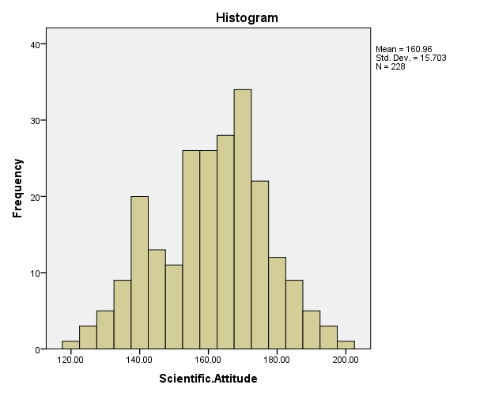

|  |  |  |  |  |  |  |  |  |  |  |  |  |  |
| --- | --- | --- | --- | --- | --- | --- | --- | --- | --- | --- | --- | --- | --- |
| Test of Normality   |  |  |  |  |  |  |  |  |  |  |  |  |  | | --- | --- | --- | --- | --- | --- | --- | --- | --- | --- | --- | --- | --- | | |  |  |  |  | | --- | --- | --- | --- | |  | Shapiro Wilk | | | |  | Statistic | Degrees of freedom | p-value | | Scientific Attitude | 0.988 | 228 | 0.051 | | |

**Figure 4.50**

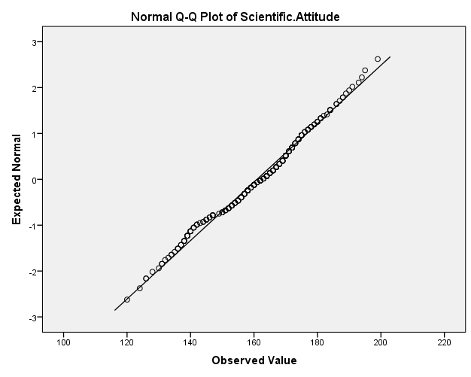

**Figure 4.51**

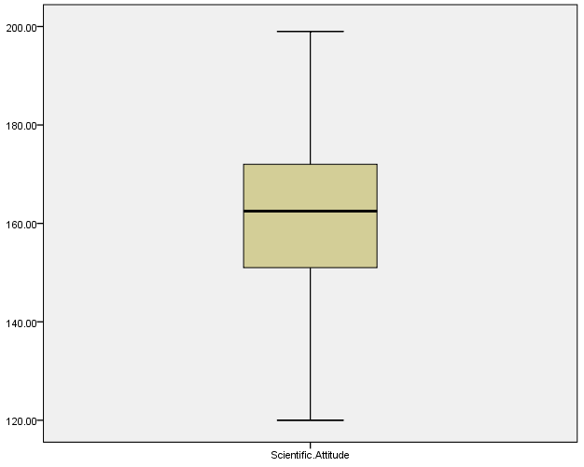

**Figure 4.52 Male Population**

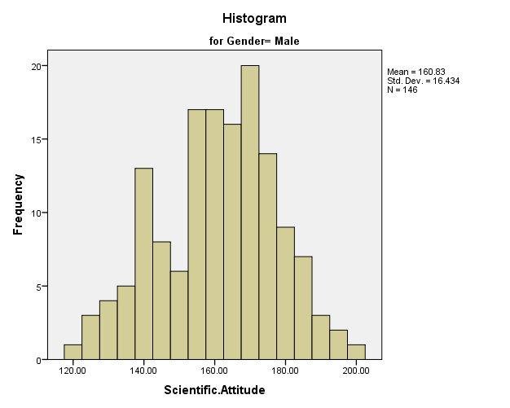

Test of Normality

|  |  |  |  |  |  |  |  |  |  |  |  |  |
| --- | --- | --- | --- | --- | --- | --- | --- | --- | --- | --- | --- | --- |
| |  |  |  |  | | --- | --- | --- | --- | |  | Shapiro Wilk | | | |  | Statistic | Degrees of freedom | p-value | | Scientific Attitude | 0.987 | 146 | 0.211 | |

**Figure 4.53**

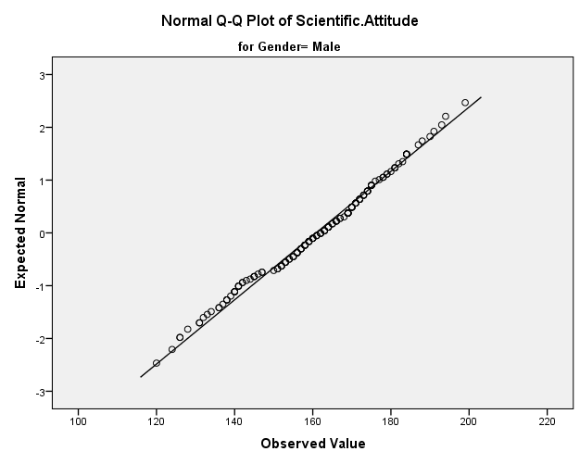

**Figure 4.54**

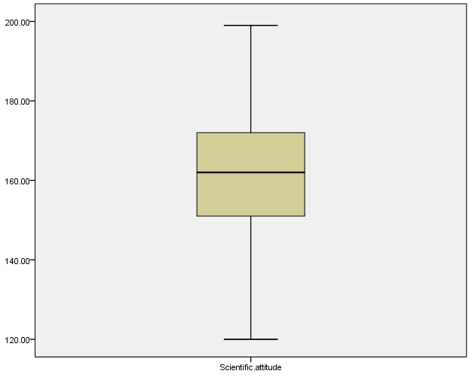

**Figure 4.55 Female Population**

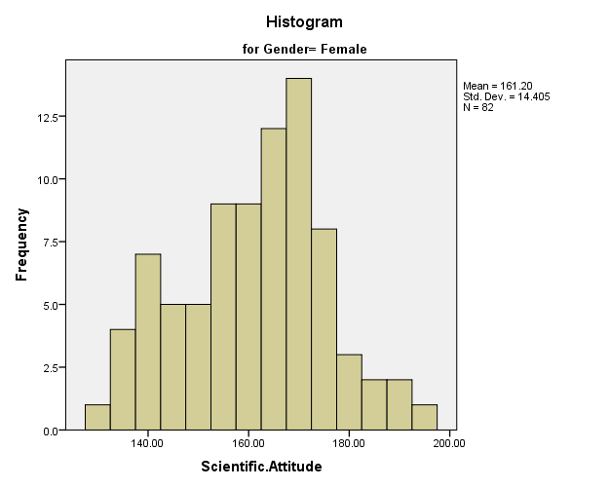

Test of Normality

|  |  |  |  |  |  |  |  |  |  |  |  |  |
| --- | --- | --- | --- | --- | --- | --- | --- | --- | --- | --- | --- | --- |
| |  |  |  |  | | --- | --- | --- | --- | |  | Shapiro Wilk | | | |  | Statistic | Degrees of freedom | p-value | | Scientific Attitude | 0.979 | 82 | 0.211 | |

**Figure 4.56**

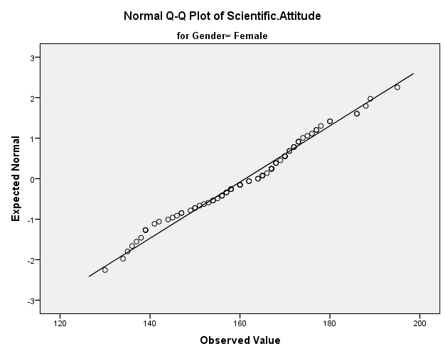

**Figure 4.57**

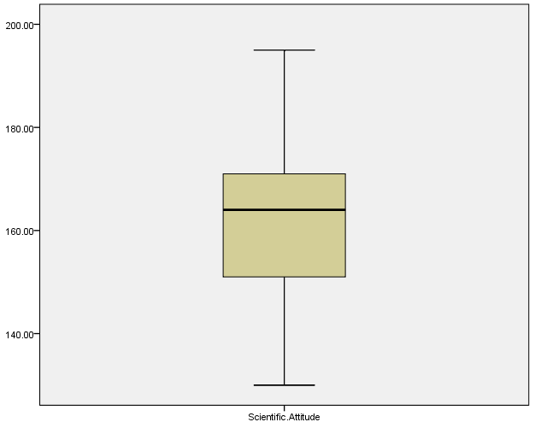

Table 4.44 lists descriptive statistics like mean standard deviation percentiles, skewness, and kurtosis. The statistics listed are for the whole sample and males and females separately. The distribution of the scientific attitude score is better understood by the coefficient of skewness. The coefficient of skewness of the whole sample was -0.221 which means the data is negatively skewed so the left tail is stretched more than the right tail but as the value is less than -0.5 the data is fairly symmetric. The kurtosis value is negative so the distribution is slightly flatter than normal but as the value is smaller than 2 it is fairly peaked. The percentiles show that half of the whole sample has scored more than 162.5 which is greater than the mean 160.9605. More than 186 have been scored by 5 percent of the sample.

The sample of male population has a mean score of 160.8288 whereas the standard deviation is 16.4335. The skewness is -0.24 which means the negatively skewed data but fairly symmetric. Kurtosis is negative which means slightly flatter than normal as value is relatively small. In the case of female sample, the mean score was found to be 161.1951. It shows that the mean scientific attitude score of male population was more than female but the standard deviation for female population was 14.4059 which is almost 2 units more than the male population. It means the scientific attitude scores for female were clustered more around the mean. The coefficient of skewness for female population was -0.155 which means negatively skewed distribution but fairly symmetric as the value is relatively small. Kurtosis is also negative which means distribution is flatter than normal.

It is noteworthy in the figures of percentile that the top 5 percent of males had scored above around 186 on the attitude scale which is almost equal to the score above which the top 5 percent of females have scored. The data shows that males with higher scores are equal in proportion to females scoring higher scores, but females have scored more consistently around the mean scores.

Normality test

The standard error in skewness denoted by e for the whole sample was 0.161. To say that the sample is normal the skewness Z value is inspected which is given by the skewness value divided by the standard error. The Z value should fall between +1.96 and -1.96.

Skewness Z Value = -0.221/0.161 = -1.37

Similar test is done on Kurtosis

Kurtosis Z Value = -0.403/0.321 = -1.25

Both the values lie between +1.96 and -1.96 which is required for data to be normally distributed. The histogram (figure 4.1), Normal Q-Q plot (figure 4.2) and Box Plot (figure 4.3) give the impression that the data is normally distributed. The Shapiro Wilk test gives P value of 0.051 which is greater than 0.05 hence we can assume data to be normally distributed.

Normality test for Sample of Male population

The standard error in skewness was 0.201 whereas in kurtosis it was 0.399.

Skewness Z Value = -0.24/0.201 = -1.194

Kurtosis Z Value = -0.418/0.399 = -1.047

Both the values lie between +1.96 and -1.96 which is required for data to be normally distributed. The histogram (figure 4.4), Normal Q-Q plot (figure 4.5), and Box Plot (figure 4.6) give the impression that the data is normally distributed. The Shapiro-Wilk test gives a P value of 0.211 which is greater than .05 hence we can assume data to be normally distributed.

Normality test for Sample of Female population

The standard error in skewness was 0.266 whereas in kurtosis it was 0.526.

Skewness Z Value = -0.155/0.266 = -0.58

Kurtosis Z Value = -0.472/0.526 = -0.897

Both the values lie between +1.96 and -1.96 which is required for data to be normally distributed. The histogram (figure 4.55), Normal Q-Q plot (figure 4.56), and Box Plot (figure 4.57) give the impression that the data is normally distributed. The Shapiro-Wilk test gives a P value of 0.211 which is greater than .05 hence we can assume data to be normally distributed.

When sample sizes are not the same there is a chance that variances are also unequal which is not appropriate for a t-test to be conducted. Thus it is essential that variances are tested before the test. The Homogeneity of variance is tested by Levene’s test, the formula for which is as follows

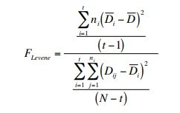

t = number of treatments

[t = k for one-way ANOVA

yij = sample observation j from treatment i (j = 1, 2,…, ni and i = 1, 2,…, t)

ni = number of observations from treatment i (at

At least one ni must be 3 or more)

N = n1 + n2 +……..+ nt = total number of pieces of data (overall size of combined samples)

ȳi = mean of sample data from treatment i

Dij = |yij – ȳi| = absolute deviation of observation j from treatment i mean

D̄i = average of the ni absolute deviations from treatment i

D̄ = average of all N absolute deviations

After Levene’s test comes the test for checking the significant difference between means. The t-test is employed where first we state our hypotheses. Two hypotheses are stated, one is the Null Hypothesis denoted by H0, and, Alternate Hypothesis denoted by HA

H0 : There is no significant difference between the mean scientific attitude of Males and Females

HA : There is a significant difference between the mean scientific attitude of Males and Females

The value of t is given by

**where:**

mean1 and mean2=Average values of each of the sample sets

*var*1 and *var*2=Variance of each of the sample sets

*n*1 and *n*2=Number of records in each sample set​

and,

Degrees of Freedom=n1+n2−2

where n1 and n2=Number of records in each sample set​

|  |  |  |  |  |  |  |  |  |
| --- | --- | --- | --- | --- | --- | --- | --- | --- |
| F | sig | t | df | Sig(2-tailed) | Mean  Difference | Std  Error  Difference | 95%  Confidence interval  Lower bound | Upper  bound |
| 1.421 | 0.234 | -0.169 | 226 | 0.866 | -0.366 | 2.17 | -4.64 | 3.91 |

Levene’s F value is 1.421 and p value is 0.234 which is greater than 0.05 which tells that the error variance of the dependent variable is equal across groups

The p-value for the t-test is greater than 0.05

0.866> 0.05

We can say that Null Hypothesis can be retained and that there is no significant difference between the mean scientific attitude of Males and Females.

**4.3 Data analysis based on Age**

Table 4.45

|  |  |  |  |
| --- | --- | --- | --- |
|  | Young Age(81) | Middle Age(118) | Higher Age(29) |
| Mean | 156.8148 | 164.7373 | 157.1724 |
| Standard Deviation | 15.39002 | 15.21607 | 15.17062 |
| 5 Percentile | 132.2 | 132.9 | 137 |
| 10 Percentile | 136 | 141.9 | 138 |
| 25 Percentile | 144.5 | 156 | 144.5 |
| 50 Percentile | 157 | 167.5 | 158 |
| 75 Percentile | 169 | 174.25 | 164.5 |
| 90 Percentile | 175.6 | 182.1 | 184 |
| 95 Percentile | 183.7 | 188 | 190 |
| Skewness | .080  Error= .267 | -.661  Error= .223 | .611  Error= .434 |
| Kurtosis | -.506  Error= .529 | .445  Error= .442 | -.032  Error= .845 |

**Figure 4.58 Young Age**

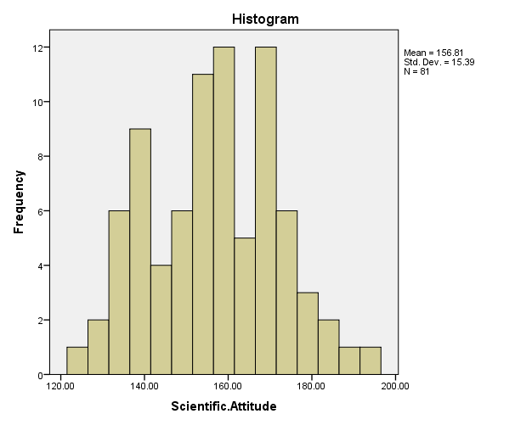

Test of Normality

|  |  |  |  |  |  |  |  |  |  |  |  |  |
| --- | --- | --- | --- | --- | --- | --- | --- | --- | --- | --- | --- | --- |
| |  |  |  |  | | --- | --- | --- | --- | |  | Shapiro Wilk | | | |  | Statistic | Degrees of freedom | p-value | | Scientific Attitude | 0.985 | 81 | 0.444 | |

**Figure 4.59**

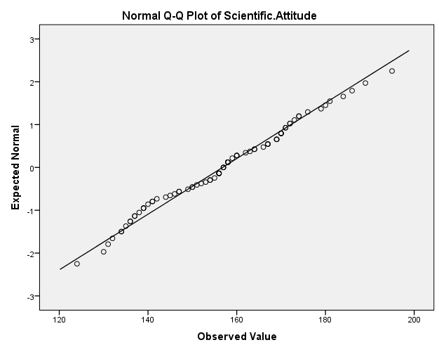

**Figure 4.60**

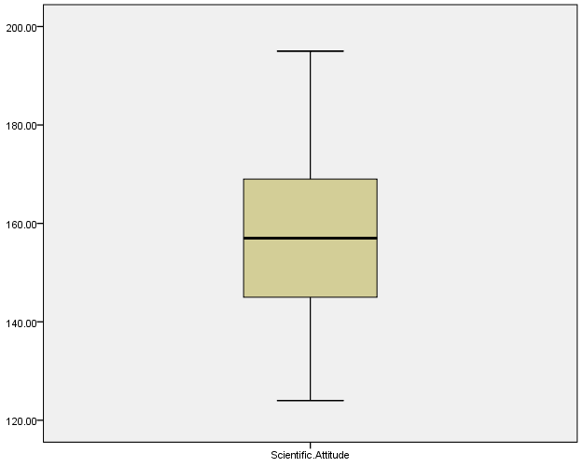

**Figure 4.61 Middle age**

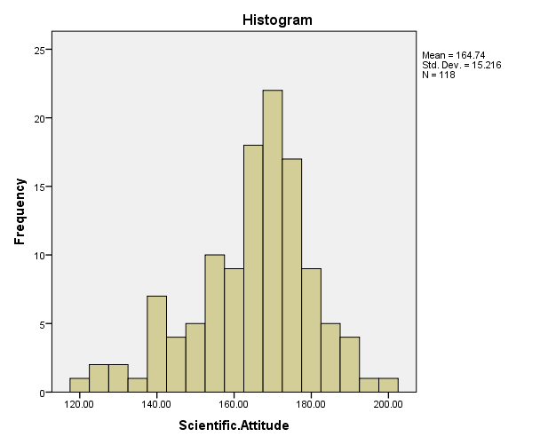

Test of Normality

|  |  |  |  |  |  |  |  |  |  |  |  |  |
| --- | --- | --- | --- | --- | --- | --- | --- | --- | --- | --- | --- | --- |
| |  |  |  |  | | --- | --- | --- | --- | |  | Shapiro Wilk | | | |  | Statistic | Degrees of freedom | p-value | | Scientific Attitude | 0.965 | 118 | 0.004 | |

|  |
| --- |
|  |

**Figure 4.62**

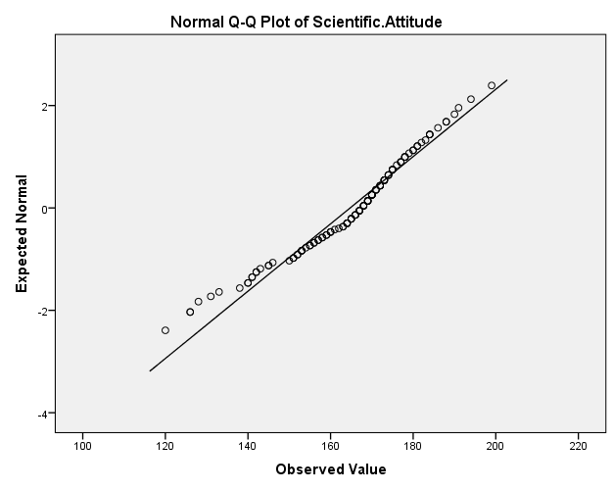

**Figure 4.63**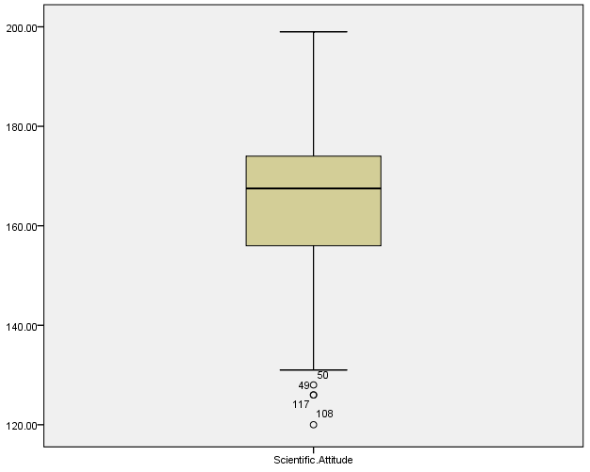

**Figure 4.64 High age**

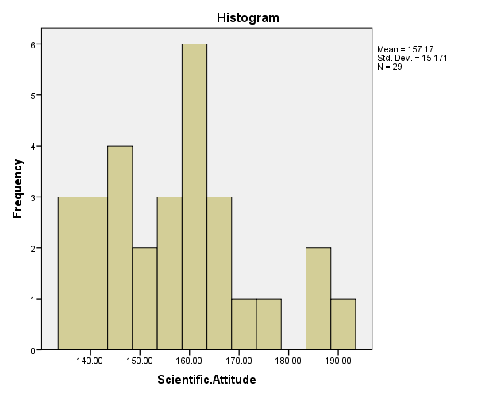

Test of Normality

|  |  |  |  |  |  |  |  |  |  |  |  |  |
| --- | --- | --- | --- | --- | --- | --- | --- | --- | --- | --- | --- | --- |
| |  |  |  |  | | --- | --- | --- | --- | |  | Shapiro Wilk | | | |  | Statistic | Degrees of freedom | p-value | | Scientific Attitude | 0.942 | 29 | 0.116 | |

**Figure 4.65**

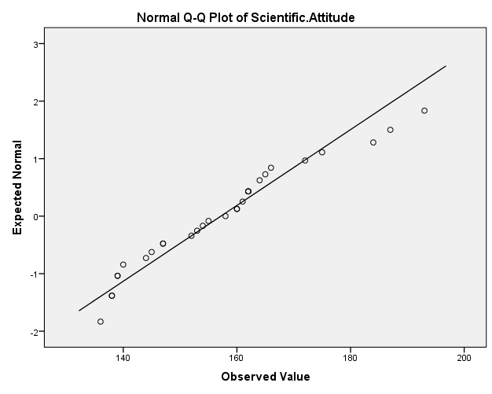

**Figure 4.66**

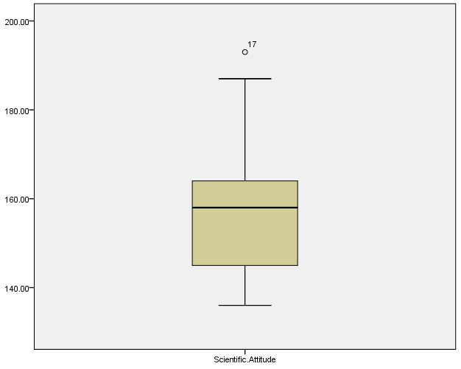

Table 4.45 is a table listing descriptive statistics like mean, standard deviation, percentiles skewness and Kurtosis for the three samples from the population namely young age, middle age and high age.

The coefficient skewness for young age was .080 which means the data is positively skewed so the right tail is stretched more than the left tail but as the value as less than 0.5 the data is fairly symmetric. The Kurtosis value is negative which means data is slightly flatter than normal but as the value is smaller than 2 it is fairly peaked. The 50 percentile shows that half of the young age has scored more than 157 and the mean is 156.81 which is lesser when compared to the mean of whole population. Top 5 percent have scored more than 186.

The coefficient of skewness for middle age was -0.661 which means that data is negatively skewed so the left tail is stretched more than the right tail but as the value is close to 0.5 the data can be considered to be fairly symmetric. The Kurtosis value is positive so it is slightly more peaked than normal but since the value is less than 2 its fairly peaked. The 50 percentile shows that half of the middle age population has scored more than 167.5 and the mean score is 164.73 which looks significantly greater than young age and high age population’s respective scores. Top 5 percent of the middle age population have scored more than 188.

The coefficient of skewness for high age was 0.611 which means that data is positively skewed so the right tail is more stretched than the left tail but as the value is close to 0.5 the data can be considered to be fairly symmetric. The Kurtosis value is negative so it is slightly flatter than normal but since the value is less than 2 its fairly peaked. The 50 percentile shows that half of the middle age has scored more than 158 and the mean score is 157.17 which makes it look closer and similar to young age population but significantly lower than middle age population.

Normality test for Sample of Young age population

The standard error in skewness was 0.267 whereas in kurtosis it was 0.529.

Skewness Z Value = 0.080/0.267 = 0.299

Kurtosis Z Value = -0.506/0.529 = -0.956

Both the values lie between +1.96 and -1.96 which is required for data to be normally distributed. The histogram (figure 4.58), Normal Q-Q plot (figure 4.59) and Box Plot (figure 4.60) give the impression that the data is normally distributed. The Shapiro Wilk test gives P value of 0.444 which is greater than .05 hence we can assume data to be normally distributed.

Normality test for Sample of Middle age population

The standard error in skewness was 0.223 whereas in kurtosis it was 0.442.

Skewness Z Value = -0.661/0.223 = -2.96

Kurtosis Z Value = 0.445/0.442 = 1.006

One of the values lies between +1.96 and -1.96 which is required for data to be normally distributed. The histogram (figure 4.61), Normal Q-Q plot (figure 4.62), and Box Plot (figure 4.63) give the impression that the data is normally distributed. The Shapiro-Wilk test gives a P value of 0.004 which is less than .05 hence we **cannot** assume data to be normally distributed.

Normality test for Sample of High age population

The standard error in skewness was 0.434 whereas in kurtosis it was 0.845.

Skewness Z Value = 0.611/0.434 = 1.407

Kurtosis Z Value = 0.032/0.845 = 0.037

Both the values lie between +1.96 and -1.96 which is required for data to be normally distributed. The histogram (figure 4.64), Normal Q-Q plot (figure 4.65), and Box Plot (figure 4.66) give the impression that the data is normally distributed. The Shapiro-Wilk test gives a P value of 0.116 which is greater than .05 hence we can assume data to be normally distributed.

|  |  |  |  |
| --- | --- | --- | --- |
| **Levene's Test of Equality of Error Variances** | | | |
| Dependent Variable: Scientific.Attitude | | | |
| F | df1 | df2 | Sig. |
| .088 | 2 | 225 | .916 |
| Tests the null hypothesis that the error variance of the dependent variable is equal across groups. | | | |

As we see p value is 0.916 which is greater than 0.05 hence Null Hypothesis is accepted so the variance across the groups is same but the data does not follow normal distribution and sample sizes are different so in this case the test recommended to check the significant difference between the groups is a non-parametric one which is the Kruskall Wallis test. In the Kruskall Wallis test we calculate H value given by the formula

* https://sphweb.bumc.bu.edu/otlt/mph-modules/bs/bs704_nonparametric/lessonimages/equation_image54.gif

where k=the number of comparison groups, N= the total sample size, nj is the sample size in the jth group and Rj is the sum of the ranks in the jth group.

H02 : The distribution of scientific attitude is the same across categories of Age

HA2 : The distribution of scientific attitude varies across categories of Age

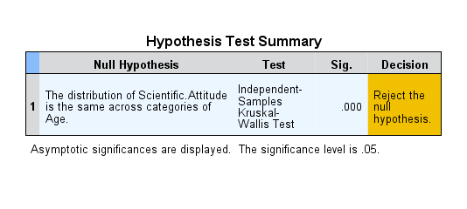

The Kruskall-Wallis test gives a very small value with no significant digit up to 3 decimal places which implies that the Null hypothesis can be rejected and the alternate hypothesis is accepted. The distribution of scientific attitude varies across categories of Age

Now, as we don’t know the differences between the groups Post hoc analysis is carried out to compare the means.

Post Hoc test

Kruskall-Wallis test calculates significant differences between all groups and does not identify which two groups are significantly different and which are not. Post Hoc test performs multiple comparisons between all combinations of groups

Mann Whitney test

The Mann-Whitney test is performed for two groups

First, the rank sum is calculated for the two groups denoted by T1 and T2 and then U1 and U2 are calculated given by the formula

U1 = n1.n2+ – T1

U2 = n1.n2+ – T2

In the next step minimum of the two U values is chosen

U =min (U1, U2)

In the next step expected value of U is calculated

Ue =

In the next step Standard error of U is calculated

E =

Then Z value is calculated

Z =

H03 : There is no significant difference between the mean ranks of the scientific attitude of High Age and Young Age

HA3 : There is a significant difference between the mean ranks of the scientific attitude of High Age and Young Age

H04 : There is no significant difference between the mean ranks of the scientific attitude of High Age and Middle Age

HA4 : There is a significant difference between the mean ranks of the scientific attitude of High Age and Middle Age

H05 : There is no significant difference between the mean ranks of the scientific attitude of Young Age and Middle Age

HA5 : There is a significant difference between the mean ranks of the scientific attitude of Young Age and Middle Age

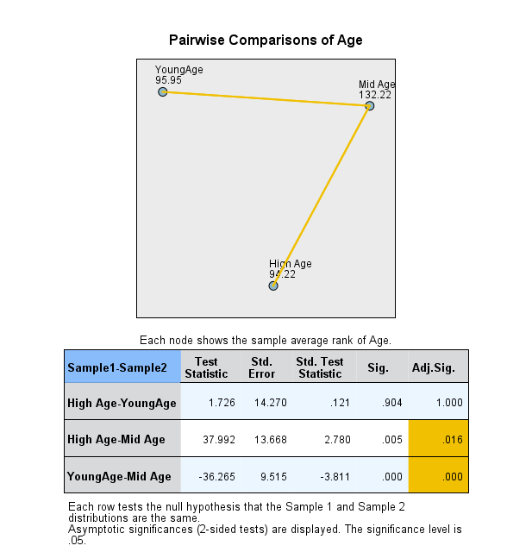

The pairwise comparisons using the Mann-Whitney test tell us that the Alternate hypotheses HA4 and HA5 are true.

**4.4 Data analysis based on qualification**

Table 4.46

|  |  |  |  |
| --- | --- | --- | --- |
|  | School Level Education(14) | College Level Education(106) | High Level Education(108) |
| Mean | 151.3571 | 159.6038 | 163.5370 |
| Standard Deviation | 14.26457 | 14.91032 | 16.11317 |
| 5 Percentile | 134 | 131.7 | 134.9 |
| 10 Percentile | 135.5 | 138 | 139.9 |
| 25 Percentile | 138.5 | 150.75 | 153.25 |
| 50 Percentile | 146 | 161.5 | 166 |
| 75 Percentile | 165.5 | 171 | 174 |
| 90 Percentile | 173.5 | 178 | 184 |
| 95 Percentile | ---- | 183.65 | 190.55 |
| Skewness | .495  Error= .597 | -.358  Error= .235 | -.271  Error= .233 |
| Kurtosis | -1.304  Error= 1.154 | -.480  Error= .465 | -.148  Error= .461 |

**Figure 4.67 School Level Education**

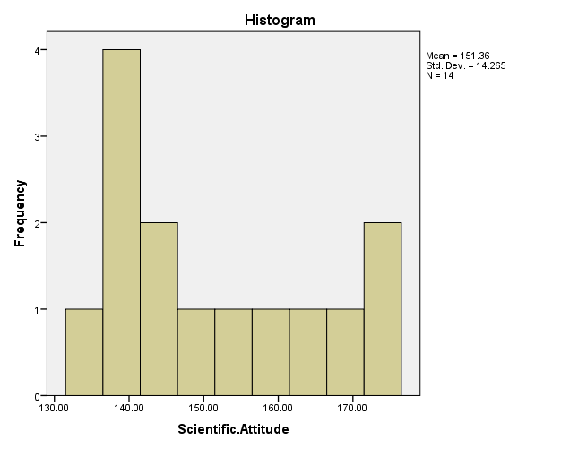

Test of Normality

|  |  |  |  |  |  |  |  |  |  |  |  |  |
| --- | --- | --- | --- | --- | --- | --- | --- | --- | --- | --- | --- | --- |
| |  |  |  |  | | --- | --- | --- | --- | |  | Shapiro Wilk | | | |  | Statistic | Degrees of freedom | p-value | | Scientific Attitude | 0.900 | 14 | 0.113 | |

**Figure 4.68**

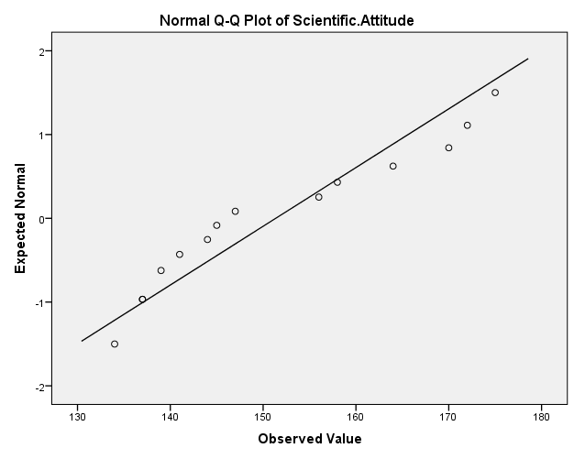

**Figure 4.69**

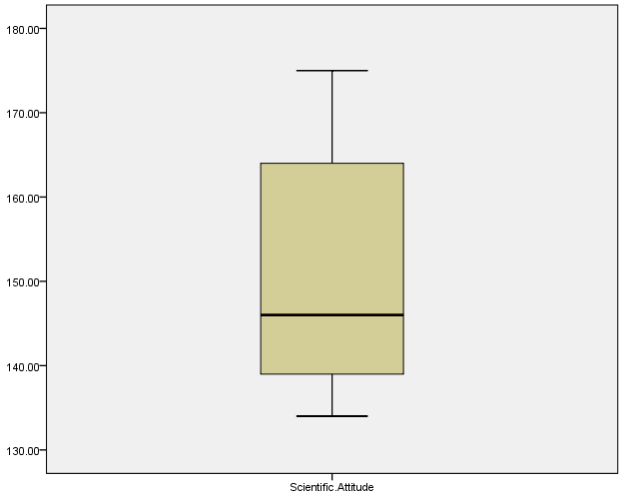

**Figure 4.70 College Level Education**

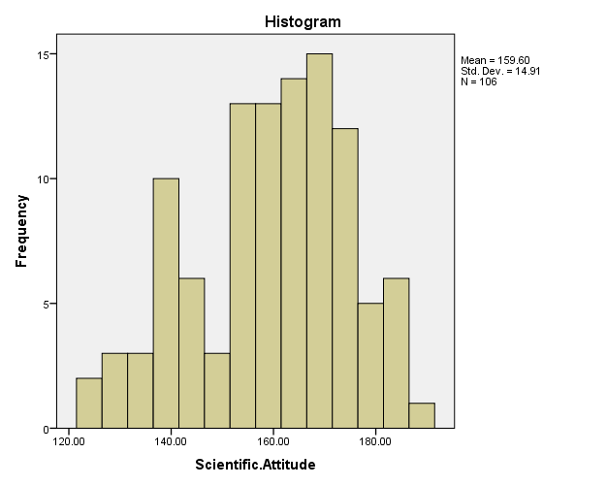

Test of Normality

|  |  |  |  |  |  |  |  |  |  |  |  |  |
| --- | --- | --- | --- | --- | --- | --- | --- | --- | --- | --- | --- | --- |
| |  |  |  |  | | --- | --- | --- | --- | |  | Shapiro Wilk | | | |  | Statistic | Degrees of freedom | p-value | | Scientific Attitude | 0.978 | 106 | 0.071 | |

**Figure 4.71**

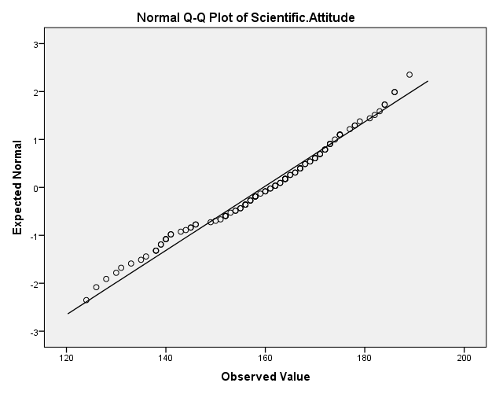

**Figure 4.72**

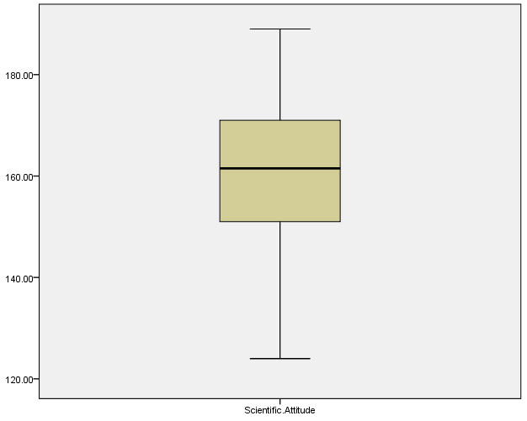

**Figure 4.73 High Level Education**

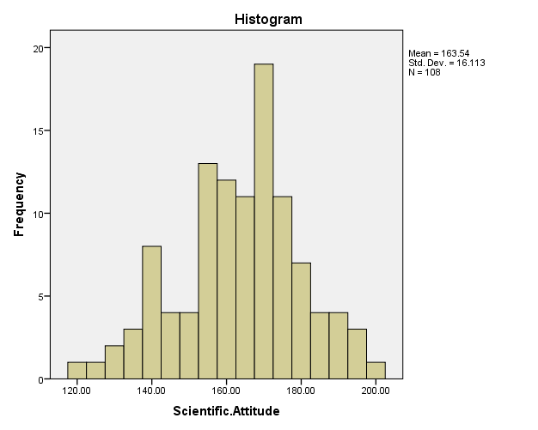

Test of Normality

|  |  |  |  |  |  |  |  |  |  |  |  |  |
| --- | --- | --- | --- | --- | --- | --- | --- | --- | --- | --- | --- | --- |
| |  |  |  |  | | --- | --- | --- | --- | |  | Shapiro Wilk | | | |  | Statistic | Degrees of freedom | p-value | | Scientific Attitude | 0.989 | 108 | 0.511 | |

**Figure 4.74**

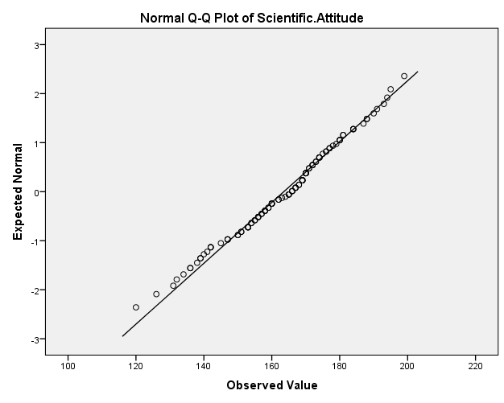

**Figure 4.75**

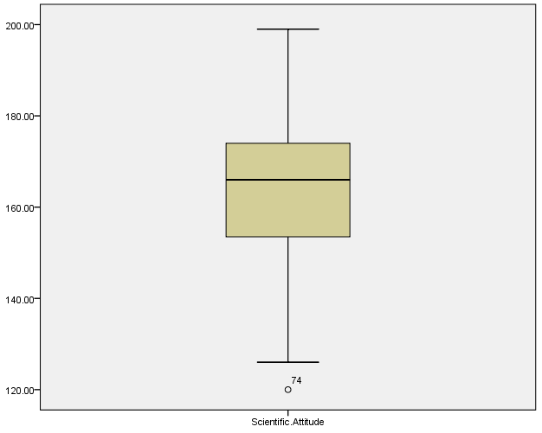

Table 4.46 is a table listing descriptive statistics like mean, standard deviation, percentiles skewness and Kurtosis for the three samples from the population namely School level, College level and high level education.

The coefficient of skewness for School level was .495 which means the data is positively skewed so the right tail is stretched more than the left tail but as the absolute value is less than 0.5 the data is fairly symmetric. The Kurtosis value is negative which means data is slightly flatter than normal but as the value is smaller than 2 it is fairly peaked. The 50 percentile shows that half of the school level population has scored more than 146 and the mean is 151.35 which looks significantly lesser when compared to the mean of whole population.

The coefficient of skewness for college level was -0.358 which means that data is negatively skewed so the left tail is stretched more than the right tail but as the absolute value is less than 0.5 the data can be considered to be fairly symmetric. The Kurtosis value is negative so it is slightly flatter than normal but since the absolute value is less than 2 its fairly peaked. The 50 percentile shows that half of the college level population has scored more than 161.5 and the mean score is 159.603 which looks significantly greater than school level population’s scores. Top 5 percent of the college level population have scored more than 183.65.

The coefficient of skewness for High level was -.271 which means the data is negatively skewed so the left tail is stretched more than the left tail but as the absolute value is less than 0.5 the data is fairly symmetric. The Kurtosis value is negative which means data is slightly flatter than normal but as the value is smaller than 2 it is fairly peaked. The 50 percentile shows that half of the high level population has scored more than 166 and the mean is 163.537 which looks significantly more when compared to the mean of school level and slightly more than college level. Top 5 percent of the high level population have scored more than 190.55.

Normality test for Sample of School level population

The standard error in skewness was 0.597 whereas in kurtosis it was 1.154.

Skewness Z Value = 0.495/0.597 = 0.829

Kurtosis Z Value = -1.304/1.154 = -1.129

Both the values lie between +1.96 and -1.96 which is required for data to be normally distributed. The histogram (figure 4.67), Normal Q-Q plot (figure 4.68) and Box Plot (figure 4.69) give the impression that the data is normally distributed. The Shapiro Wilk test gives P value of 0.113 which is greater than .05 hence we can assume data to be normally distributed

Normality test for Sample of college level population

The standard error in skewness was 0.235 whereas in kurtosis it was 0.465.

Skewness Z Value = -0.358/0.235 = -1.523

Kurtosis Z Value = -0.480/.465 = -1.032

Both the values lie between +1.96 and -1.96 which is required for data to be normally distributed. The histogram (figure 4.70), Normal Q-Q plot (figure 4.71) and Box Plot (figure 4.72) give the impression that the data is normally distributed. The Shapiro-Wilk test gives a P value of 0.071 which is greater than .05 hence we can assume data to be normally distributed.

Normality test for Sample of High

level population

The standard error in skewness was 0.233 whereas in kurtosis it was 0.461.

Skewness Z Value = -0.271/0.233 = -1.173

Kurtosis Z Value = -0.148/.461 = -0.321

Both the values lie between +1.96 and -1.96 which is required for data to be normally distributed. The histogram (figure 4.73), Normal Q-Q plot (figure 4.74), and Box Plot (figure 4.75) give the impression that the data is normally distributed. The Shapiro-Wilk test gives a P value of 0.511 which is greater than .05 hence we can assume data to be normally distributed.

|  |  |  |  |
| --- | --- | --- | --- |
| **Levene's Test of Equality of Error Variances** | | | |
| Dependent Variable: Scientific.Attitude | | | |
| F | df1 | df2 | Sig. |
| .223 | 2 | 225 | .801 |
| Tests the null hypothesis that the error variance of the dependent variable is equal across groups. | | | |
|  | | | |

**Figure 4.76**

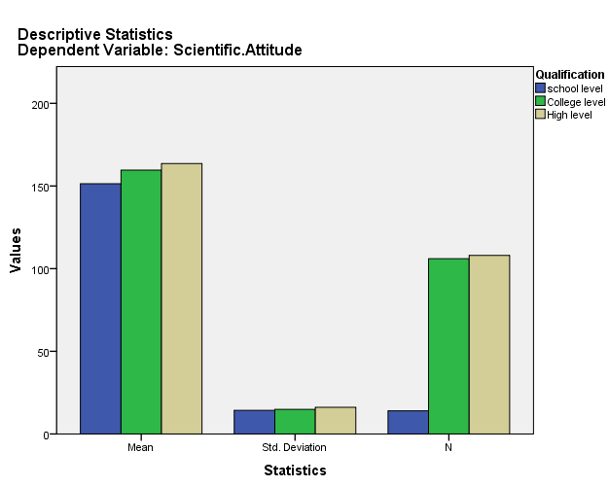

As we see p value for the Levene’s test is 0.801 which is greater than 0.05 hence Null Hypothesis is accepted so the variance across the groups is same and the data also follows normal distribution but sample sizes are different as shown in Figure 4.76 so in this case the test recommended to check the significant difference between the groups Welch’s One-way ANOVA test. In this test, the F ratio is calculated in the same way as in normal ANOVA but there are some adjustments

First we calculate weight based on sample size and variance. For the sample size nk and variance Sk

wk = nk/(sk )2

Then we calculate a grand mean based on a weighted mean for each group so we take the mean of each group, xk, and multiply it by its weight wk we do this for each group and then divide this total by the sum of weights

Xgrand = ∑ wk.xk / ∑ wk

Now the sum of squares as in ANOVA is given by

SSM = ∑ nk (xk – xgrand)

It will be adjusted for Welch and given by

SSMwelch = ∑ wk(xk – xgrand)2

Now we find the mean of squares which will be given by

MSMwelch = ∑ wk(xk – xgrand)2/ k-1

Now a term lambda will be calculated

Λ = 3( ∑(1- )2 /nk – 1)/ k2- 1

F Ratio is given by F = MSMwelch/ (1 + (2 Λ(k-2)/3))

Now the two hypotheses for the test are

H06 : The distribution of scientific attitude is the same across categories of Qualification

HA6 : The distribution of scientific attitude varies across categories of Qualification

|  |  |  |  |  |
| --- | --- | --- | --- | --- |
| **Robust Tests of Equality of Means** | | | | |
| Scientific Attitude | | | | |
|  | Statistica | df1 | df2 | Sig. |
| Welch | 4.876 | 2 | 37.172 | .013 |
| a. Asymptotically F distributed. | | | | |

We can see, p-value for the Welch’s Anova test is less than 0.05 which means Null hypothesis can be rejected and the alternate hypothesis is accepted. The distribution of scientific attitude varies across categories of Qualification.

Post Hoc test

The games Howell test has been employed for comparison between groups which requires the calculation of the **qσ, k, df** value for different σ, k, and df values, where σ is given by

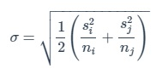

and S is the variance and n is the sample size of the groups in consideration

Degrees of freedom is given by using Welch’s correction

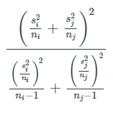

The t-value is given by Welch’s t-test

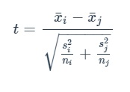

The confidence interval is given by

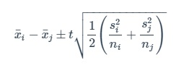

p-values are calculated using Tukey’s studentized range

qt* √2,k,df

H07 : There is no significant difference between the means of the scientific attitude of School Level and College Level

HA7 : There is a significant difference between the means of the scientific attitude of School Level and College Level

H08 : There is no significant difference between the means of the scientific attitude of College Level and High Level

HA8 : There is a significant difference between the means of the scientific attitude of College Level and High Level

H09 : There is no significant difference between the means of the scientific attitude of School Level and High Level

HA9 : There is a significant difference between the means of the scientific attitude of School Level and High Level

|  |  |  |  |  |  |  |
| --- | --- | --- | --- | --- | --- | --- |
| **Multiple Comparisons** | | | | | | |
| Dependent Variable: Scientific.Attitude | | | | | | |
| Games-Howell | | | | | | |
| (I) Qualification | (J) Qualification | Mean Difference (I-J) | Std. Error | Sig. | 95% Confidence Interval | |
| Lower Bound | Upper Bound |
| school level | College level | -8.24663 | 4.07817 | .137 | -18.7098 | 2.2165 |
| High level | -12.17989* | 4.11560 | .022 | -22.7046 | -1.6552 |
| College level | school level | 8.24663 | 4.07817 | .137 | -2.2165 | 18.7098 |
| High level | -3.93326 | 2.12164 | .155 | -8.9411 | 1.0746 |
| High level | school level | 12.17989* | 4.11560 | .022 | 1.6552 | 22.7046 |
| College level | 3.93326 | 2.12164 | .155 | -1.0746 | 8.9411 |
| *. The mean difference is significant at the 0.05 level. | | | | | | |

Since the p-value in the comparison table is <0.05 only for the pair of School Level and High-Level Null hypothesis H09 is rejected which means there is a significant difference between means of the scientific attitude of the people coming from School Level and High-level education.

**Figure 4.77**

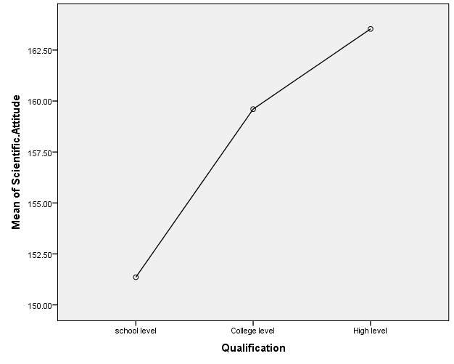

The Pearson Correlation between Scientific attitude and Qualification comes out to be 0.200 which indicates a significant positive correlation but the correlation is weak

The Spearman’s correlation coefficient comes out to be 0.174 which is a significant positive correlation but the correlation is weak.

**4.5 Data analysis based on time devoted to online science communication in Hindi**

Table 4.47

|  |  |  |  |
| --- | --- | --- | --- |
|  | Less time devoted(103) | Average time devoted(81) | More time devoted(44) |
| Mean | 159.1942 | 164.1728 | 159.1818 |
| Standard Deviation | 15.33550 | 14.47911 | 17.99001 |
| 5 Percentile | 131.4 | 137.2 | 130.5 |
| 10 Percentile | 138 | 140.2 | 134 |
| 25 Percentile | 147 | 156.5 | 144.5 |
| 50 Percentile | 162 | 165 | 156.5 |
| 75 Percentile | 170 | 173.5 | 172.75 |
| 90 Percentile | 177.6 | 183.8 | 186 |
| 95 Percentile | 181.8 | 187.9 | 192.25 |
| Skewness | -.283  Error= .238 | -.373  Error= .267 | .150  Error= .357 |
| Kurtosis | -.360  Error= .472 | -.071  Error= .529 | -.742  Error= .702 |

**Figure 4.78 Less time devoted**

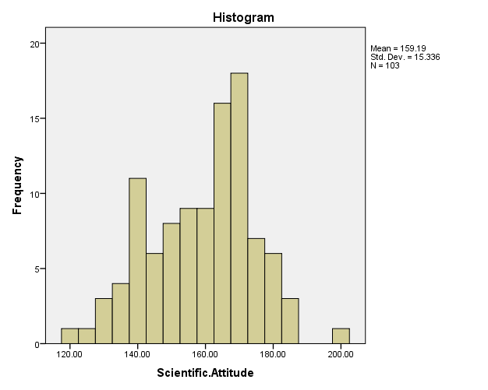

Test of Normality

|  |  |  |  |  |  |  |  |  |  |  |  |  |
| --- | --- | --- | --- | --- | --- | --- | --- | --- | --- | --- | --- | --- |
| |  |  |  |  | | --- | --- | --- | --- | |  | Shapiro Wilk | | | |  | Statistic | Degrees of freedom | p-value | | Scientific Attitude | 0.981 | 103 | 0.136 | |

**Figure 4.79**

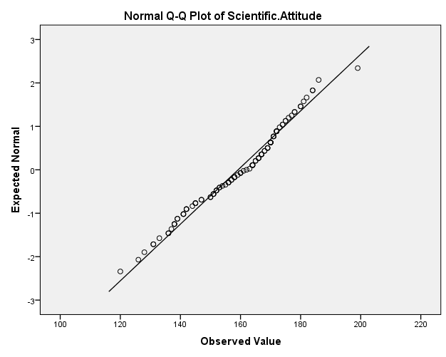

**Figure 4.80**

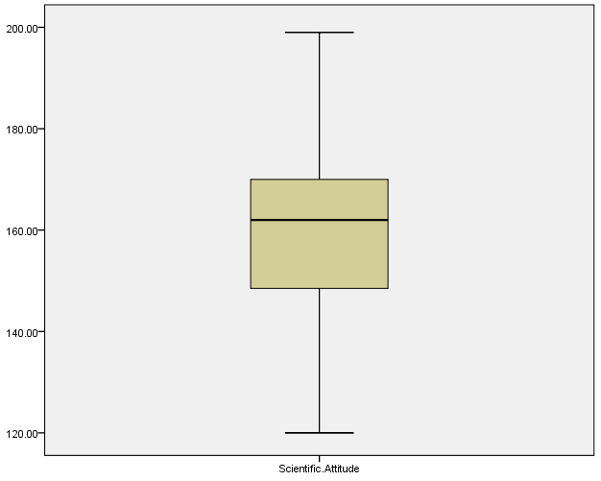

**Figure 4.81 Average time devoted**

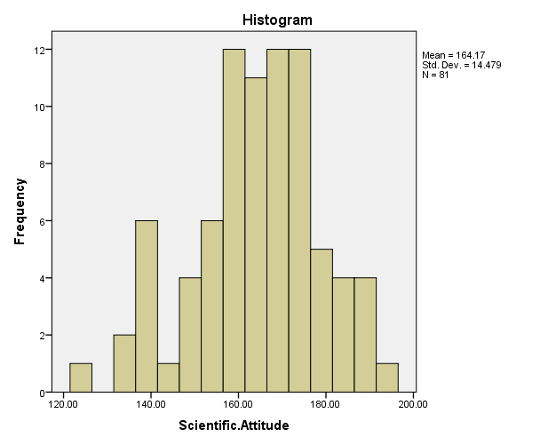

Test of Normality

|  |  |  |  |  |  |  |  |  |  |  |  |  |
| --- | --- | --- | --- | --- | --- | --- | --- | --- | --- | --- | --- | --- |
| |  |  |  |  | | --- | --- | --- | --- | |  | Shapiro Wilk | | | |  | Statistic | Degrees of freedom | p-value | | Scientific Attitude | 0.982 | 81 | 0.303 | |

**Figure 4.82**

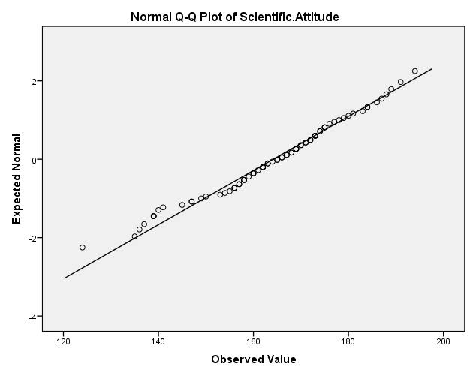

**Figure 4.83**

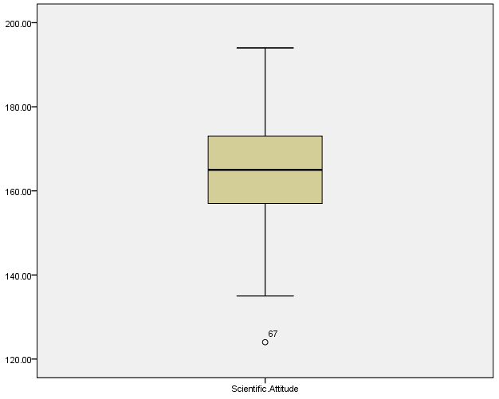

**Figure 4.84 More time devoted**

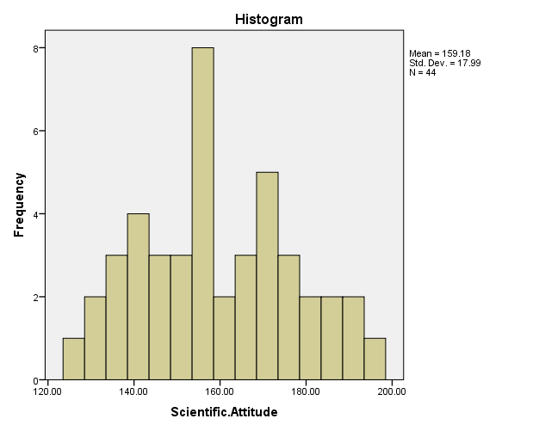

Test of Normality

|  |  |  |  |  |  |  |  |  |  |  |  |  |
| --- | --- | --- | --- | --- | --- | --- | --- | --- | --- | --- | --- | --- |
| |  |  |  |  | | --- | --- | --- | --- | |  | Shapiro Wilk | | | |  | Statistic | Degrees of freedom | p-value | | Scientific Attitude | 0.977 | 44 | 0.513 | |

**Figure 4.85**

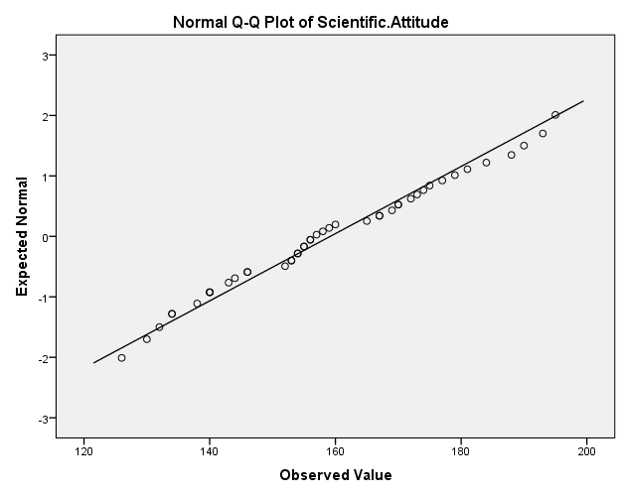

**Figure 4.86**

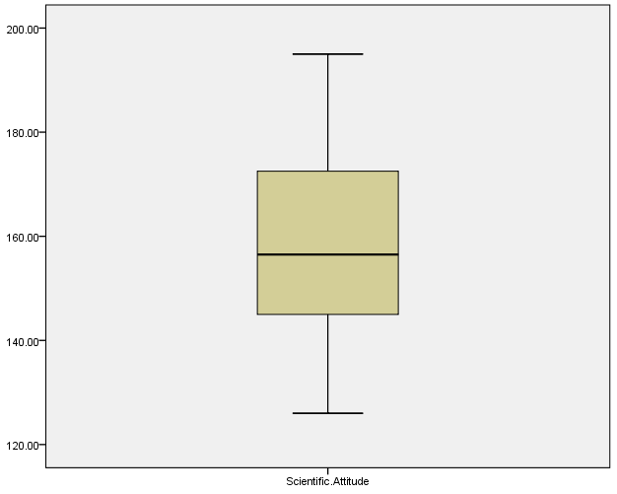

Table 4.47 is a table listing descriptive statistics like mean, standard deviation, percentiles skewness and Kurtosis for the three samples from the population namely Less time devoting, Average time devoting and high time devoting.

The coefficient of skewness for Less time devoting was -0.283 which means the data is negatively skewed so the left tail is stretched more than the right tail but as the absolute value is less than 0.5 the data is fairly symmetric. The Kurtosis value is negative which means data is slightly flatter than normal but as the value is smaller than 2 it is fairly peaked. The 50 percentile shows that half of the Less time devoting population has scored more than 162 and the mean is 159.194 which looks close to the mean of whole population. Top 5 percent have scored more than 181.8

The coefficient of skewness for Average time devoting was -0.373 which means that data is negatively skewed so the left tail is stretched more than the right tail but as the absolute value is less than 0.5 the data can be considered to be fairly symmetric. The Kurtosis value is negative so it is slightly flatter than normal but since the absolute value is less than 2 its fairly peaked. The 50 percentile shows that half of the Average time devoting has scored more than 165 and the mean score is 164.1728 which looks slightly greater than less time devoting population’s scores. Top 5 percent average time devoting population have scored more than 187.9.

The coefficient of skewness for High time devoting was -0.150 which means that data is positively skewed so the right tail is stretched more than the left tail but as the absolute value is less than 0.5 the data can be considered to be fairly symmetric. The Kurtosis value is negative so it is slightly flatter than normal but since the absolute value is less than 2 its fairly peaked. The 50 percentile shows that half of the High time devoting have scored more than 156.5 and the mean score is 159.181 which looks slightly less than average and less time devoting population’s scores. Top 5 percent high time devoting population have scored more than 192.25

Normality test for Sample of Less time population

The standard error in skewness was 0.238 whereas in kurtosis it was 0.472.

Skewness Z Value = -0.283/0.238 = -1.189

Kurtosis Z Value = -0.360/.472 = -0.762

Both the values lie between +1.96 and -1.96 which is required for data to be normally distributed. The histogram (figure 4.78), Normal Q-Q plot (figure 4.79) and Box Plot (figure 4.80) give the impression that the data is normally distributed. The Shapiro Wilk test gives P value of 0.136 which is greater than .05 hence we can assume data to be normally distributed.

Normality test for Sample of Average time devoting population

The standard error in skewness was 0.267 whereas in kurtosis it was 0.529.

Skewness Z Value = -0.373/0.267 = -1.397

Kurtosis Z Value = -0.071/.529 = -0.134

Both the values lie between +1.96 and -1.96 which is required for data to be normally distributed. The histogram (figure 4.81), Normal Q-Q plot (figure 4.82) and Box Plot (figure 4.83) give the impression that the data is normally distributed. The Shapiro Wilk test gives P value of 0.303 which is greater than .05 hence we can assume data to be normally distributed.

Normality test for Sample of High time devoting population

The standard error in skewness was 0.357 whereas in kurtosis it was 0.702.

Skewness Z Value = 0.150/0.357 = 0.420

Kurtosis Z Value = -0.742/0.702 = -1.056

Both the values lie between +1.96 and -1.96 which is required for data to be normally distributed. The histogram (figure 4.84), Normal Q-Q plot (figure 4.85), and Box Plot (figure 4.86) give the impression that the data is normally distributed. The Shapiro-Wilk test gives a P value of 0.513 which is greater than .05 hence we can assume data to be normally distributed.

|  |  |  |  |
| --- | --- | --- | --- |
| **Levene's Test of Equality of Error Variancesa** | | | |
| Dependent Variable: Scientific.Attitude | | | |
| F | df1 | df2 | Sig. |
| 2.016 | 2 | 225 | .136 |
| Tests the null hypothesis that the error variance of the dependent variable is equal across groups. | | | |
| **Figure 4.87** | | | |

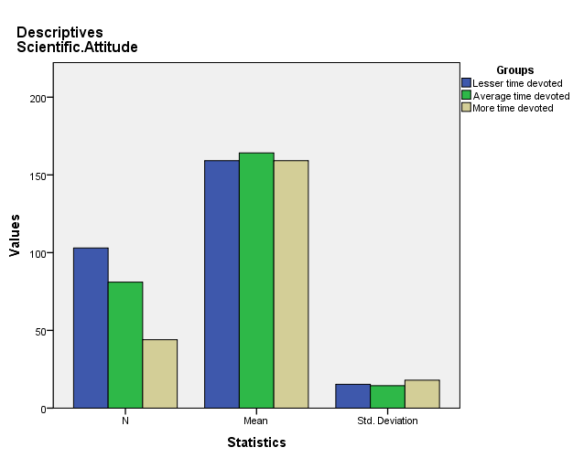

As we see p value for the Levene’s test is 0.136 which is greater than 0.05 hence Null Hypothesis is accepted so the variance across the groups is same and the data also follows normal distribution but sample sizes are different as shown in Figure 4.87 so, in this case, the test recommended to check the significant difference between the groups is Welch’s One-way ANOVA test.

H010 : The distribution of scientific attitude is the same across categories of Time devoted

HA10 : The distribution of scientific attitude varies across categories of Time devoted

|  |  |  |  |  |
| --- | --- | --- | --- | --- |
| **Robust Tests of Equality of Means** | | | | |
| Scientific.Attitude | | | | |
|  | Statistica | df1 | df2 | Sig. |
| Welch | 2.848 | 2 | 108.833 | .062 |
| a. Asymptotically F distributed. | | | | |

We can see, p-value for the Welch’s Anova test is greater than 0.05 which means the Null hypothesis can be accepted and the alternate hypothesis is rejected. The distribution of scientific attitude does not vary across categories of Time devoted.

**Figure 4.88**

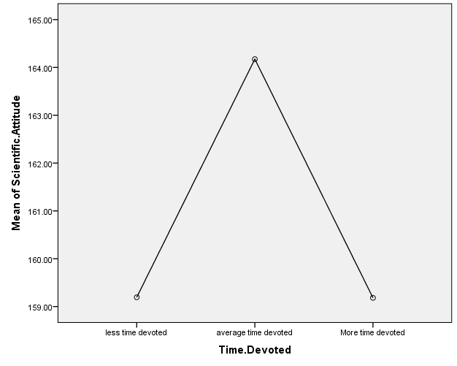

The Pearson Correlation between Scientific attitude and Time devoted comes out to be -0.002 which indicates there isn’t a significant correlation at all.

The Spearman’s correlation coefficient comes out to be 0.043 which indicates there isn’t a significance correlation at all.

**4.6 Data analysis based on Preference for Hindi**

Table 4.48

|  |  |  |  |
| --- | --- | --- | --- |
|  | Hindi not preferred(66) | No preference(58) | Hindi preferred(104) |
| Mean | 157.7121 | 161.8966 | 162.5 |
| Standard Deviation | 16.57223 | 15.51535 | 15.07457 |
| 5 Percentile | 130.35 | 133.85 | 134.5 |
| 10 Percentile | 137.4 | 138.8 | 139.5 |
| 25 Percentile | 142.75 | 151.75 | 154.25 |
| 50 Percentile | 157 | 164.5 | 164 |
| 75 Percentile | 170.25 | 172 | 173.5 |
| 90 Percentile | 180.3 | 184 | 180.5 |
| 95 Percentile | 183.65 | 188.1 | 186.75 |
| Skewness | .162  Error= .295 | -.235  Error= .314 | -.467  Error= .237 |
| Kurtosis | -.529  Error= .582 | -.193  Error= .618 | -.068  Error= .469 |

**Figure 4.89 Hindi not preferred**

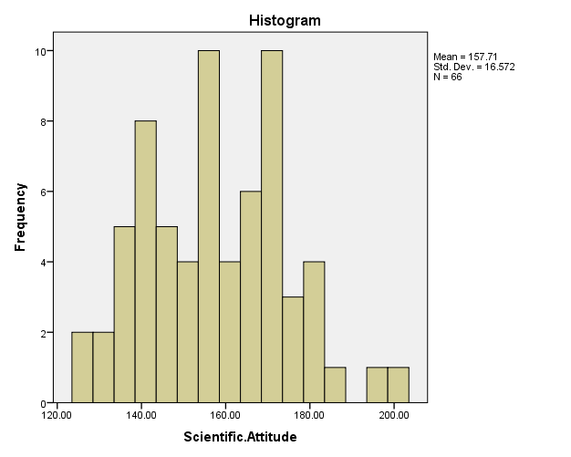

Test of Normality

|  |  |  |  |  |  |  |  |  |  |  |  |  |
| --- | --- | --- | --- | --- | --- | --- | --- | --- | --- | --- | --- | --- |
| |  |  |  |  | | --- | --- | --- | --- | |  | Shapiro Wilk | | | |  | Statistic | Degrees of freedom | p-value | | Scientific Attitude | 0.982 | 66 | 0.444 | |

**Figure 4.90**

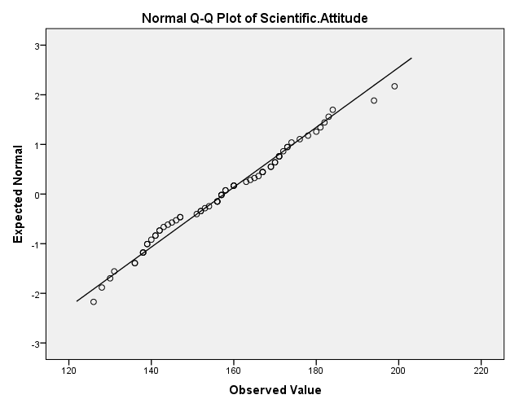

**Figure 4.91**

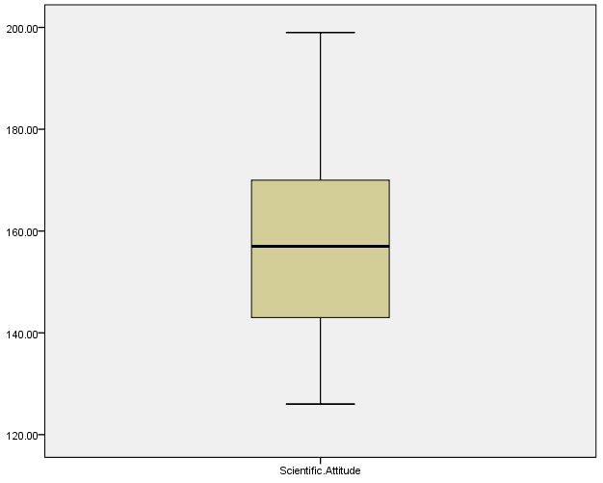

**Figure 4.92 No preference**

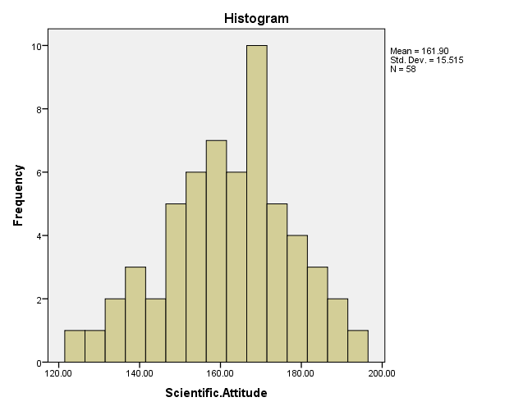

Test of Normality

|  |  |  |  |  |  |  |  |  |  |  |  |  |
| --- | --- | --- | --- | --- | --- | --- | --- | --- | --- | --- | --- | --- |
| |  |  |  |  | | --- | --- | --- | --- | |  | Shapiro Wilk | | | |  | Statistic | Degrees of freedom | p-value | | Scientific Attitude | 0.989 | 58 | 0.860 | |

**Figure 4.93**

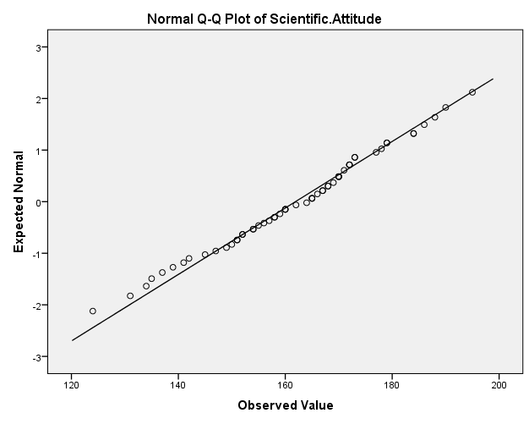

**Figure 4.94**

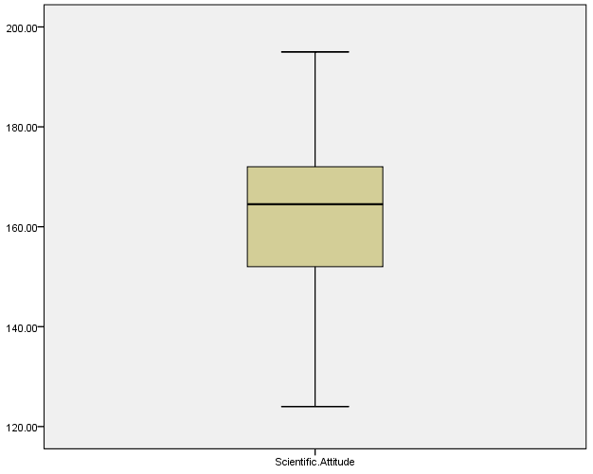

**Figure 4.95 Hindi Preferred**

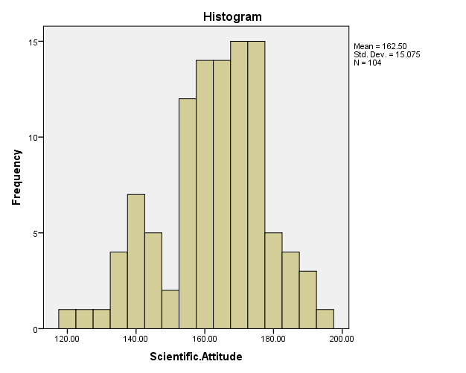

Test of Normality

|  |  |  |  |  |  |  |  |  |  |  |  |  |
| --- | --- | --- | --- | --- | --- | --- | --- | --- | --- | --- | --- | --- |
| |  |  |  |  | | --- | --- | --- | --- | |  | Shapiro Wilk | | | |  | Statistic | Degrees of freedom | p-value | | Scientific Attitude | 0.978 | 104 | 0.074 | |

**Figure 4.96**

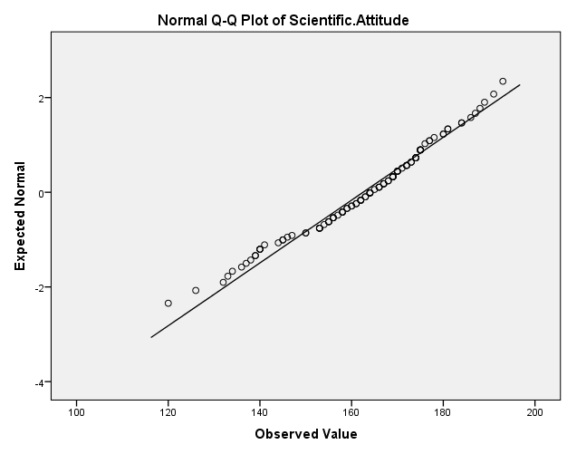

**Figure 4.97**

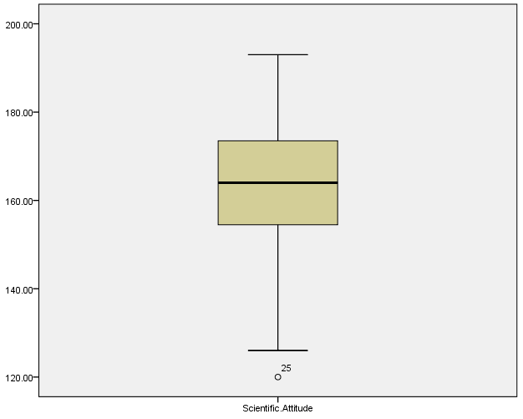

Table 4.48 is a table listing descriptive statistics like mean, standard deviation, percentiles skewness and Kurtosis for the three samples from the population namely Preferring Hindi, Neutral and Not preferring Hindi.

The coefficient of skewness for Not Preferring Hindi population was 0.162 which means the data is positively skewed so the right tail is stretched more than the left tail but as the absolute value is less than 0.5 the data is fairly symmetric. The Kurtosis value is negative which means data is slightly flatter than normal but as the value is smaller than 2 it is fairly peaked. The 50 percentile shows that half of the Not Preferring Hindi population has scored more than 157 and the mean is 157.712 which looks slightly less than the mean of whole population. Top 5 percent have scored more than 183.65.

The coefficient of skewness for Neutral population was -0.235 which means that data is negatively skewed so the left tail is stretched more than the right tail but as the absolute value is less than 0.5 the data can be considered to be fairly symmetric. The Kurtosis value is negative so it is slightly flatter than normal but since the absolute value is less than 2 its fairly peaked. The 50 percentile shows that half of the Neutral population has scored more than 164.5 and the mean score is 161.8966 which looks slightly greater than Not preferring Hindi population’s scores. Top 5 percent Neutral population have scored more than 188.1 on attitude scale.

The coefficient of skewness for Preferring Hindi population was -0.467 which means that data is negatively skewed so the left tail is stretched more than the right tail but as the absolute value is less than 0.5 the data can be considered to be fairly symmetric. The Kurtosis value is negative so it is slightly flatter than normal but since the absolute value is less than 2 its fairly peaked. The 50 percentile shows that half of the Preferring Hindi population has scored more than 164 and the mean score is 162.5 which looks slightly greater than Neutral and Not preferring Hindi population’s scores. Top 5 percent Preferring Hindi population have scored more than 186.75 on attitude scale.

Normality test for Sample of Not Preferring Hindi HindiHindipopulation

The standard error in skewness was 0.295 whereas in kurtosis it was 0.582.

Skewness Z Value = 0.162/0.295 = 0.549

Kurtosis Z Value = -0.529/0.582 = -0.908

Both the values lie between +1.96 and -1.96 which is required for data to be normally distributed. The histogram (figure 4.89), Normal Q-Q plot (figure 4.90) and Box Plot (figure 4.91) give the impression that the data is normally distributed. The Shapiro Wilk test gives P value of 0.444 which is greater than .05 hence we can assume data to be normally distributed.

Normality test for Sample of Neutral HindiHindipopulation

The standard error in skewness was 0.314 whereas in kurtosis it was 0.618.

Skewness Z Value = -0.235/0.314 = -0.748

Kurtosis Z Value = -0.193/0.618 = -0.312

Both the values lie between +1.96 and -1.96 which is required for data to be normally distributed. The histogram (figure 4.92), Normal Q-Q plot (figure 4.93) and Box Plot (figure 4.94) give the impression that the data is normally distributed. The Shapiro-Wilk test gives a P value of 0.860 which is greater than .05 hence we can assume data to be normally distributed.

Normality test for Sample of Preferring Hindi HindiHindipopulation

The standard error in skewness was 0.237 whereas in kurtosis it was 0.469.

Skewness Z Value = -0.467/0.237 = -1.970

Kurtosis Z Value = -0.068/0.469 = -0.144

One of the values lies between +1.96 and -1.96 which is required for data to be normally distributed but the other is slightly out of the range. The histogram (figure 4.95), Normal Q-Q plot (figure 4.96), and Box Plot (figure 4.97) give the impression that the data is normally distributed. The Shapiro-Wilk test gives a P value of 0.074 which is greater than .05 hence we can assume data to be normally distributed.

|  |  |  |  |
| --- | --- | --- | --- |
| **Levene's Test of Equality of Error Variancesa** | | | |
| Dependent Variable: Scientific.Attitude | | | |
| F | df1 | df2 | Sig. |
| .667 | 2 | 225 | .514 |
| Tests the null hypothesis that the error variance of the dependent variable is equal across groups. | | | |
| a. Design: Intercept + Hindi.Preference | | | |

**Figure 4.98**

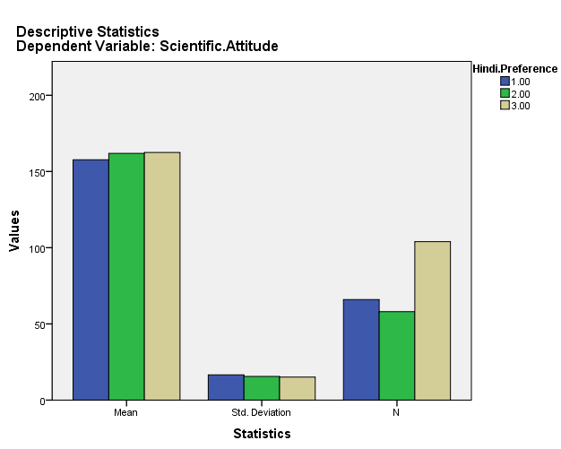

As we see p value for the Levene’s test is 0.514 which is greater than 0.05 hence Null Hypothesis is accepted so the variance across the groups is same and the data also follows normal distribution but sample sizes are different as shown in Figure 4.97 so in this case the test recommended to check the significant difference between the groups Welch’s One-way ANOVA test.

H011 : The distribution of scientific attitude is the same across categories of Hindi preference

HA11 : The distribution of scientific attitude varies across categories of Hindi preference

|  |  |  |  |  |
| --- | --- | --- | --- | --- |
| **Robust Tests of Equality of Means** | | | | |
| Scientific.Attitude | | | | |
|  | Statistica | df1 | df2 | Sig. |
| Welch | 1.894 | 2 | 128.434 | .155 |
| a. Asymptotically F distributed. | | | | |

We can see, the p-value for the Welch’s Anova test is greater than 0.05 which means the Null hypothesis can be accepted and the alternate hypothesis is rejected. The distribution of scientific attitude does not vary across categories of Hindi preference

Figure 4.99

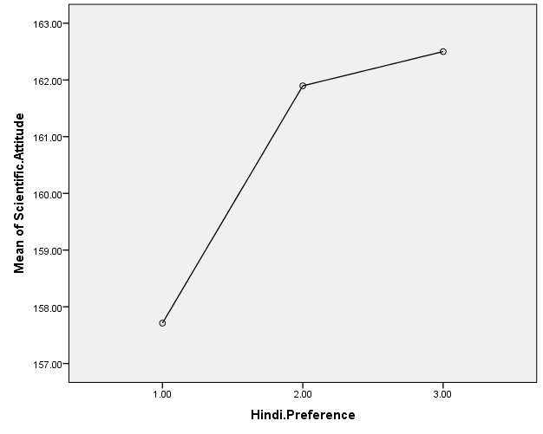

The Pearson Correlation between Scientific attitude and Hindi preference comes out to be 0.141 which indicates there is a significant positive correlation but it is weak.

The Spearman’s correlation coefficient comes out to be 0.148 which indicates there is a significant positive correlation but it is weak.

**Conclusion**

**Conclusion**

**5.1 Findings & Discussion**

India as a country has progressed manifold since it attained its independence in 1947. The journey in science communication also began at the same time. Pioneering initiatives like Vigyan Prasar, National Council for Science & Technology Communication(NCSTC), and Science Magazine for Rural India(SRISTI) aimed to cultivate scientific temper among the Indian masses. Over the decades, these efforts were complemented by a slew of science fairs, exhibitions, print media, radio, and television programs.

There is an aspect of science communication in India that is very unique and it is the role of vernacular languages. Given that India is a linguistically diverse country with over 1500 dialects, it’s imperative to break the barrier created by the English language while effectively communicating science to all citizens. This necessity has resulted in several successful initiatives, like the publication of science magazines in various regional languages and the airing of science-based programs on all India Radio in different dialects.

With the digital revolution, the landscape of science communication in India has seen a significant shift. Social media platforms, digital news outlets, and online blogs have played a vital role in making science communication more accessible and interactive. Moreover, the increased availability of smartphones and internet connectivity, even in rural areas, has opened new avenues for digital science outreach.

As we know the majority of India is Hindi speaking which is a compelling reason to take up research on the subject of mass communication in Hindi. Combined together with Social Media, Online science communication in Hindi promises to be an even better research subject. It is an inspiring journey for India toward becoming a scientifically literate and rational nation. Whether science communication happening online in Hindi has an impact on the people who consume it is the major research question of this study.

The data analysis carried out in the previous chapter gave us some interesting findings.

The scientific attitude score was calculated and categorized for males and females which was analyzed to find out if there was any significant difference between the two groups. The analysis was performed after checking the normal distribution of both groups. Both groups passed the normality test which allowed us to go further with the t-test. The p-value for the t-test came out to be 0.866 which is greater than our chosen significance level of 0.05 hence the Null hypothesis was retained. This means there was no significant difference between the mean scientific attitude of males and females. This finding shows that gender doesn’t play a role in determining any person’s scientific attitude. Such revelation coming out of this study is a message to our society that people can possess the traits of being rational and scientific irrespective of their gender.

The scientific attitude score was again categorized into three groups on the basis of age. People up to 29 years of age were categorized as young age, people from the age 0f 30 years to 49 years were categorized as middle age, and people over 50 years were categorized as high age. The group of middle-aged did not pass the normality test which meant that a non-parametric test was required to check if there were any significant differences between the scientific attitude of the three groups. Kruskall- Wallis test was employed for this purpose. The p-value for the test came out to be very very low so the Null hypothesis was rejected which meant there was a significant difference between the groups. A Post Hoc test was performed which was the Mann-Whitney test. It gave us the result that there was a difference between the mean ranks of the scientific attitude of the pair of high age and middle age and the pair of young age and middle age. The Average rank age of middle age was higher than the other two which means people of middle age had scored higher than young age and high age. It can be concluded from the analysis that middle age might have had a better understanding of the questions and a higher scientific attitude which seems to be on the expected lines as young people might not have developed better understanding skills and high-age people might be more conservative in their attitude.

The scientific attitude score was categorized into three groups on the basis of qualification. People with primary and high school education were categorized into school-level education, people with graduate degrees were categorized into college-level education, and people with postgraduate or higher degrees were categorized into high-level education. The groups passed the normality test but the group sizes were unequal which meant that Welch’s Anova test was required to check if there was any significant difference between the scientific attitude of the groups. The p-value for the test came out to be less than 0.05 which meant that there was a significant difference between the three groups. To carry out a pairwise comparison between the groups Games Howell test was employed. The p-value came out to be less than 0.05 for the pair of school-level and high level which meant that there was a significant difference between means of the scientific attitude of the people coming from School Level and High-level education. Figure 4.77 gives the idea that as the qualification of the group went higher so did the scientific attitude of the group. The correlational analysis also indicated that there is a positive correlation though it was weak. This result was also on the expected lines.

The scientific attitude score was categorized into three groups based on the time devoted to online science communication in Hindi. The three groups were Less time devoted, Average time devoted, and More time devoted. The groups were normally distributed but the group sizes were unequal which meant Welch’s ANOVA was the right test for the groups. The p-value came out to be greater than 0.05 which meant there was no significant difference between the mean scientific attitude of the three groups. The result implied that Post hoc test was not required. The correlational analysis also did not indicate any correlation between time devoted and scientific attitude. This was not on the expected lines as people who devote more time to science communication should have shown higher scores. This gives the idea that science communication consumption doesn’t necessarily override the beliefs and attitudes of people. Cultural and social beliefs might be stronger than the scientific attitude.

The scientific attitude score was categorized into three groups based on the preference for Hindi in consuming online science communication. The three groups were Hindi not preferred, no preference for language, and Hindi Preferred. The groups were normally distributed but the group sizes were unequal which meant Welch’s ANOVA was the right test for the groups. The p-value came out to be greater than 0.05 which meant there was no significant difference between the mean scientific attitude of the three groups. The result implied that Post hoc test was not required. The correlational analysis indicated a positive but weak correlation between preference for Hindi and scientific attitude score. This was on the expected lines as people with a preference for Hindi scored more on the scientific attitude score owing to the fact that they were consuming the content in their preferred language “Hindi”.

**5.2 Role of Scientists and Researchers**

The onus of science communication doesn't rest solely on dedicated agencies or the media; scientists and researchers play a crucial role too. The trend of researchers stepping out of their labs to interact directly with the public is on the rise in India. The "scientist-citizen" model is increasingly being recognized and encouraged, allowing for a more direct and authentic connection between science and society.

**5.3 Challenges and Opportunities**

Despite the progress, science communication in India faces several challenges. The dearth of professional science communicators, the lack of emphasis on science communication in research, the persisting language barrier, and the widespread dissemination of pseudoscience are among the significant hurdles.

On the other hand, there's an array of opportunities. Harnessing the power of digital media, cultivating science journalism, encouraging more scientists to communicate their work, and developing dedicated science communication programs in universities are just some ways to elevate the current state of science communication in India.

**5.4 The Future of Science Communication in India**

As India continues to establish itself as a global hub for scientific research and technological innovation, the need for effective science communication will become increasingly crucial. Bridging the gap between the scientific community and the public, debunking myths and pseudoscience, and fostering a society where science is understood, appreciated, and celebrated are vital for the nation's progress.

For this, a multi-faceted approach is needed. Strengthening traditional modes of science communication, like print and broadcast media, leveraging the power of digital platforms, cultivating science journalism, making science education more interactive, and incentivizing scientists to participate in public communication are all steps in the right direction. It's a task that requires the active involvement of policy-makers, educators, scientists, journalists, and the public.

Science communication in India, while on a promising trajectory, has a long road ahead. It's an exciting journey that holds immense potential for India's scientific, technological, and societal advancement.

**Suggestions**

**How to improve Science communication?**

Science communication, the process of sharing and disseminating scientific information to the public, is a vital part of the global scientific landscape. However, in many countries, including India, there is a significant gap between science and society. We have to look for ways to enhance science communication in India, a country with a rich scientific heritage and growing potential in modern scientific research.

Understanding the Current Scenario:

Before moving towards improvements, it is essential to comprehend the current state of science communication in India. While the country has a robust and evolving scientific community, the lack of effective scientific communication often results in public misperceptions about science, vaccine hesitancy, climate change denial, and other such issues. The problem often lies in the delivery and interpretation of scientific information. Complex jargon and a lack of relatability often make it difficult for the public to understand and apply scientific knowledge.

Proposed Strategies for Improving Science Communication in India:

1. Simplify Scientific Language:

The most critical step towards effective science communication is to simplify the scientific language. Scientists and researchers often use terminology that can be complex and confusing to the general public. To bridge this gap, it's vital to translate these complex ideas into simpler, more accessible language without diluting scientific accuracy. Popular science magazines, science sections in newspapers, radio and TV programs, and digital platforms can play an instrumental role in this.

1. Incorporate Science Communication in Education:

Early exposure to effective science communication can nurture a society that understands and appreciates science. Including modules on science communication in the school, curriculum can equip students with the ability to understand scientific concepts and communicate them effectively. Further, higher education institutions should also offer courses and training programs in science communication to train future scientists, journalists, and educators.

1. Leverage Digital Platforms:

With the digital revolution, information dissemination has never been easier. Social media platforms, blogs, podcasts, and online video channels offer a great opportunity for science communication. Scientists, institutions, and educators can leverage these platforms to reach a wider audience. The government can also initiate online science communication platforms to keep the public updated about various scientific developments.

1. Public Engagement Programs:

Science is not only for scientists, but it's for everyone. Public engagement programs like science fairs, exhibitions, seminars, webinars, and open lectures can stimulate interest in science. Through these interactive platforms, people can engage directly with scientists and researchers, fostering a better understanding of scientific processes.

1. Strengthen Science Journalism:

Science journalism plays a crucial role in the effective communication of science. Hence, it is essential to strengthen this sector by providing science journalism fellowships and training programs. Science journalists need to be trained to translate scientific jargon into language that the layperson can understand, to present facts accurately, and to explain the relevance and impact of scientific findings to daily life.

1. Collaboration and Partnership:

Collaboration between scientists, journalists, educators, and policymakers can improve the effectiveness of science communication. Joint efforts can lead to a comprehensive strategy that caters to different segments of society and addresses various communication challenges.

1. Policy Support:

Science communication should be considered a priority at the policy level. The government can provide support in the form of funding, training programs, and incentives for science communication initiatives. Policy interventions can also ensure that scientific institutions have designated departments for science communication.

1. Evaluation and Feedback:

For any initiative to be successful, constant evaluation is crucial. Regular assessment of science communication initiatives can provide insights into their effectiveness and areas of improvement. Feedback from the public can be instrumental in making science communication more relevant and accessible.

Improving science communication in India is not a task for a single stakeholder; it requires the collective effort of the scientific community, the education sector, the media, the government, and the public. Effective science communication can empower individuals with knowledge, facilitate informed decision-making, and foster a culture of scientific curiosity and understanding. As India continues to grow in scientific research and technology, it is time to give equal emphasis to science communication, to bring science closer to society